Array of 8 Circularly Polarized Microstrip Antenna for 802.11ac MIMO WLAN

Sholihin 1,2, A.A Pramudita.2, and Eka Susanti 3,4

1Electrical Engineering dept. Politeknik Negeri Sriwijaya Palembang, Indonesia

2 Telecommunication Engineering dept. Telkom University line 4: Bandung, Indonesia

3 Electrical Engineering dept. Politeknik Negeri Sriwijaya Palembang, Indonesia

Abstract— An Array of 8 Circularly Polarizer Microstrip Antenna was proposed as MIMO antenna for IEEE 802.11ac MIMO WLAN system. The proposed antenna is applied for access point side. Antenna arrangement in two different polarization has investigated and the results show that setting the adjacent element with different polarization such as right hand and left hand circular polarization was used to suppress the mutual coupling between antenna. The highest mutual coupling is -26.8 dB. Each antenna element covers 480 MHz bandwidth. The calculation of estimated MIMO capacity that supported by the antenna shows that 1 Gbps capacity can be reach using the proposed antenna.

Index Terms— Circularly polarized, microstrip, MIMO, antenna

1. Introduction

The demand of telecommunication system which support high data rate transmission is continually increases day by day. Its driven by many multimedia applications, social media application and internet of things that used by users. Multiple-Output (MIMO) is promising technology that can be applied to increase the channel capacity in supporting high data rate transmission without increase the bandwidth [1,2]. A MIMO system have two or more antennas in a single physical transmission. By utilizing multiple antennas, data throughput and range are increased compared to a single antenna using the same radio transmit power. MIMO antennas improve link reliability and experience less fading than a single antenna system. By transmitting multiple data streams at the same time, wireless capacity is increased [2].

The channel correlation in MIMO system, generally reduces the MIMO capacity. The channel correlation in MIMO interpreted in term of spatial correlation related to propagation and mutual coupling between antennas in MIMO antenna. The MIMO capacity is not only determined by the number elements of antenna but also by the array characteristic such as spatial correlation, mutual impedance and bandwidth each antenna that is used in MIMO antenna [3-7]. Several previous researches are investigated the effect of antenna mutual coupling to its MIMO capacity [5-7]. Low mutual coupling between antenna in MIMO become important consideration in designing the MIMO antenna. Many researches in designing MIMO antenna reported the low level mutual coupling is achieved at -20dB to 27 dB [8-11]. Several number methods have been studied and proposed for suppressing the mutual coupling between elements in microstrip array antenna. Spacing is the simplest method of adjusting coupling level [12,13], however, the solution enlarging the spacing between antenna elements shall increases the dimensions of the antenna. A slot structure on the ground plane and simple conducting strips that located between patch antenna has proposed as a method to reduce the mutual coupling between the patch antenna elements. The result shows that the method significantly reduces the mutual coupling between patch [14]. The addition of the Defected Ground Structure [15,16] is essentially an attempt to influence the current distribution on the antenna surface which can also be used to reduce coupling levels, but will have an impact on the fabrication complexity. Polarization arrangement between antenna elements will reduce the coupling level between elements [17]. Cross polarization orientation will lead to increasing in polarization loss factor, therefore this concept can be used as a simple method to reduce coupling levels.

IEEE 802.11ac is a communications standard for wireless local area network (WLAN) that supports transmitting data at speeds above 1 Gbps. In this paper, a design of array of 8 circularly polarized microstrip antennas is proposed as MIMO antenna for IEEE.8011.ac MIMO system that is operated at 5 GHz channel. The Monopole has the same behavior with dipole antenna and theoretically proofed that parallel has higher mutual coupling level than perpendicular arrangement [7]. Experiment results on a kind of microstrip antenna for MIMO that reported in [9] show that the parallel arrangement has coupling level -20 dB and the perpendicular arrangement has -25 dB. Array of circularly polarized with co-polarization and cross polarization arrangement are investigated its effect to mutual coupling level and MIMO capacity in obtaining the 1 Gbps channel capacity. Analysis of MIMO capacity of proposed antenna is included in this study.

Numerical simulation using CST studio has been done in designing the proposed MIMO antenna. The results show that the proposed antenna has cover 480 MHz bandwidth at 5 GHz channel. The results show that the proposed antenna has cover 480 MHz bandwidth around 5 GHz channel and has also low return loss. In this paper, arrangement of the polarization between adjacent antenna element as right hand and left hand circular polarization is successfully reduced the coupling level below -26.8 dB and supports to reach a compact design of the antenna. The radiation pattern of the proposed antenna is closed to omnidirectional and potentially implement for access point system with good covered area.

This paper is organized as follow; in the first section discussed about the background of research, the problems that addressed on the design of MIMO antenna and selection of design concepts. Then the second section described about the design concept of the proposed MIMO antenna and the complete dimensions of the proposed MIMO antenna. Afterward the third section discussed the results of the numerical studies that have been done in designing process and then the last is the conclusion of the whole discussion in this paper.

1. Propose Antenna Design

The antenna that proposed as MIMO antenna for IEEE 802.11ac MIMO system is array antenna that consists of 8 microstrip antennas with corned truncated that arrange in circular array. The antenna is proposed as MIMO antenna at access point side. Circular array arrangement is chosen to cover all direction surrounding the access point. Microstrip antenna element is studied in this paper because of several features of its antenna that suitable for the purpose MIMO system such as directional radiation pattern that can be used to increase the space diversity, compact dimension that suitable to support a simple integration with access point device (router). Microstrip antenna has frequently studied in many previous research on MIMO antenna. The microstrip antenna element is printed on a structure of double layer PCB as shown in Fig 1. The rectangular patch with corner truncated shapes is printed on the top of the dielectric substrate and the bottom side is ground plane. Each microstrip antenna elements is feed using coaxial feeding method to give easier way to change its polarization as right hand or left hand circularly polarized. The proposed antenna is printed on an FR4 substrate having dielectric constant of *εr*=4.3, tangent loss of 0.025 and a thickness of 1.6 mm. The complete dimensions of the antenna are follows; p = 11.4 mm, s = 1mm, g = 20 mm, h = 1.6 mm and d=2.6 mm.

The circular array structure of the proposed antenna is depicted in Fig.3. In order to study the effect of polarization arrangement to mutual impedance between elements, two array scenarios are investigated. Scenario-A is depicted in Fig.2. In this scenario, microstrip antenna element are arranged with the same polarization. Scenario-B is depicted in Fig.3. In this scenario, each adjacent microstrip antenna elements are arrange with cross polarization. The dimension of the antenna is determined based on the formula of microstrip antenna and continued with parametric study to obtain the optimum dimension which is performed using numerical simulation.

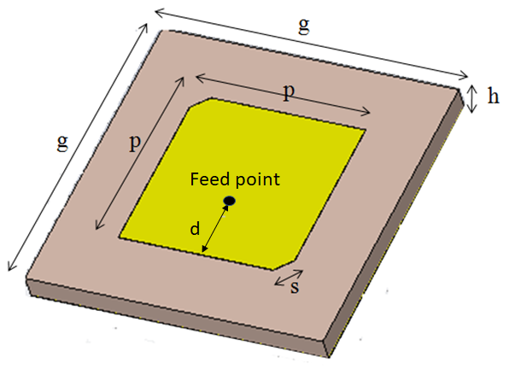

1. The dimension of circularly polarized microstrip antenna that used as antenna element in proposed MIMO antenna.

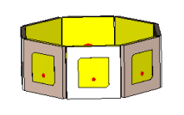

Fig 2. MIMO antenna configuration with Scenario-A

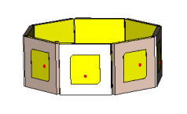

1. MIMO antenna configuration with Scenario-B



Fig 3. S11 of circularly polarized microstrip antenna that used in Scenario-A and Scenario-B.

1. Result and Discussion

The *S11* of each circularly polarized microstrip antenna that used in Scenario-A and Scenario-B are depicted in Fig. 4. The numerical simulation results in Fig.4 shows that each antenna elements in Scenario-A has 480 MHz bandwidth of *S11*<-10 dB within range 5.498 MHz to 5.978 MHz. The Scenario-B has 480 MHz bandwidth within range 5.515 MHz to 5.995 MHz. This result indicates that proposed antenna with 8 elements potentially reaches the total capacity 1 Gbps.

In Scenario-A, antenna elements are arranged in the same polarization and in Scenario-B antenna elements are arranged in cross-polarization for two adjacent elements. The results show that mutual coupling between element in Scenario-A has highest value of -21.2 dB and the lowest value of -34.5 dB. Meanwhile, for Scenario-B, the results show that mutual coupling between

elements has highest value of -26.8 dB and lowest value of -49.5 dB. The mutual coupling in Scenario-B is lower than in Scenario-A. Its agree with theory and the result in previous research that cross polarization arrangement causes lower mutual coupling that co-polarization arrangement [17]. Furthermore, Scenario-B is selected as proposed MIMO antenna for IEEE 802.11ac MIMO system.

The numerical simulation results of antenna radiation pattern are shown in Fig. 5 and Fig. 6. Each antenna element has maximum main beam in eight different direction. The coverage of the MIMO antenna can be divided into 8 sectors and each antenna elements will cover one sector. Combination of each antenna radiation pattern have an omnidirectional coverage which is suitable to be applied as an antenna for both indoor and outdoor access points.

The MIMO channel capacity that can be supported by proposed antenna system is approximated by capacity calculation that discussed in [7]. By assuming that mutual coupling between antennas has been suppressed to reach low level mutual coupling. The capacity calculation is performed by considering spatial correlation matrix. Fig.7 shows the spectral efficiency at different SNR condition. The estimated MIMO capacity can be achieved by the proposed MIMO is greater than 1Gbps, either at low SNR level. Several steps of this research still need to be done such as antenna fabrication and measurement.





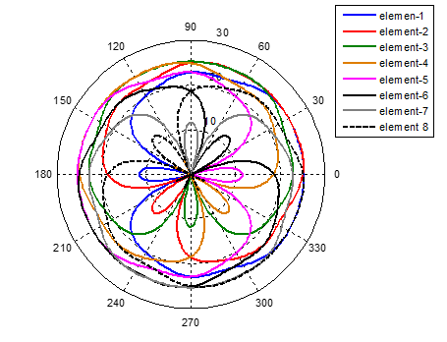

Fig 5. Radiation pattern of proposed antenna for Scenario-A. (a) Radiation pattern of element-1. (b) Radiation pattern of element-2. (c) Radiation pattern of each element.

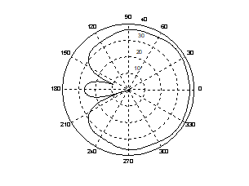

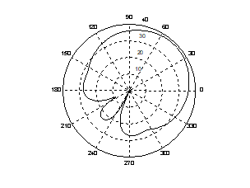

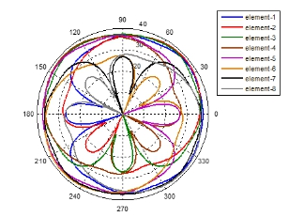

Fig. 6 Radiation pattern of proposed antenna for Scenario-B. (a) Radiation pattern of element-1. (b) Radiation pattern of element-2. (c) Radiation pattern of each element.



Estimated spectral efficiency of proposed antenna vs SNR

1. Conclusion

Array of 8 circularly polarized microstrip antennas has designed and proposed for IEEE 802.11a MIMO system that operate at 5 GHz channel. The antenna is proposed to be used for access point antenna. The numerical simulation study has performed to reach the design. MIMO antenna arrangement in two different polarization scenarios has investigated and the result shows that arrangement of two adjacent element in different polarization i.e. right hand and left hand circular polarization successfully suppressed the mutual coupling. The highest mutual coupling between element is -26.8 db. Combination of each antenna radiation pattern have an omnidirectional coverage which is suitable for access point system. The capacity calculation is performed and the result shows that the estimated MIMO capacity that can be achieved by the proposed MIMO is greater than 1 Gbps, either at low SNR level.

**References**

1. Daniel W. Bliss, Keith W. Forsythe, and Amanda M. Chan, MIMO Wireless Communication, Lincoln Laboratory Journal, Vol.15, No.1, 2005, pp.97-126.
2. T. L. Marzetta, "Massive MIMO: An Introduction," in Bell Labs Technical Journal, vol. 20, no., pp. 11-22, 2015.
3. X. Liu, M. Bialkowski and F. Wang, "Investigation into the Effects of Spatial Correlation on MIMO Channel Estimation and Capacity," 2008 4th International Conference on Wireless Communications, Networking and Mobile Computing, Dalian, 2008, pp. 1-4.
4. H. T. Hui, "Influence of Antenna Characteristics on MIMO Systems with Compact Monopole Arrays," in IEEE Antennas and Wireless Propagation Letters, vol. 8, pp. 133-136, 2009.
5. J. W. Wallace and M. A. Jensen, "Mutual coupling in MIMO wireless systems: a rigorous network theory analysis," in IEEE Transactions on Wireless Communications, vol. 3, no. 4, pp. 1317-1325, July 2004.
6. Xin Li and Zai-Ping Nie, "Mutual coupling effects on the performance of MIMO wireless channels," in IEEE Antennas and Wireless Propagation Letters, vol. 3, no. 1, pp. 344-347, Dec. 2004.
7. Xia Liu and Marek E. Bialkowski, “Effect of Antenna Mutual Coupling on MIMO Channel Estimation and Capacity,” International Journal of Antennas and Propagation, vol. 2010, Article ID 306173, 9 pages, 2010. doi:10.1155/2010/306173
8. Hussein Hamed Mahmoud Ghouz,Novel Compact and Dual-Broadband Microstrip MIMO Antennas for Wireless Applications, Progress in Electromagnetics Research B, Vol. 63, 107–121, 2015.
9. A.A. Asaker,R.S. Ghoname, A.A. Zekry, Design of a Planar MIMO Antenna for LTE-Advanced, International Journal of Computer Applications (0975 – 8887),Volume 115 – No. 12, April 2015.
10. I. K. Sokhi, Ramesh R and Usha Kiran K, "Design of UWB-MIMO antenna for wireless applications," 2016 International Conference on Wireless Communications, Signal Processing and Networking (WiSPNET), Chennai, 2016, pp. 962-966.
11. J. Ren, W. Hu, Y. Yin and R. Fan, "Compact Printed MIMO Antenna for UWB Applications," in IEEE Antennas and Wireless Propagation Letters, vol. 13, no. , pp. 1517-1520, 2014.
12. Kraus. D.Antennas, 1st edition, McGraw Hill, 1965.
13. Constantine A. Balanis, Antenna Theory: Analysis and Design, John Wiley & Sons, 2011.
14. Ahmad Emadeddin, Saeideh Shad, Zahra Rahimian, H.R. Hassani,High mutual coupling reduction between microstrip patch antennas using novel structure,AEU - International Journal of Electronics and Communications,Volume 71,2017, Pages 152-156, ISSN 1434-8411
15. M. I. Ahmed, A. Sebak, E. A. Abdallah and H. Elhennawy, "Mutual coupling reduction using defected ground structure (DGS) for array applications," 2012 15 International Symposium on Antenna Technology and Applied Electromagnetics, Toulouse, 2012, pp. 1-5.
16. G. Han, L. Han, R. Ma, Q. Zeng and W. Zhang, "A novel MIMO antenna with DGS for high isolation," 2016 IEEE MTT-S International Conference on Numerical Electromagnetic and Multiphysics Modeling and Optimization (NEMO), Beijing, 2016, pp. 1-2.
17. Sholihin, E. Susanti, A. A. Pramudita and M. M. Rose, "MIMO antenna with cross polarisation printed yagi elements for MIMO router," 2017 3rd International Conference on Wireless and Telematics (ICWT), Palembang, Indonesia, 2017, pp. 65-69.