An Automatic Scheduling System for Perishable Product’s Supply Chain

Isbat Uzzin Nadhori 1, Ahmad Syauqi Ahsan2

1 Departemen Teknik Informatika dan Komputer , Politeknik Elektronika Negeri Surabaya

2 Departemen Teknik Informatika dan Komputer , Politeknik Elektronika Negeri Surabaya

Abstract—Perishable products are a kind of agricultural product that has a very short shelf-life, such as fruits and vegetables. To maintain the quality, as expected by consumers, it needs a system that could be utilized to manage production planning of those perishable products. By utilizing this system should also minimize human error hence reducing the loss. To increase the availability of fruits and vegetables for people who live in cities is by shortening the distance between supplier (farmer) and consumer (citizen). Urban Farming is one way to increase the availability of fruits and vegetables for people who live in city. To create an efective Urban Farming infrastructure, it need a system by utilizing information technology to manage its supply chain. All members of the supply chain network including producers (farmers), distribution center, administrator, retailers, and consumer can access this system. Members of the supply chains can manage every information related to him/her, and able to see the information of the other members when needed. With the integrated information, the planting schedule planning process, the selection of products that will be planted, harvest schedules, and reports related to the fulfillment of the request can be done easily and faster

Index Terms— scheduling; supply chain; perishable product.

1. Introduction

Most of products produced by agricultural industry, especially fruits and vegetables, are perishable product. They have very short shelf-life. The quality of these kind of product will immediately decline since harvested, and will reach the condition that the product is not consumable after a certain period of time. The rapid decline in quality of these perishable products makes planting planning and distribution processes become very complicated. Lose demand if the planting time is late, while reduced profits if the planting time is too early. If the planting time is too early, the crop should be harvested before the demand exist. The harvested product should be taken care while waiting for demand, thus increasing the cost and reducing the profit.

To maximize the profit of agricultural business, especially for perishable products, an accurate information in a supply chain needed for better decision-making process on planting management (when to start planting and what type of crop should be planted). Supply chain for perishable product should considers the strict production deadlines and rapid decline of the product’s quality. In addition, agricultural production process that is strongly influenced by the environmental condition is often a challenge in itself

With the well managed information in supply chain, the agricultural product could be arrived at consumers location with high degree of freshness. Fresher the product will increase consumers’ desire to buy it. Consumers of these kind of products usually pay special attention to the freshness of the product. They are willing to spend more money for products with a higher degree of freshness (Tsiros & Heilman, 2005)

Producers (farmers) of urban farming used to have a limited land area. This condition increases difficulty for producer to be able to perform production prosesses at an economical cost. To ease this difficulty, it needs a system that has ability to produce planting and harvesting schedule by considering the consumers’ demand. The created schedule should also be able to coordinate all producers’ schedule. Main goal of this system is to optimize the production processes of urban farming and minimize harvested products that is not absorbed by the market

The goal of this research is to build an integrated system for agricultural product’s supply chain. It should be able to integrates every information related to all supply chain’s members. Every member of this system, including farmers, distribution centers, retailers, and consumers could access those informations and use it to improve their role in the supply chain network. The system should also be able to generate planting and harvesting schedule along with type of crops to be planted automatically. Unfulfilled demand reports generated by this system could ease the decision-making process associated with land capacity addition and product prioritization.

2. Previous Work

An urban farming is an activity to produce agricultural products carried out in urban areas. The main challenge of urban farming is limited land. Thus, several tasks to improve planting schedule, align production with market demand, and create an efficient distribution processes needs to be done to obtain the maximum profit.

Urban farming has several advantages compared to conventional agriculture which is done in rural area. Since most of consumers stay in city, urban farming has the advantage of being closer to consumers. Closeness to consumers will reduce the costs required to perform the distribution process. The close proximity between producers and consumers will also increase the freshness level of the product when it reaches the consumer, thus increasing customers’ satisfaction and make them willing to buy the product again

Prajogo & Olhager (2012) explained that integrated goods and information flow is very important for a supply chain management and it could increase its performance. One of the main objectives of information integration is to make real-time decision-making process related to product delivery become possible. Prajogo & Olhager (2012) have shown that information sharing can lower the costs through inventory reductions.

Ahumada and Vilalobos (2011) said that production planning should consider several factors including price estimation, availability of both land labor resources, transportation and inventory cost, and decomposition process of the product. They have developed a model to solve several problems of production and distribution planning of perishable products. Main objective of this model is to maximize profit of agricultural product’s producers. This model could be used at the beginning of the growing season to produce planting schedule, crop’s type to be seed, and target market. Data from agricultural area in northwestern Mexico have been used to validate this model

Seyedhosseini and Ghoreyshi (2014) have been developed a model to manage production and distribution planning of perishable products. The main focus of this research is to reduce the total cost by manage production quantities, inventory strategy, and distribution route.

3. Desain System

This research develops an urban agricultural supply chain management system that should be able to generate recommendations on planting schedules, crop’s type selection, harvesting schedules, and reports related to demand fulfillment.

The system consists of 5 roles: farmers as land’s owner, a distribution center (DC) or head quarter (HQ), retailers, and consumers. Farmers can perform production activities start from planting to harvesting, without abilities to determine the crop’s type to be planted and the time of planting and harvesting. All decisions related to planting time and harvesting time are done by the distribution center. Products that have been harvested by farmers should be deliver directly to distribution center and then distribute to retailers. Consumers only able to buy the product through retailers

Distribution center would use related information from retailers and farmers to plan the production process. The production planning that consist of planting schedule, crop’s type to be planted, and harvesting schedule will be informed to farmers. Farmers should use this informations to do their production process (planting and harvesting).

Interface of this system divided into two main components. The first interface component used for interaction with individual consumers while the second interface component is a portal that could be accessed by all member of the supply chain. In addition to receiving orders, the first interface componen could also be utilized to estimate the product’s demand and interest. Both of these main interface components utilize the same centralized database, hence will improve the system performance since there are no transportation and conversion of information

Based on description of the system above, model’s construction is done using tool from Unified Modeling Language (UML), which is use-case diagram. Use-case diagram used to describe all functions that exist in the urban agricultural supply chain management system. The use-case diagram of the system can be seen in the picture below.



Fig. 1 *Use case diagram* for the urban agricultural supply chain management system

From fig. 1 above it can be seen that there are 5 types of actors (roles) of this system, consists of Customer, Store Admin, Retailer, Farmer, and the DC (Distribution Center) Admin/Manager. Each type of actor may consist of several members, where each member will get different information according to their characteristics. As an example, a farmer A will receive different information compared to information that received by farmer B related to planting schedules.

Consumers have ability to view the list of products offered, check the product’s availability, purchase product(s), and monitor the purchase(s) that has been made. Retailers can monitor product stock and expiration date, change the product’s availability (add or subtract), set the product price, and check and follow up customer’s order(s). Retailers could also make order from distribution center and monitor those orders. Farmer can view the planting’s schedule that should be done in their farm(s) and manage their owned farm(s).

DC Manager has ability to monitor stocks at distribution center, view the flow of products in and out, view planting status on farmers, and handling the requests from consumers. DC Manager could also generate schedules and reports based on customers and retailers’ demands. The latter process will generate planting schedules for each farm owned by joined farmers, unfulfilled customers’ order(s), and ulfulfilled order(s) from retailers. The algorithm of this scheduling proses could be seen in the following picture.



Fig. 2 Algorithm for scheduling the planting period

Fig. 2 above is the algorithm used to generate schedules for the planting period. The first task is calculating the time required for each ordered product to grow. The second task is to read each demand’s information ordered from the fastest time, and then distributed it into unoccupied farm. The next task is to calculate the ordered products that could not be planted due to insufficient time or farm area. And the last task calculating the expected profid based on planting schedule.

4. Testing And Discussion

There are two types of consumers for this system: individual consumer and large consumers. Individual consumers (called as customer) buy the product through online stores, while large consumers (called as retailers) place the orders in advance. The retailer could also place a repeated order, an order that should be fulfilled during a certain time span for every determined time interval. The main difference between demands from the two types of consumers is the uncertainty element. Demand from the retailer is sure and sustainable, while demand from the customer is uncertain.

Based on demands from customer and retailer, a planting schedule (including the crop’s type to be planted) is generated for all products automatically, and will then be distributed to joined farmers. An example of planting schedule for Farmer C, one of the farmers who are members of the system, could be seen in the following picture.

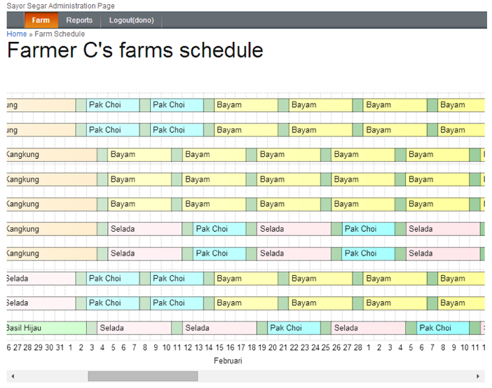

Fig. 3 Planting schedule

Fig. 4 above is the planting schedule for the farm owned owned by farmers C. It could be seen crop’s type that should be plant for every farm’s slot (this farm has 10 slots).

References

1. M. Tsiros and C. M. Heilman, "The effect of expiration dates and perceived risk on purchasing behavior in grocery store perishable categories," Journal of Marketing, vol. 69, no. 2, 2005
2. F. Marinelli, M. E. Nennii and A. Sforza, "Capacitated lot sizing and scheduling with parallel machines and shared buffers: a case study in a packaging company," Annals of Operation Research, vol. 150, pp. 177-192, 2007
3. M. L. Entrup, “Advanced planning in fresh food industry,” Heidelberg: Physica-Verlag, 2005
4. X. Q. Cai, J. Chen, Y. B. Xiao and X. L. Xu, "Product selection, machine time allocation, and scheduling decisions for manufacturing perishable products subject to a deadline," Computer & Operation Research, vol. 35, pp. 1671-1683, 2008
5. A. Osvald and L. Z. Stirn, "A vehicle routing algorithm for the distribution of fresh vegetables and similar perishable food," Journal of Food Engineering, vol. 85, no. 2, pp. 285-295, 2008
6. S.-I. Hsu, S.-F. Hung and H.-C. Li, "Vehicle routing problem with timewindows for perishable food delivery," Journal of Food Engineering, vol. 80, no. 2, p. 465–475, 2007
7. Prajogo, D., & Olhager, J. "Supply chain integration and performance: The effects of long-term relationships, information technology and sharing, and logistics integration.", Int. J. Production Economics, 2012
8. O. Ahumada and J. R. Vilalobos, "A tactical model for planning the production and distribution of fresh produce," Annals of Operation Research, vol. 190, no. 1, pp. 339-358, 2011
9. S. M. Seyedhosseini and S. M. Ghoreyshi, " An Integrated Model for Production and Distribution Planning of Perishable Products with Inventory and Routing Considerations.", Mathematical Problems in Engineering, 2012.