Design of E-KTM Based On Contactless Smartcard for Access Electro Department Parking Service State Polytechnic of Semarang

Sarono Widodo1, Riska Nanda Istiqomah2, Sindu Maulana H3.,and Agus Rochadi4

1,2,3,4 State Polytechnic of Semarang

Abstract—E-KTM is an electronic student identification (card ID) card which function besides to student identity, it can be used to access several services at State Polytechnic of Semarang such as to access parking service. In this research, E-KTM has used contactless smart card technology will be used to access facilities parking at electro department area parking. The gate of parking area will be installed two barrier gate to entrance and exit. To access this parking facility, E-KTM must be attached to RFID reader near the entrance gate, and then the barrier gate could open. The system controlled with microcontroller arduino Mega 2560 and will automatically take and save the data of the card ID in database system, and then the infrared sensor would detected the object and a few minutes the barrier gate closed. The system also works for the exit. While the performance to determine average service time with results 2.927 open time and 2.913 close time 2.95 seconds for entrance gate and 2.792 open time and 2.789 close time for exit gate.

Index Terms—E-KTP card ID, Parking service, database system.

1. 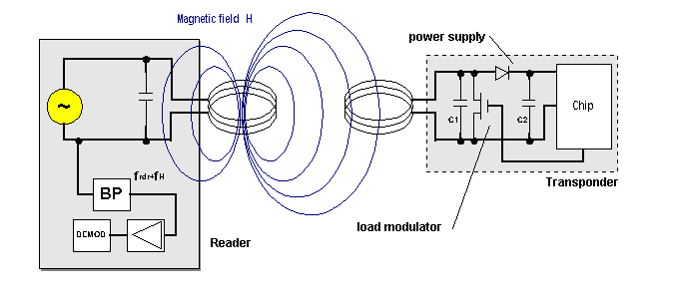Introduction

Student Identification Card (KTM) is an indentity card which owned by a student at college. This identity card (ID card) made with RFID tag. In State Polytechnic of Semarang, the student can access parking service using the card ID.

Student entered electro parking area use card ID which there is tag that have been registered in database. The smard reader read the tag and match with existing database. This system composed by input and output unit, controller, and database. This system is equipped with IP Cam to monitor access to the parking area.

2. Basic Theory

2.1. RFID (Radio Frequency Identification)

RFID or Radio Frequency Identification is a method used to store or receive data from distance without contact on device (contactless) called RFID tag. RFID tag can be found on smart card. RFID has an antenna that allowed to receive and respond when RFID get radio waves from RFID transceiver (smart card reader) [1].

Smart card is a plastic card shaped like credit card which embedded a chip in the card. Chip is an integrated circuit made of processor and memory, the chip has supplied power to smart card to process the data, such as integrating data, saving data and write or read data.

Corresponding author. Tel.:+6285727287729

Email : sarwede@gmail.com

Fig.1. RFID work systems[2].

Contactless card is a card that can communicate with the reader without physical contact. When the card have been closer to the reader and the chip on card will get electromagnetic waves used to process data flow to the reader[3].

.

2.2. Arduino Mega 2560

Arduino is a microcontroller which designed to be used easly to application system. One of type Arduino is Arduino Mega 2560. This Arduino consist high specification, include additional digital I/O pin, analog I/O pin, serial port, etc [4].

2.3. Ethernet Shield

Ethernet shield is an electronic module which compatible with arduino used to provide connectivity with LAN network via RJ45 port. Ethernet shield equipped with Wiznet 5100 chip as Ethernet controller. Ethernet shield communicated with arduino via Serial Peripheral Interface bus on digital pin 10, 11,12, and 13.

1. Research Method

Research method has been used experimental research method. This method includes design, implementation, testing, and analysing.

3.1. System Design

System design purposed to provide overall picture about the system will be created, so that made it easier for us to make the systems.

Infrared sensor

gate

Web server/ database

Arduino

reader

))((

Card ID

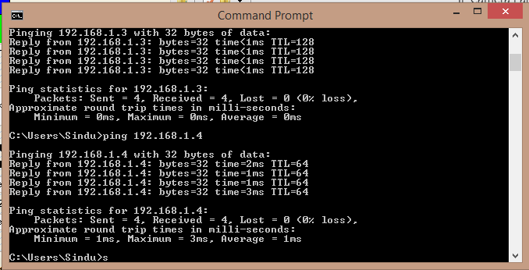

Swich ethernet

Ethernet shield

))

IP cam

laptop

AP

))

Fig.2.Design system.

3.2. Hardware Design and implementation

Design of E-KTM based smart card contactless to access parking made by several hardware that will support the performance of program that have been made. The hardware design consist circuit design of arduino Mega 2560:

* Module RC522
* Ethernet shield
* Motor driver
* Limit switch
* Infrared sensor

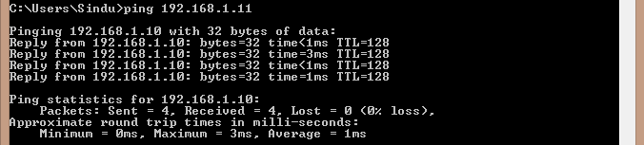

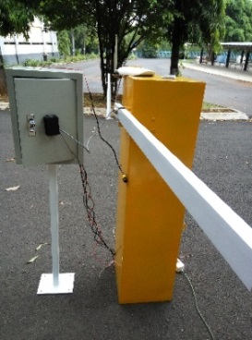

Fig.3. Barrier Parking gate.

3.3. Software Design and implementation

In the software design will be created a design include:

* Design of joint service E-KTM web page
* Design of parking services web page
* Design of display on exit gate

3.4. Testing system

The first testing is client-server connection. The following are result of test client-server connectivity:



Fig.4. Check IP address PC server

. Fig.5.Connected IP server to IP Cam

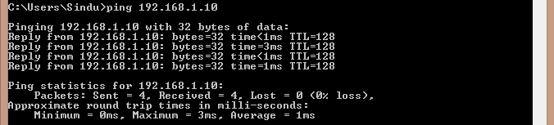

Fig.6. Connected IP server to IP entrance gate

Fig.7. Connected IP server to IP exit gate

The second test is RFID reader. On testing RFID reader which measures the distance read of card ID to RFID reader. This test used to detect maximum distance RFID reader to read card ID. This test used a ruler to measure read distance of RFID reader. The result is shown in table 1.

Table 1

Measurements of distance read card ID to RFID readera

|  |  |  |
| --- | --- | --- |
| Measurement | Distance (cm) | Status |
| 1 | 0 | read |
| 2 | 0.5 | read |
| 3 | 1 | read |
| 4 | 1.1 | read |
| 5 | >1.1 | Not read |

a Reprinted from *Measurement of distance read card ID to RFID reader*

The next measurement is test entrance gate and exit gate. Testing entrance gate and exit gate is used arduino through arduino IDE’s serial monitor program. This test determined to whether card ID are used, it is registered or unregistered. If the card ID is registered, the barrier gate will open, but it’s not registered, the barrier gate will not open. RFID reader which are used in project has type RC522 that has working on frequency 13.56 MHz. Arduino connected by Ethernet shield and connected to central database using a network existing. The result is shown in table 2.

Table 2

Measurements of serial monitor arduinob

|  |  |  |
| --- | --- | --- |
| Measurement | Image | Status |
| 1 |  | Data registered |
| 2 |  | Data not regsitered |

b Reprinted from *Measurement of serial monitoring arduino*

Testing infrared sensor voltage to measure voltage when infrared active. Infrared sensor are actived when the sensor detects an object that’s passed. The result is shown in table 3.

Table 3

Measurements of infrared sensorc

|  |  |  |
| --- | --- | --- |
| Measurement | Condition | Voltage (Volt) |
| 1 | Detected | 0.3 |
| 2 | Not detected | 4 |

c Reprinted from *Measurement of infrared sensor*

Velocity testing on entrance gate and exit gate measured velocity when the barrier open and close with two different stopwatch. When the barrier open, measurement began after card ID to the reader, how long the time until the barrier open. And when the barrier close, measurement began after motorcycle through the infrared sensor, how long the time until the barrier close. The result of entrance gate is shown in table 4 and exit gate is shown in table 5.

Table 4

Measurements of velocity when entrance gate open and closed

|  |  |  |  |  |
| --- | --- | --- | --- | --- |
| Measurement | Open | | Close | |
| Stopwatch1 (seconds) | Stopwatch2 (seconds) | Stopwatch1 (seconds) | Stopwatch2 (seconds) |
| 1 | 3.1 | 3.1 | 2.9 | 2.93 |
| 2 | 2.8 | 3 | 2.75 | 3.08 |
| 3 | 2.94 | 2.81 | 2.7 | 3.1 |
| 4 | 2.82 | 3.1 | 2.7 | 3 |
| 5 | 2.7 | 2.9 | 2.9 | 3.07 |
| Average | 2.872 | 2.982 | 2.79 | 3.036 |

d Reprinted from *Measurement of velocity when entrance gate open and close*

Table 5

Measurements of velocity when exit gate open and closee

|  |  |  |  |  |
| --- | --- | --- | --- | --- |
| Measurement | Open | | Close | |
| Stopwatch1 (seconds) | Stopwatch2 (seconds) | Stopwatch1 (seconds) | Stopwatch2 (seconds) |
| 1 | 2.8 | 2.75 | 2.7 | 2.75 |
| 2 | 2.62 | 2.9 | 2.82 | 2.9 |
| 3 | 2.7 | 2.7 | 2.8 | 2.83 |
| 4 | 2.8 | 2.85 | 2.62 | 2.79 |
| 5 | 2.9 | 2.9 | 2.8 | 2.88 |
| Average | 2.764 | 2.82 | 2.748 | 2.83 |

e Reprinted from *Measurement of velocity when exit gate open and close*

1. Anaylisis of Result

Design of E-KTM Based on contactless smartcard for Access Electro Department Parking Services State Polytechnic of Semarang has several aspect of testing, there are :

4.1. Connectivity testing

In this connectivity test, Ping from server to client. IP server is 192.168.1.3 and IP client is 192.168.1.4 for IPcam, 192.168.1.10 for entrance gate and 192.168.1.11 for exit gate. In this connectivity test has been successfully. From server already connected to client by checking ping and the results can reply 100% between server and client. From this test that proved between server and client has connected.

4.1. Connectivity testing

Reader test used to test reading distance of RFID reader by placing the card in front of the reader then measured by using ruler until the reader does not detect, maximum result is 1.1 cm.

In entrance gate and exit gate testing with arduino serial monitor. The goal is to see if the card has been registered into database or not registered. If the data is not yet registered, the barrier gate can’t be open. However, if the card already registered, the barrier gate will be open.

IP cam testing that capture picture when entrance gate opened using IP camera application. The data saved on local disk storage in server parking. And then, the data will showing on display when the user exit the gate.

All of the test have been successful, but there is few problem when the card tagged, usually have to find a good position so that the chip on the card can be detected by the reader and should get contacted with black box. And also IP cam is often has blank when capturing motion because slow response from IP cam.

1. Conclusion

Based on result of testing the system has been implemented, it can be concluded that :

1. Smartcard changes the function of Student Identity Card which can be used as such to access parking area.
2. Parking transactions are recorded in database web.
3. The security in electro parking area can be guaranteed because the system equipped by IP cam that can take pictures of motorcycle from the owners of E-KTM.
4. The performance to determine average service time with results 2.927 open time and 2.913 close time 2.95 seconds for entrance gate and 2.792 open time and 2.789 close time for exit gate.

References

The references should be brought together at the end of the article, and numbered in the order of their appearance in the text. Authors should check whether every reference in the text appears in the list of references and vice versa. Numerals for references are given in square brackets [ ]. Do not set reference numbers in superscript. The font size for the reference list should be 8pt. Please follow the style in the examples below for Journal references, Books, Edited Books, and Patents.

References

[1] Radio Frequency Identification Technology inii Federal Government. <http://www.gao.gov/new.items/d05551.pdf>. Access 23 Mai 2016.

[2] Prinsip Kerja RFID, <http://RFID-handbook.com>. Access 22 Mai 2016

[3] Rankl,Woflgang, Effing, Sart card Handbook Third Edition.S.1. John Wiley & Sons,Ltd.2003

[4] Arduino. <https://www.arduino.cc/en/main/ArduinoBoardMega2560>. Access 20 Mai 2016

[5] Ethernet Shield. https:// www.arduino.cc /en/Main/ Arduino Ethernet Shield. Access 20 mai 2016.