# ————————————————————————————————————

Performance Evaluation a High gain 16dB Square 4x4 Array design Microstrip Antenna for Communication System

Irfan Mujahidin1

*1,2) Telecommunication Engineering Electrical Engineering Department, Politeknik Negeri Semarang*

Abstract— The increased gain in the antenna of the directional radiation pattern microstrip design using the 4x4 element array method was proposed in this study. The proposed antenna is designed to work in the frequency range of 11300 – 11650 MHz for wearable communication systems using microwave radio transmission channels. To increase gain, the proposed antenna in optimization uses an array with 4x4 elements. From the results of the design structure, a return loss value of -35.61 dB and a VSWR of 1.1227 was obtained. The resulting bandwidth of a 4x4 element array antenna is 250. the impedance of 50.77 + h 2.88 Ω at a working frequency of 11.5GHz. The gain of the 4x4 element array antenna is 16.25 dB at a working frequency of 11500 MHz and its maximum gain is 16.5 dB at a working frequency of 11700 MHz. Optimization with the 4x4 element array method managed to increase Gain up to 65.76% compared to the 2x2 element array design. The proposed antenna is suitable as a candidate for use in microwave radio communication systems, IoT, and Wearable antennas.

Keywords— High gain, Array design, Microstrip, Antenna

## Introduction

Microwave communication systems have been widely developed and used for satellite communication purposes [1]. Based on the regulations set by [2] the working frequency of the microwave radio communication system is 11 GHz with a working frequency range of 11300 – 11650 MHz. Microwave radio communication systems require antennas with high gain for communication between the transmitter and receiver radios to take place properly. The use of microstrip antennas for microwave radio communication systems has been exposed in several previous studies [3], [4]. The advantage of microstrip antennas is a compact and low-cost design, but microstrip antennas have several disadvantages including narrow bandwidth and low gain [5]. Based on previous research, increased gain from microstrip antennas can be obtained using several techniques, including parasitic [6], arrays [7] and slot additions [8].

Previous research conducted by [9] [10] proposed the design of a truncated corner microstrip antenna with a 1x2 array of elements that produces a gain of 8.12 dB at a frequency of 11300 MHz. Furthermore, the research proposed by [9] has successfully designed the optimization of circular polarization microstrip antennas using arrays of 4x4 elements with a gain of 16.25 dB at a frequency of 11500 MHz. However, the gains resulting from previous research are not optimal so optimization needs to be done. In general, antennas used for microwave radio communication use a parabolic antenna type with a gain in the range of 15-30 dBi with a beam width of 5°-15° [11][12]. This study proposes optimization from previous studies by optimizing microstrip antennas using a 4x4 array of elements. The purpose of increasing the number of elements is to produce a gain that is following the standard needs of the microwave communication system. The advantage of the proposed antenna is that it has a compact design and affordable manufacturing costs when compared to parabolic antennas commonly used for microwave radio communication.

## Previous Research

* 1. **Antenna Design 4x2 Element**

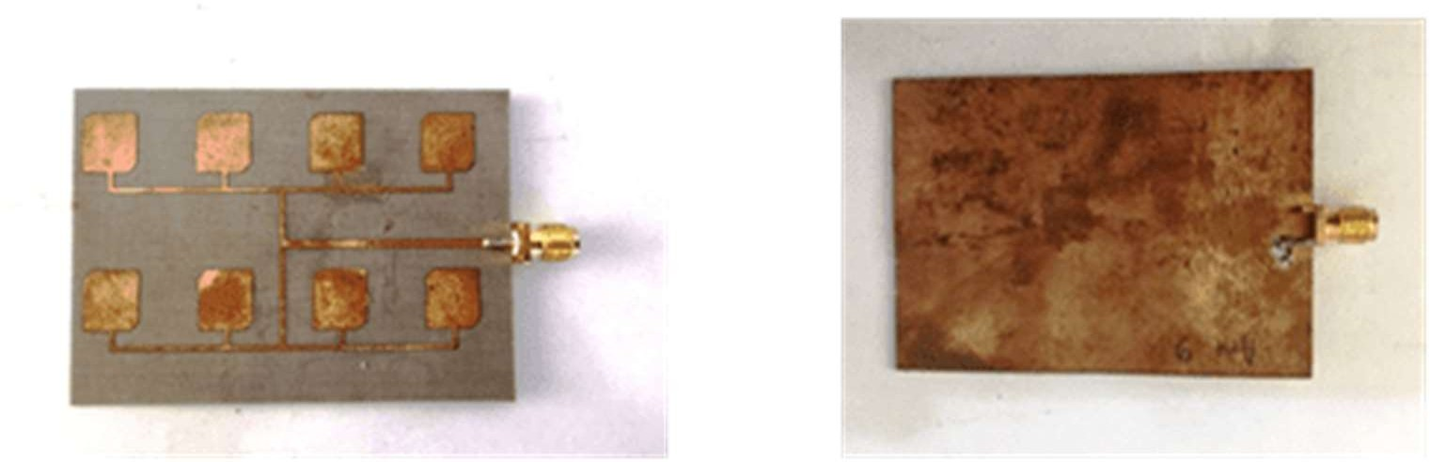In previous studies, antennas designed using the 4x2 element array method were successfully fabricated and measured their performance [9]. The fabrication results of the pre-designed antenna are shown in Figure 1.

Figure 1**.** results of manufacturing antenna microstrip array 4x2 elements

The model proposed in this research is an 8x2 array of elements arranged horizontally. The 8x2 array A is the design of the 8x2 antenna array. The elements shown in Figure 2 and Table 1 show the dimensions of the antenna array. The proposed antenna.

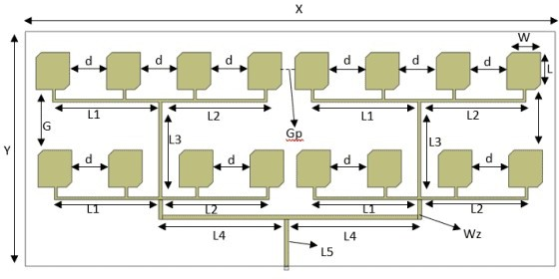

Figure 2 Modeling of antenna array with 8x2 elements

Table 1. Antena array dimension with 8x2 Eleme n

|  |  |  |  |
| --- | --- | --- | --- |
| **Parameters** | **Dimension** | **Parameters** | **Dimension** |
| X | 135 mm | L2 | 26.8 mm |
| Y | 60 mm | L3 | 29 mm |
| W | 7.2 mm | L4 | 32 mm |
| L | 8.1 mm | L5 | 12 mm |
| Wz | 0.7 mm | Gp | 3.4 mm |
| L1 | 27.1 mm | d | 9.4 mm |
| G | 15.6 mm | ∆l | 1.9 mm |

Figure 2 shows the optimized antenna design by adding 8 elements connected using microstrip channels with impedances of 100 Ω and 50 Ω. The dimensions of the elements and edge pieces on the microstrip antenna have been exposed and developed in previous research [9], [13]. Table 1 shows the dimensions of the antenna modeling using an 8x2 array of elements with the distance between the elements d = 9.4 mm, G = 15.6 mm, and Gp = 3.4 mm. The dimensions of the distance between the elements and the recording channels L1, L2, L3, L4, L5, L6, and L7 were obtained from the results of optimization and simulation using AWR Microwave Office software.

.

1. **Structure and Specifications**

**3.1 Antenna Array**

In general, antennas with one patch element produce low gain, so the radiation pattern of the antenna produced is widened. Some applications need to design antennas with characteristics that have high directivity. It aims to meet the needs of long-distance communication. Although this can be achieved by enlarging the dimensions of an antenna so that the size of the antenna becomes larger [14], [15].

Enlarging the dimensions of a single element of the antenna can result in more directional directivity. Another way to enlarge the dimensions of the antenna without having to increase the size of a single element is to form the antenna into an array. In its implementation, the elements on the antenna of the array are identical. In addition to producing high directivity, arrays can also increase the maximum gain value of an antenna. The higher the gain of an antenna, the greater or more directional the directivity of the antenna, while the radiation pattern tends to narrow, causing the beamwidth value to be small [16], [17]. Figure 2 depicts antennas arranged in an array of 1×2 using rectangular patches.

**3.2 Proposed specifications**

In this study, the antenna is designed to have a working frequency range of 11300 – 11650 MHz whose frequency range is recommended for use in Japan [18]. The limit of the return loss value used is ≤ 15 dB which means that the power reflected by the source is 3.1% [19]. Then the gain value designed ≥ 7 dB [20], [21]. Antenna specifications are shown in Table 2.

Table 2. Antenna specifications

|  |  |
| --- | --- |
| **Parameters** | **Specifications** |
| Frequency Resonancy | 11.5 GHz |
| Working Frequency | 11. 3 – 11. 65 GHz |
| *Return Loss* | ≤ 15 dB |
| *Bandwidth* | 200 MHz |
| Gain | ≥ 7 dB |
| Radiation patterns | Directors |
| Polarization | Linear |

Fr4 Epoxy is used as an antenna substrate material. Rogers Fr4 Epoxy has a material permittivity (εr) of 4.2 with a material thickness (h) of 1.8 mm. The reason for choosing Fr4 Epoxy material is because this material can be used to produce a larger dimensional shape and can work at high frequencies and has a small material permittivity. In addition, the material used for the *ground plane* and *patch* is *a cooper* with a thickness of 0.035 mm.  *Cooper* is generally used for microstrip antennas because it is very easy to find and has fairly good conductivity.

## Result and Performance Evaluation

## 4.1 4 × 4 Rectangular Patch Array Microstrip Antenna

## The design stage begins with determining the specifications and shape of the antenna to be designed. Then, calculations are carried out using equations that have been obtained from various references to be designed in the software. In its design, the antenna was designed first without the addition of a feed array.

## This is done to determine changes in antenna performance when a feed array is added to the multi-patch antenna. Once designed, the antenna is simulated and reviewed whether it meets the parameters that a 4 × 4 Rectangular Patch Array Microstrip Antenna Design with an 11.5 GH Frequency feed array is desirable. The parameters seen at the time of testing are the resonant frequency of the antenna, return loss, bandwidth, radiation pattern, gain, and aperture efficiency. If the antenna design has not reached the specifications, then optimization or recalculation is carried out [22]. Optimization is carried out by increasing or decreasing the dimensions obtained from the calculation.

## Figure 3 shows the design of a rectangular patch microstrip antenna arranged in a 4 ×4 array without the addition of a feed array and with the addition of a feed array. The dimensions of the antenna are the result of optimization from the simulation so that the parameters are obtained to meet the desired antenna specifications.

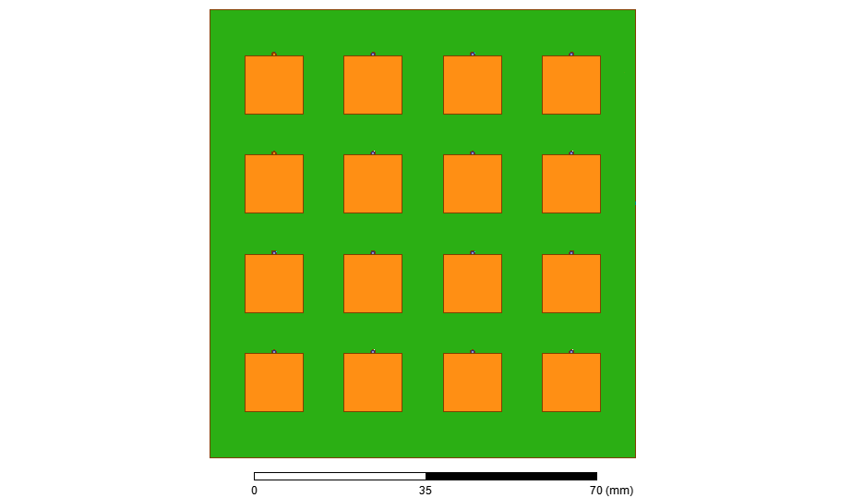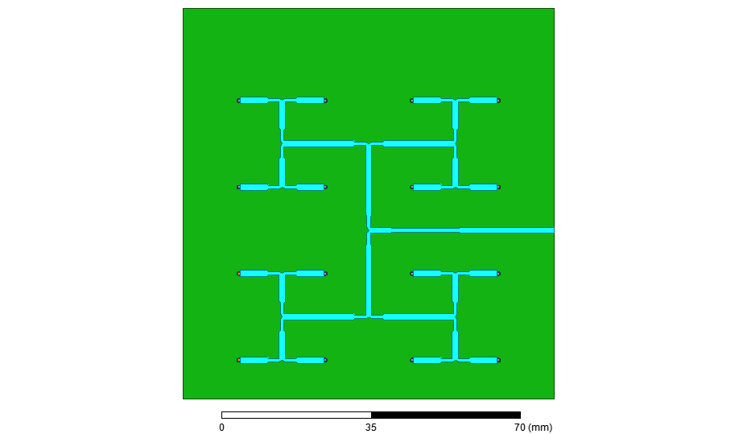

Figure 3. Microstrip *Rectangular Patch Array* 4x4 Antenna Design with feed array.

In its design, the impedance used in feeders connected to *loose* lines is 50.77 + j 2.88 Ω, while in *feeders* for *patches* it is 100.1 + j 1.87 Ω. Before the simulation, it is necessary to add a limitation in the form of a vacuum. This is done to condition the antenna simulation according to the real conditions in the field. The size of the vacuum used in general ≥1/4 λ.

**4.2 Performance evaluation**

Bandwidth is a frequency range limited by a certain return loss value (S11). In this study, the limit of the return loss value used was less than -15 dB. Return loss is a parameter used to find out how much power is lost due to the reflection of the transmission line so that it cannot be fully irradiated by the antenna. The results of the simulated return loss chart can be seen in Figure 4.



Figure 4. Return Loss Rectangular 4x4 Patch Array

Figure 6 shows the results of simulating return loss values using rectangular patches arranged in an array of 4 ×4. From the curve, the return loss value for non-slot antennas reached a value below -15 dB in the frequency range of 11.3 – 11.65 GHz. This means that there is still 250 MHz to reach the frequency of 11.5 GHz. The minimum return loss value occurs at a frequency of 11.5 GHz either using a feed array with a value of -35.61 dB This indicates that the antenna can work at the desired resonant frequency, which is 11.5 GHz. There was an increase in antenna bandwidth by 230 MHz or by 65.76% from the initial bandwidth of the antenna. Thus, the antenna using the array has met the desired bandwidth specifications. In addition, adding slots on the antenna patch can reduce the return loss value, the smaller the return loss value, the smaller the power reflected will be.

Gain is the value of the ratio of power intensity in a certain direction to the intensity of power obtained from a reference antenna that radiates power isotropically. Gain measurement relates to how far the antenna radiates in a given direction. The higher the antenna gain, the more directed the direction of antenna radiation to the desired angle. In Figure 4.3, you can see the results of the simulation of the maximum gain value of the antenna.

Figure 5 represents the maximum antenna gain value in a rectangular plot using a rectangular patch with a 1x2 rectangular patch array. Where the maximum gain value of the rectangular patch antenna is 6.70 dB, while for the rectangular patch array 4x4 antenna is 16.25 dB, thus, compiling an array antenna can increase antenna gain by 3.09 times. The use of more and more elements can result in more significant gains [13].



Figure 5. Rectangular Patch Gain Results of Rectangular 4x4 Patch Array

The radiation pattern is a two-dimensional graphic form that describes the radiant properties of the antenna. There are two things in the review of radiation patterns: elevation represented as theta (θ) and azimuth represented as phi (φ). In Figure 9 and Figure 10, we can see the shape of the Radiation Pattern in two dimensions

Figure 6 shows a graphical statement of radiation patterns in a three-dimensional rectangular patch array of 4×4 antennas using feed arrays. The theta direction at the antenna elevation using x,y, and z coordinates has a maximum radiant direction at an angle of 10° and 0° on the z-axis with a value of 16.5 dB, while the azimuth direction at an angle of -90° has a weakening below -2.73 dB. Thus, from the direction of elevation and azimuth the antenna has a radiation pattern directionally, this is also evidenced by the direction of the transmission more dominantly towards the top (positive axis) [23]. In addition, the addition of a feed array has little effect on changing the antenna radiation pattern. However, the antenna design can meet the specifications of the antenna radiation pattern, which is directive.

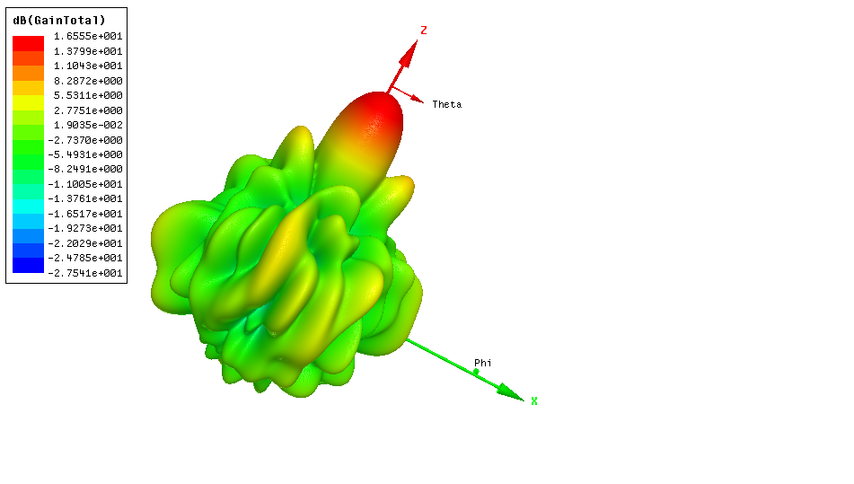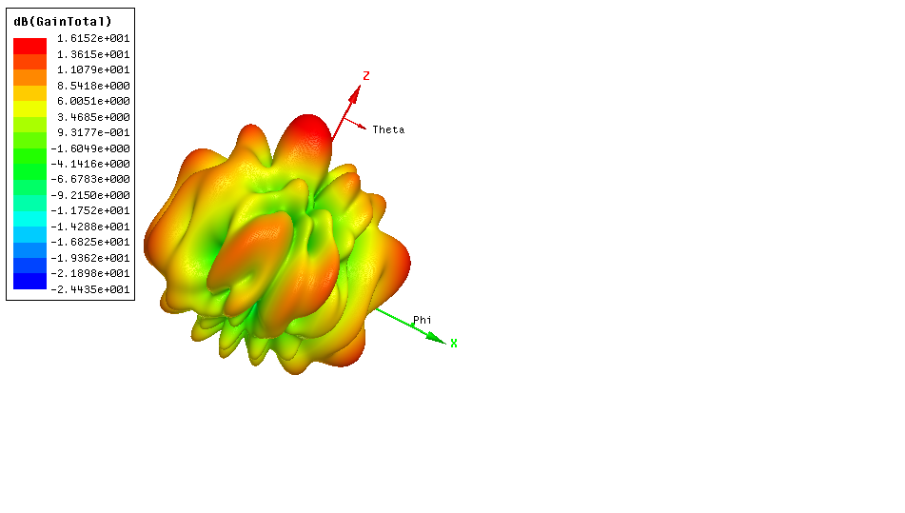

Figure 6. Radiation Pattern Simulation Results (left) and *Beamwidth* Angle Width Calculation

(right)  *Rectangular Patch Array* 4×4 Azimuth.

The theta direction at the antenna elevation using x,y, and z coordinates has a maximum radiant direction at an angle of 10° and 0° on the z-axis with a value of 16.15 dB, while for the azimuth direction at an angle of -90° and 180° has a weakening below -1.6 dB. Thus, from the direction of elevation and azimuth, the antenna has a radiation pattern directionally. This is also evidenced by the direction of the transmit being more dominant to the direction. In addition, the addition of a feed array has little effect on changes in the antenna radiation pattern[12], [24]. However, the antenna design can meet the specifications of the antenna radiation pattern, which is omnidirectional.

**5. Conclusion**

In this study, a pre-designed microstrip antenna was developed by adding the number of elements in the array method to 16 elements. The optimization stages are carried out using planar modeling of 4x4 element arrays. The purpose of adding elements to the array method is to increase the gain value of the designed antenna. From the measurement results, a return loss value of -35.61 dB and a VSWR of 1.1227 was obtained. The resulting bandwidth of a 4x4 element array antenna is 250. the impedance of 50.77 + h 2.88 Ω at a working frequency of 11.5GHz. The gain of the 4x4 element array antenna is 16.25 dB at a working frequency of 11500 MHz, and its maximum gain is 16.5 dB at a working frequency of 11700 MHz. Optimization with the 4x4 element array method managed to increase Gain up to 65.76% compared to the 2x2 element array design. The proposed antenna is suitable as a candidate for use in microwave radio communication systems, IoT, and Wearable antennas.

Corresponding author. Tel.: 0818087472301

Email: irfan.mujahidin@polines.ac.id

**References**

[1] H. Henninger, J. Biggs, and K. von Ellenrieder, “Safety-aware optimal attitude pointing for low-thrust satellites,” *Applied Sciences (Switzerland)*, vol. 11, no. 7, 2021, doi: 10.3390/app11073002.

[2] L. Zhou *et al.*, “Light-driven methane dry reforming with single atomic site antenna-reactor plasmonic photocatalysts,” *Nat Energy*, 2020, doi: 10.1038/s41560-019-0517-9.

[3] J. Zhang, X. Ge, Q. Li, M. Guizani, and Y. Zhang, “5G Millimeter-Wave Antenna Array: Design and Challenges,” *IEEE Wirel Commun*, 2017, doi: 10.1109/MWC.2016.1400374RP.

[4] I. Mujahidin and A. Kitagawa, “CP Antenna with 2 × 4 Hybrid Coupler for Wireless Sensing and Hybrid RF Solar Energy Harvesting,” *Sensors (Switzerland)*, vol. 21, pp. 1–20, 2021, doi: 10.3390/s21227721.

[5] Z. Su, K. Klionovski, H. Liao, Y. Chen, A. Z. Elsherbeni, and A. Shamim, “Antenna-on-Package Design: Achieving Near-Isotropic Radiation Pattern and Wide CP Coverage Simultaneously,” *IEEE Trans Antennas Propag*, vol. 69, no. 7, 2021, doi: 10.1109/TAP.2020.3044134.

[6] M. Wagih, G. S. Hilton, A. S. Weddell, and S. Beeby, “Dual-Band Dual-Mode Textile Antenna/Rectenna for Simultaneous Wireless Information and Power Transfer (SWIPT),” *IEEE Trans Antennas Propag*, 2021, doi: 10.1109/TAP.2021.3070230.

[7] Y. Han, L. Zhu, Y. Bo, W. Che, and B. Li, “Novel Low-RCS Circularly Polarized Antenna Arrays via Frequency-Selective Absorber,” *IEEE Trans Antennas Propag*, 2020, doi: 10.1109/TAP.2019.2939845.

[8] L. Santamaria, F. Ferrero, R. Staraj, and L. Lizzi, “Slot-Based Pattern Reconfigurable ESPAR Antenna for IoT Applications,” *IEEE Trans Antennas Propag*, vol. 69, no. 7, 2021, doi: 10.1109/TAP.2020.3044399.

[9] S. Alam, I. Surjati, Y. K. Ningsih, L. Sari, E. Syukriati, and A. Safitri, “Design of Truncated Microstrip Antenna with Array 4×2 for Microwave Radio Communication,” in

*Proceedings - CAMA 2019: IEEE International Conference on Antenna Measurements and Applications*, 2019. doi: 10.1109/CAMA47423.2019.8959571.

[10] S. Liu, Y. Hou, W. Xie, S. Schlücker, F. Yan, and D. Y. Lei, “Quantitative Determination of Contribution by Enhanced Local Electric Field, Antenna-Amplified Light Scattering, and Surface Energy Transfer to the Performance of Plasmonic Organic Solar Cells,” *Small*, vol. 14, no. 30, 2018, doi: 10.1002/smll.201800870.

[11] L. Malviya, R. K. Panigrahi, and M. v. Kartikeyan, “MIMO antennas with diversity and mutual coupling reduction techniques: A review,” *Int J Microw Wirel Technol*, vol. 9, no. 8, 2017, doi: 10.1017/S1759078717000538.

[12] D. A. Prasetya, A. Sanusi, G. Chandrarin, E. Roikhah, I. Mujahidin, and R. Arifuddin, “Community Culture Improvisation Regarding Waste Management Systems and Per Capita Income Increase,” *Journal of Southwest Jiaotong University*, vol. 54, no. 6, 2019.

[13] I. Mujahidin, “A Compct 5.8 GHz CPW Double Square Edge Antenna With BPF Stepped Impedance Resonator,” *PRotek : Jurnal Ilmiah Teknik Elektro*, 2020, doi: 10.33387/protk.v7i2.2026.

[14] C. A. Balanis, “Antenna Theory Analysis and Desing,” *Weley*, vol. 4, no. 3, 2016.

[15] I. Mujahidin, “A Compct 5.8 GHz CPW Double Square Edge Antenna With BPF Stepped Impedance Resonator,” *PRotek : Jurnal Ilmiah Teknik Elektro*, 2020, doi: 10.33387/protk.v7i2.2026.

[16] C. A. Balanis, *Antenna Theory: Analysis and Design, (3RD ED.)*. 2009.

[17] I. Mujahidin and A. Kitagawa, “The Novel CPW 2 . 4 GHz Antenna with Parallel Hybrid Electromagnetic Solar for IoT Energy Harvesting and Wireless Sensors,” vol. 12, no. 8, pp. 393–400, 2021.

[18] S. Tariq, S. I. Naqvi, N. Hussain, and Y. Amin, “A Metasurface-Based MIMO Antenna for 5G Millimeter-Wave Applications,” *IEEE Access*, vol. 9, 2021, doi: 10.1109/ACCESS.2021.3069185.

[19] H. C. Huang and J. Lu, “Evolution of Innovative 5G Millimeter-Wave Antenna Designs Integrating Non-Millimeter-Wave Antenna Functions Based on Antenna-in-Package (AiP) Solution to Cellular Phones,” *IEEE Access*, vol. 9, 2021, doi: 10.1109/ACCESS.2021.3077309.

[20] W. Hong, K. H. Baek, and S. Ko, “Millimeter-Wave 5G Antennas for Smartphones: Overview and Experimental Demonstration,” *IEEE Trans Antennas Propag*, 2017, doi: 10.1109/TAP.2017.2740963.

[21] I. Mujahidin and A. Kitagawa, “The Novel CPW 2.4 GHz Antenna with Parallel Hybrid Electromagnetic Solar for IoT Energy Harvesting and Wireless Sensors,” *International Journal of Advanced Computer Science and Applications*, vol. 12, no. 8, 2021, doi: 10.14569/IJACSA.2021.0120845.

[22] Constantine A. Balanis, “[Book] Antenna theory: Analysis and Design,” *WILEY Book*, 2016.

[23] K. A. Fante and M. T. Gemeda, “Broadband microstrip patch antenna at 28 GHz for 5G wireless applications,” *International Journal of Electrical and Computer Engineering*, vol. 11, no. 3, 2021, doi: 10.11591/ijece.v11i3.pp2238-2244.

[24] T. M. Cao, T. H. T. Phuong, and T. D. Bui, “Circularly polarized antenna array based on hybrid couplers for 5g devices,” *Bulletin of Electrical Engineering and Informatics*, vol. 10, no. 3, 2021, doi: 10.11591/eei.v10i3.3017.