AUTOMATIC MANUAL SMART LIGHT CONTROL SYSTEM WITH STATUS FEEDBACK

Samuel Beta1, Fahmi Baihaqi2, Ivandi Julatha Putra3

1,2 Telecommunication Engineering, Electrical Engineering Department, Politeknik Negeri Semarang

Abstract— The need for light is one of the main needs for human life today. Advances in technology are very helpful in many aspects of life, especially in terms of light. Thanks to advances in technology, humans do not only rely on sunlight as a means of lighting their daily lives because lamps have been found as a substitute for lighting. Controlling the lights manually certainly has drawbacks as is often the case in this village where the owner often leaves the house with the lights on, this can cause a waste of electricity and short circuits can occur in the lights if they are constantly on. Where researchers use applied research methods which are research methods that are carried out with the intention of implementing, testing, and evaluating the ability of a theory that is applied in solving practical problems. However, researchers also use IoT (Internet of Things) technology and Internet Messenging applications, namely Telegram. Where this IoT technology is a technology that utilizes the internet network connected to a network of lights through a sensor, namely the NodeMCU Esp8266 Microcontroller. While the Telegram application is used as an aid to make it easier to monitor or control both turning on and off the lights remotely using the application, the Telegram application also sends feedback on the status of the lights. From the results of this study, it can be expected that this control system can assist in controlling or controlling lights easily and practically over long distances using the telegram application..

Keywords— Internet of Things, Air Conditioner, Blynk, NodeMCU ESP8266.

1. Pendahuluan

A lamp is a device that produces light. The word "lamp" can also mean light bulb. Lights require energy to produce light, the energy used can be electricity, gas, and other energy. Existing lamps use electrical energy as a source of power. Electrical energy was chosen because it is more efficient, easier to implement and safer. The lamp can also adjust the color and brightness of the light that is produced.

Telegram has long been popular long before the smartphone era. Telegram used to be a post office facility that was used to send long-distance text messages quickly. However, after the rapid development of technology, this facility was lost and was no longer used. Now the name Telegram is taken by a startup that is developed into an application. Telegram is a cloud-based instant messaging application focused on speed and security. Telegram is designed to make it easier for users to send text messages, audio, video, images and stickers safely (Fahana & Ridho, 2018).

The use of this remote control as a communication tool and smartphone has experienced many developments at this time, such as as a means of controlling home lighting combined with Arduino components and utilizing existing facilities on Telegram. From the convenience and the proliferation of social media such as the telegram application among the public.

This study aims to make it easier to control and have a feedback status of the lights with centralized control of the Telegram application without using a switch. The results of the research on controlling lights with NodeMCU and ESP-12E through the Telegram chatbot application, distance has no effect on the system performance of the device, what makes the delay response different at each different distance is the difference between network connections and also network quality from each different location.

Research on the control and monitoring of building lights by (Muhammad Suprayogi, 2019) and (Mochamad Iqbal Fahrezi, 2018). Research conducted by (Muhammad Suprayogi, 2019) discusses the application of the internet of things (iOT) to building light control and monitoring systems using telegram-based nodemcu. Meanwhile (Mochamad Iqbal Fahrezi, 2018) developed a home light control system via a telegram bot based on the internet of things. uses raspberryPi3 as a telegram bot server and for system development this tool uses the prototype method from the results of testing this tool functions properly and is feasible to use for controlling household appliances.

Therefore, in this paper the development of a lamp control and monitoring system uses a telegram that can be accessed remotely.

1. Metode
2. *Desain Sistem*

The need for this research is to know the presence of people in the room and detect the status of the lights. Then the need to manually control the lights. Requires the ability of the system to provide status feedback to users.

There are 2 conditions for reading the whereabouts of a person which will trigger the system to provide an on/off light notification.

1. When the PIR sensor detects the presence of people in the room, the light will automatically turn on. The LDR sensor detects the light is on and the system gives an on light notification.
2. When the PIR sensor does not detect the presence of people in the room, the lights automatically turn off. The LDR sensor detects an off light and the system gives an off light notification.

In monitoring the status of the lights, the system will provide on/off status with the LDR sensor. When the lamp is damaged / fails to turn on, the user will know the actual status of the lamp and immediately take action to check and replace the lamp.

This study uses PIR sensors to determine the presence of people in the room, LDR sensors to determine the actual condition of the light status, relays to control the on / off lights.

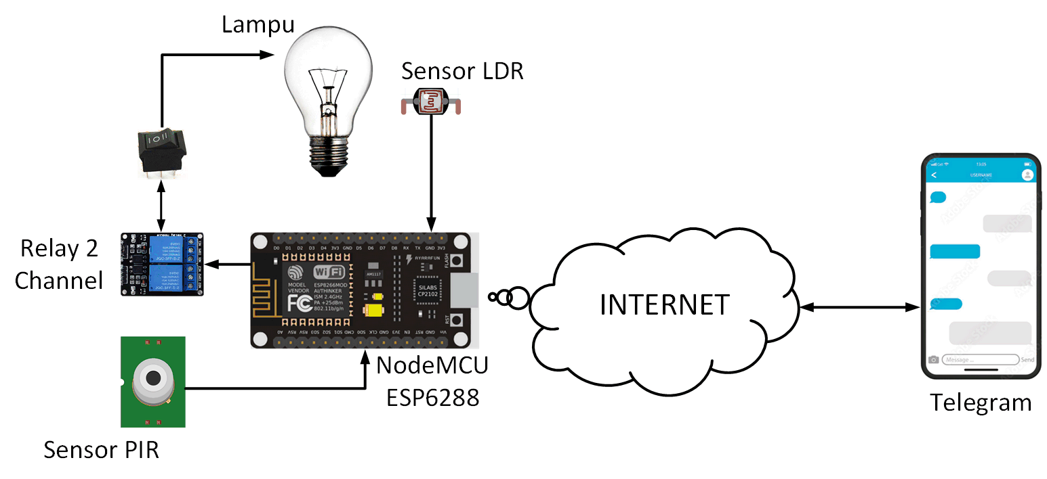

Figure 1 Design System

As seen in the picture above, the system uses a PIR sensor to detect the presence of people in the room, an LDR sensor to determine the real status of the lights. The sensor is connected to the nodemcu esp8266 via cable. NodeMCU ESP8266 as a control center connected to the internet via a WiFi radio network. NodeMCU ESP8266 can provide notifications to telegram bots that have been made, there are two conditions for nodemcu esp8266 to provide notifications to telegrams. When the PIR sensor detects the presence of humans in the room, the lights automatically turn on and provide notification to the Telegram bot that the lights are on or when the PIR sensor does not detect the presence of humans in the room, the lights automatically turn off and provide notifications to the Telegram bots that the lights are off. Besides that, there are conditions for monitoring the status of the lights with the LDR sensor and manual control of the lights on / off.

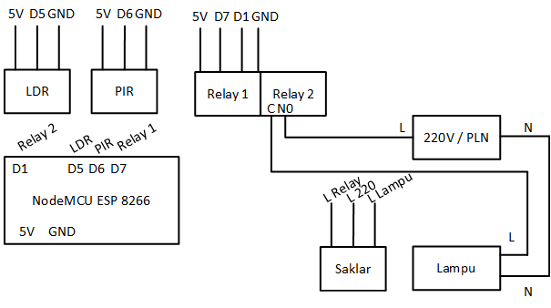

Gambar 2 Skematik Diagram

The picture above shows a schematic diagram for monitoring and controlling lights. The NodeMCU ESP 8266 pins are connected to sensor outputs and relay inputs. The output of the PIR sensor is connected to pin D6, the output of the LDR sensor is connected to pin D5, the input of the relay is connected to pins D1 and D7. For the vcc pin (5 volts) and the grounding pin, all are connected. To control the lamp, pin C relay is connected to L lamp and pin N0 relay is connected to 220V / PLN.

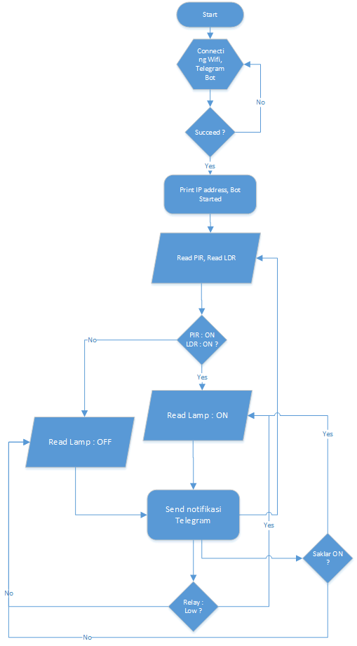

Figure 3 Program Flow Chart

The picture above shows the steps of the system program. The first step in the system is to connect to WiFi, then connect the telegram bot then read the PIR and LDR sensor values if they meet the requirements then the lights are on, if they don't meet the requirements then the lights are off then send notifications to telegram. From the notification, you can then control the relay. If the relay is low then the light is on, if the relay is high then the light is off.

1. *Metode Penelitian*

In particular, the method used in this study is the waterfall method. This method is carried out with a systematic approach, starting from the system requirements stage and then the analysis, design, implementation, verification, and maintenance stages. The steps that must be passed must be completed one by one (cannot jump to the next stage) and run sequentially.

The stages in this research:

1. System Requirements

Knowing and understanding how the information needs of the user for the tool to be made. This information collection method is obtained by way of discussion, observation, surveys, interviews. The information obtained is then processed and analyzed in order to obtain complete data or information regarding the specification of the user's requirements for the tool being made..

1. Design

Information regarding system requirements specifications is then implemented in the design. Design planning is done with the aim of helping to provide a complete picture of what must be done. This stage also helps to prepare the material requirements that will be made as a whole.

1. Implementation

Implementation is the stage of making tools and programs. In this stage, functional testing of the tool that has been made is carried out. Does it meet the desired criteria or not.

1. Verification

After the tool is tested in the implementation stage, it is then integrated into the system as a whole, then an overall inspection and test is carried out to identify possible system failures and errors.

1. Maintenance

In the last stage, the finished tool is operated by the user and carried out maintenance. Maintenance allows for repairs to errors that were not detected in the previous stages. Maintenance includes repairing errors, improving the implementation of system units, and upgrading and adapting systems to requirements.

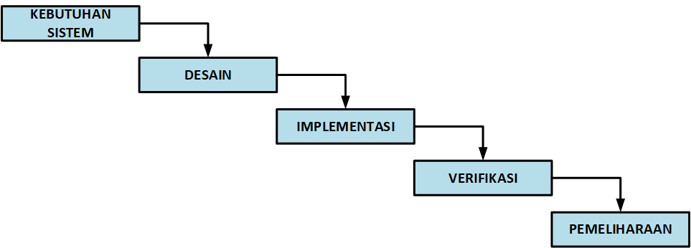Figure 4. Waterfall Model

1. Results and Discussion

From the implementation of the system, this study obtained the following results :

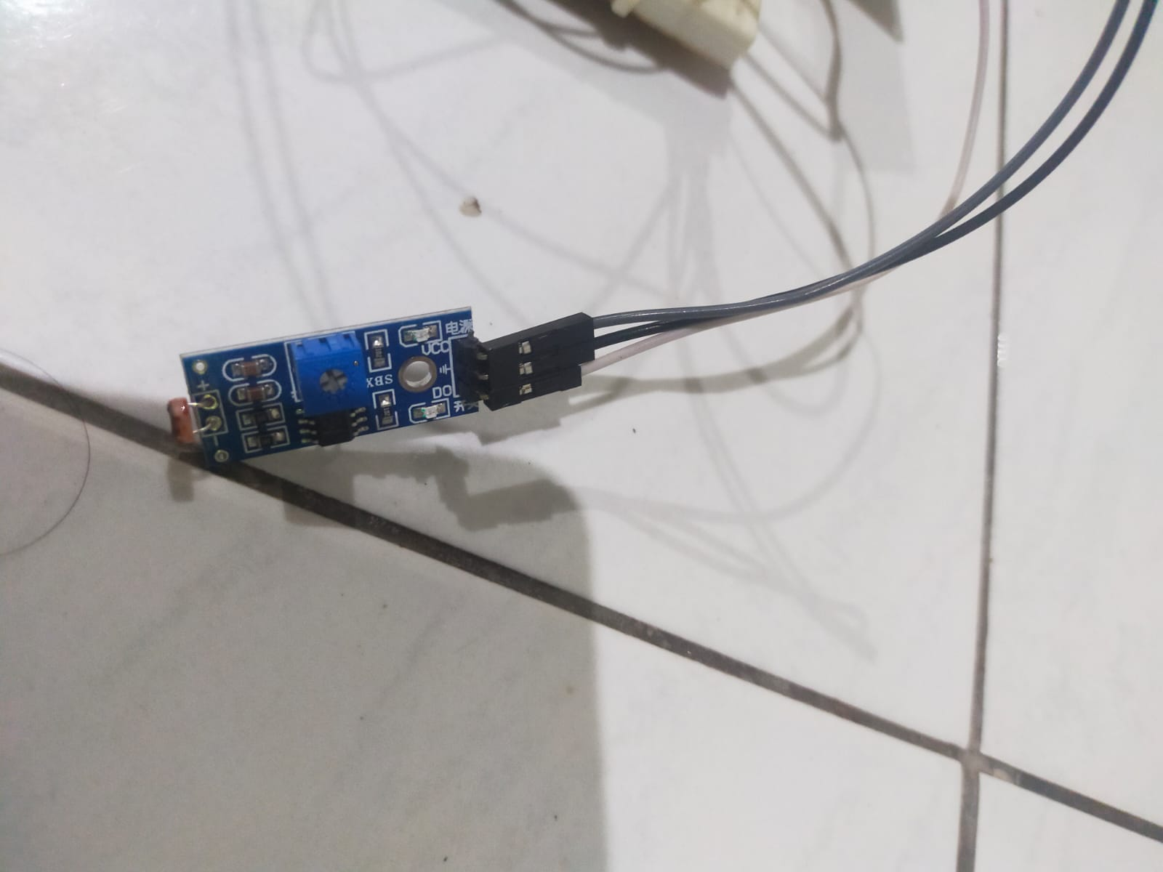

Figure 5. LDR Sensor

The picture above shows the LDR sensor that has been installed with the system..

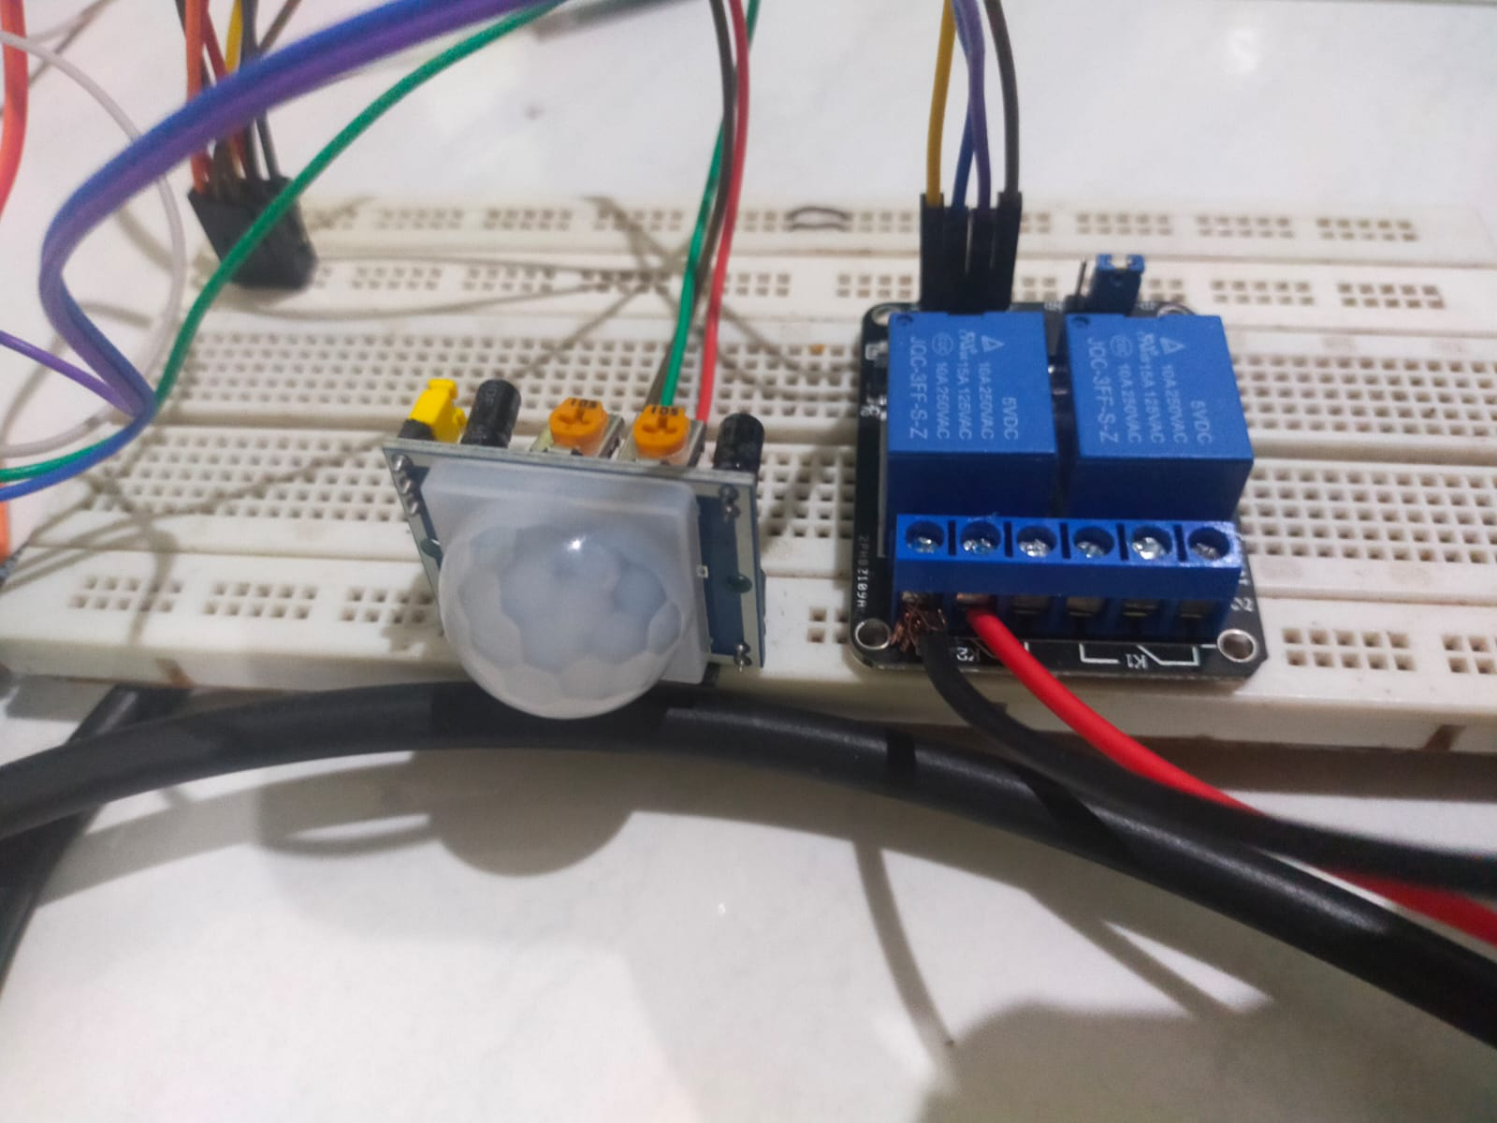

Figure 6. PIR Sensors and Relays

The picture above shows the PIR sensor and relay that has been installed with the system.

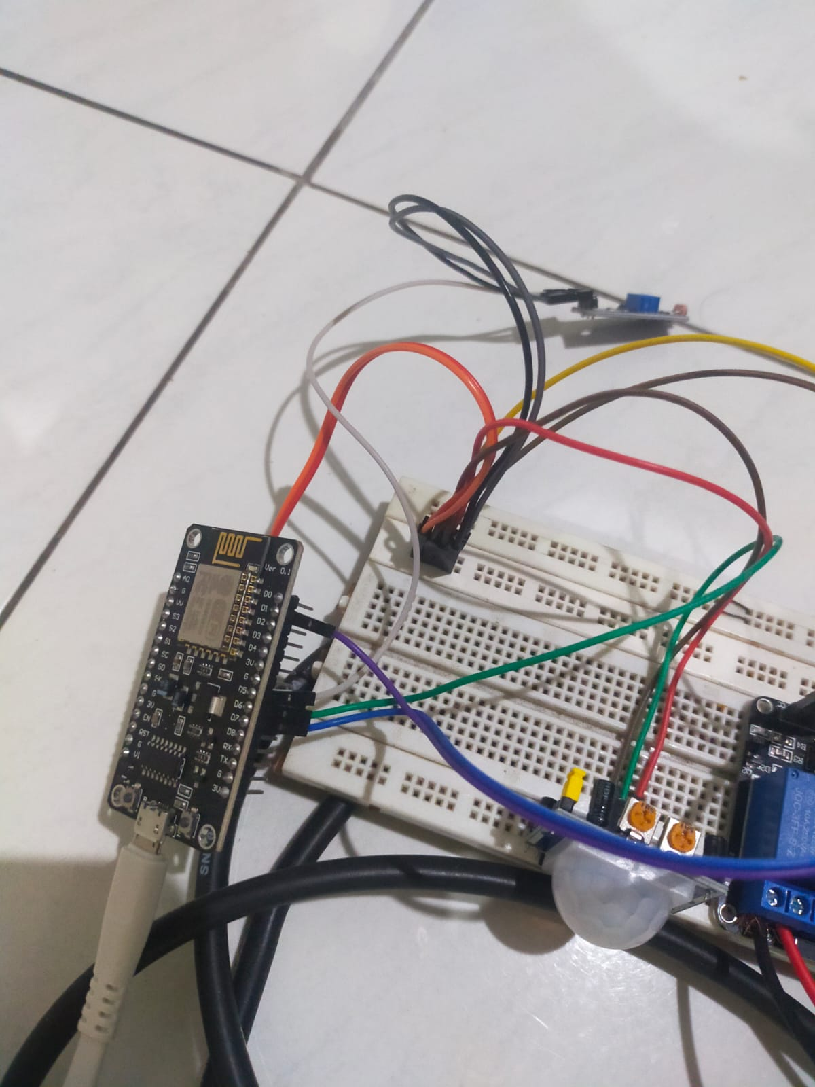

Figure 7. NodeMCU esp 8266

The picture above shows the nodemcu esp8266 module that has been installed with the system.

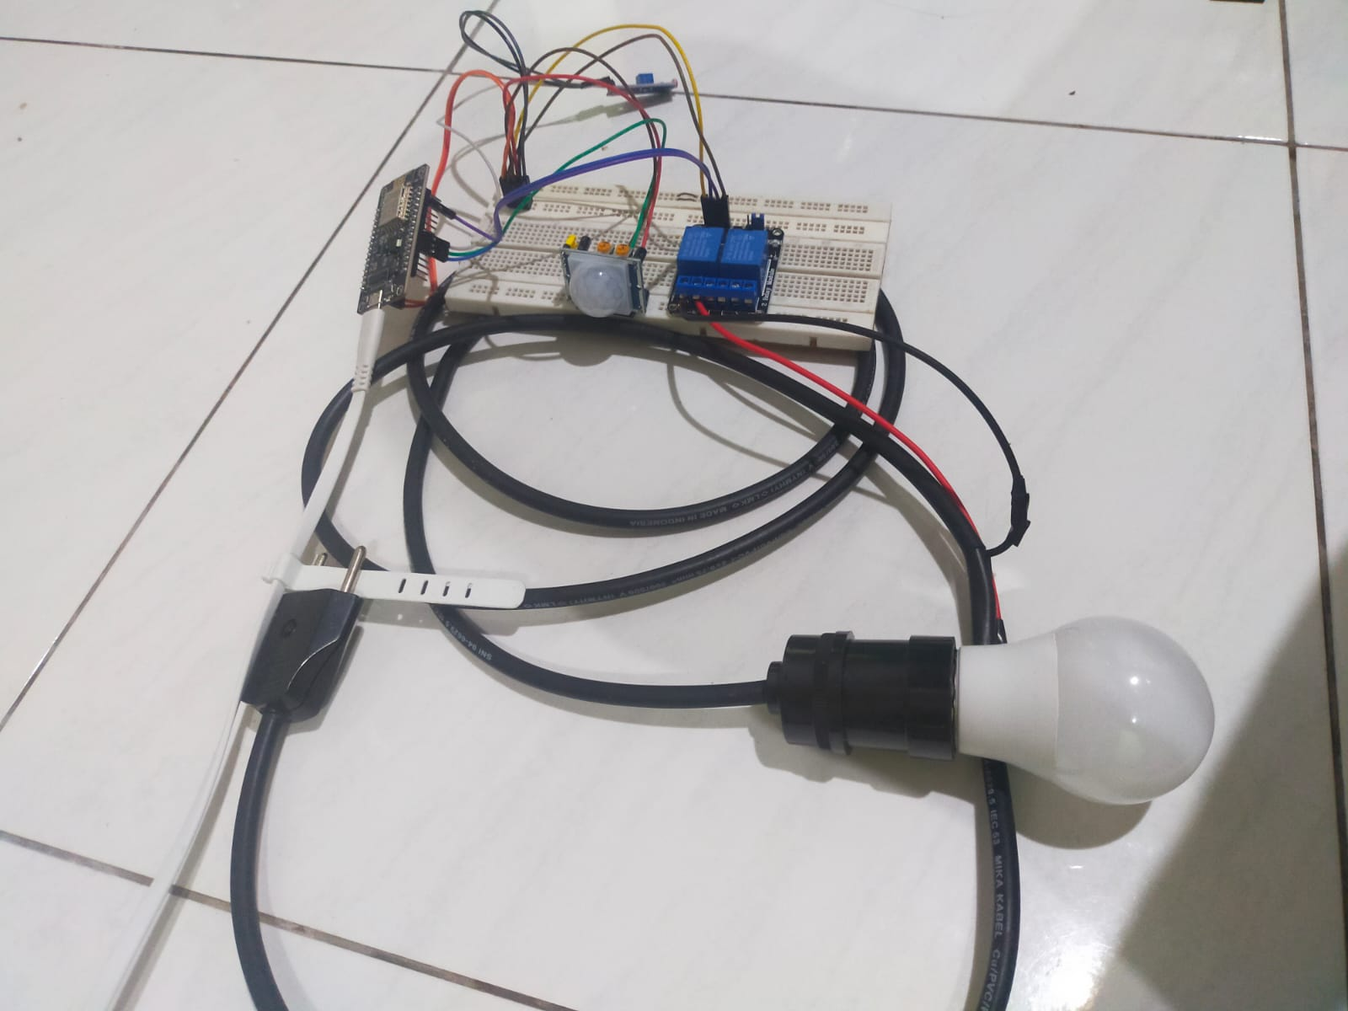

Figure 8. Overall System

The picture above is a series of the whole system.

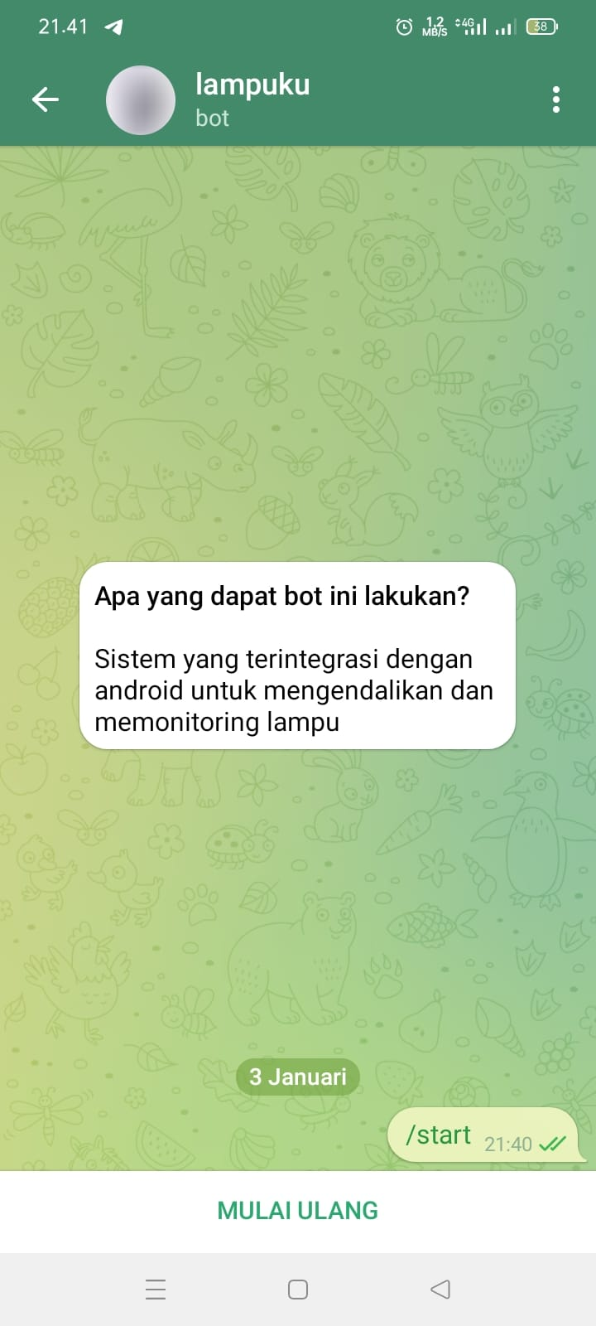

Figure 9. The initial appearance of the Telegram Bot

The picture above is the initial appearance of the Telegram Bot smart light system.

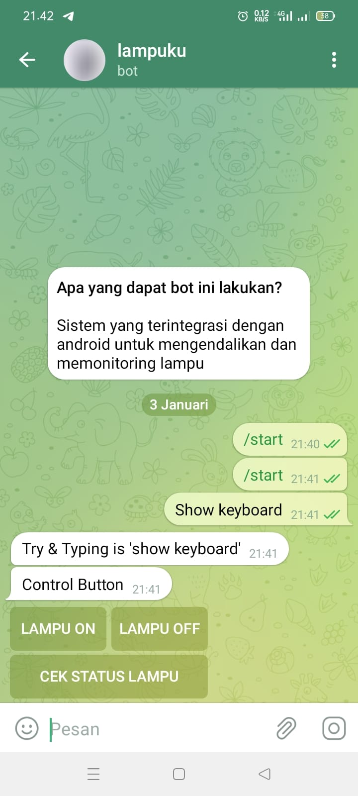

Figure 10. Telegram Bot Starting View

The picture above shows how to start the telegram bot.

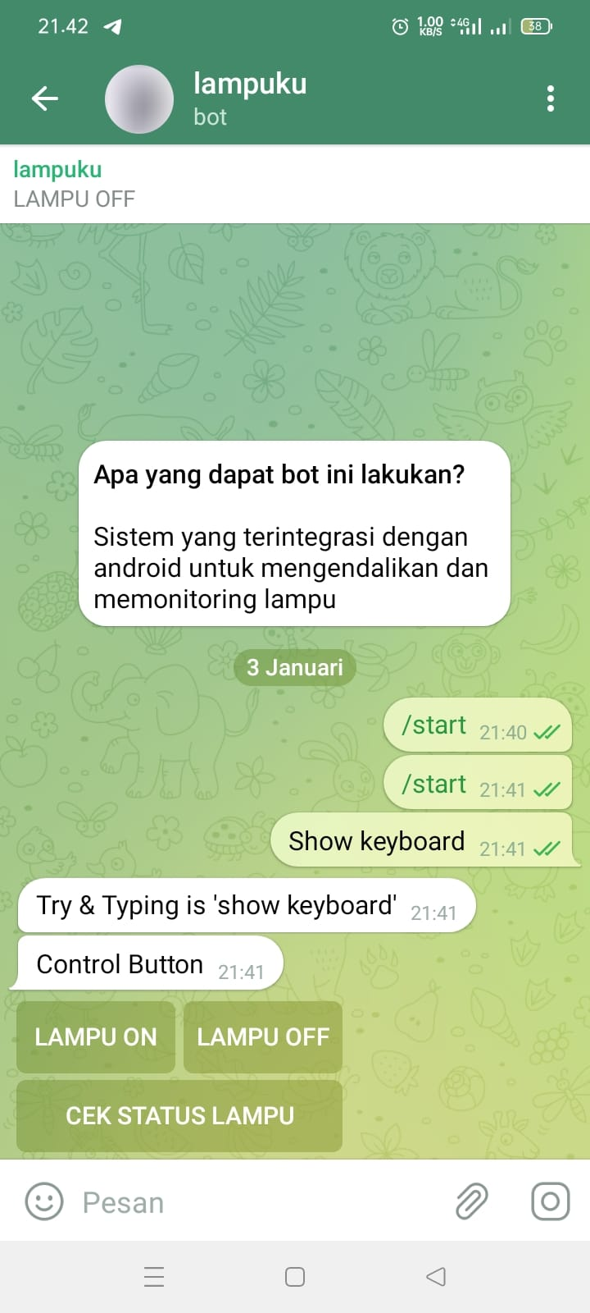

Figure 11. Status Light off

The picture above shows the display of the status of the light which shows the light is off.

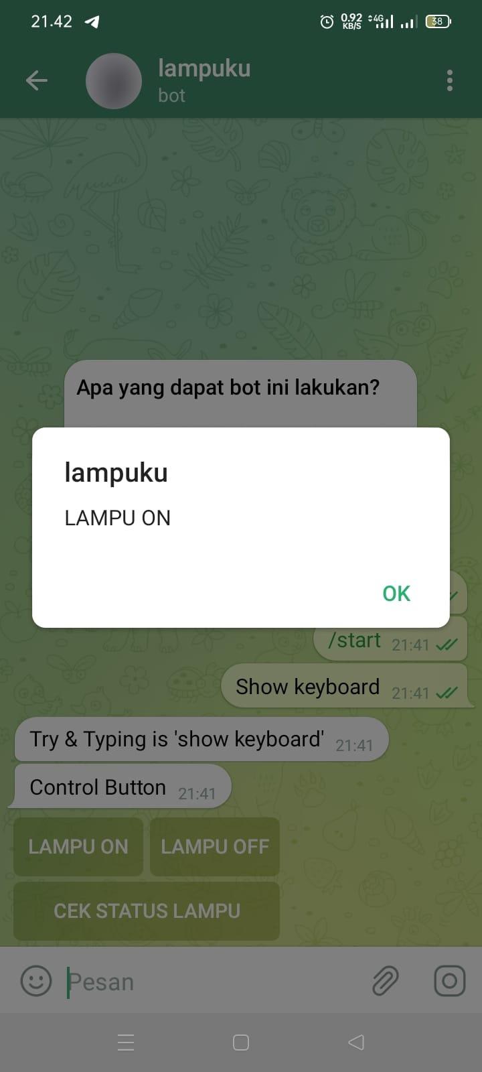

Figure 12. Manual Control Lights on

The picture above shows the light control is on so the light will turn on.

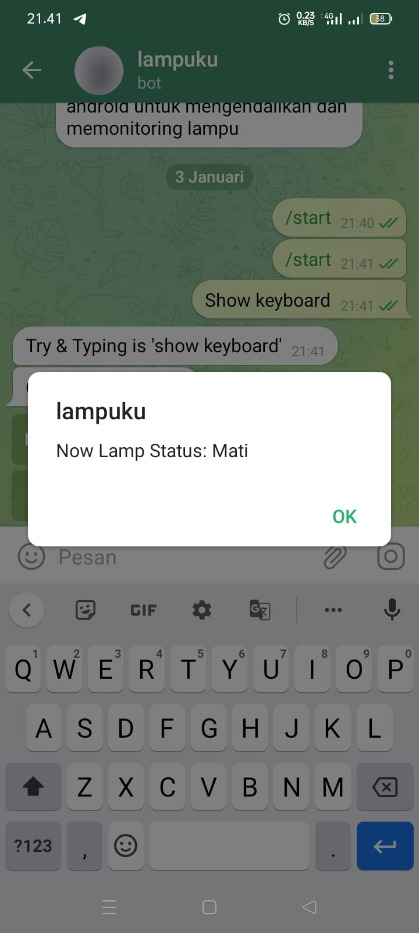

Menyala

Figure 13. Status Lights on

The picture above shows the status of the light on because the manual control is on.

1. Conclusion

The conclusion of this research is :

1. Have successfully made a light control monitoring system with status feedback.
2. The system has succeeded in giving telegram notifications with the status of the light on or off
3. The system successfully controls automatic and manual lights

References

1. Athallah, Y., & Agung, R. (2022). *Vol. Viii No. 1 Februari 2022 Jurnal Teknik Informatika Stmik Antar Bangsa Rancang Bangun Prototype Monitoring Lampu Jalan Secara Otomatis Menggunakan Mikrokontroller Esp32 Dan Api Bot Telegram*.
2. Fahana, J., Umar, R., & Ridho, F. (2017). Pemanfaatan Telegram Sebagai Notifikasi Serangan untuk Keperluan Forensik Jaringan. In *Jurnal Sistem Informasi* (Issue 6).
3. Fahrezi, M. I., (2018) *Sistem Kendali Lampu Rumah Melalui Bot Telegram Dengan Berbasis Internet Of Things*.
4. Fitriansyah, F. (2020). *Penggunaan Telegram Sebagai Media Komunikasi Dalam Pembelajaran Online*. https://doi.org/10.31294/jc.v20i2
5. Nega, M., Susanti, E., & Hamzah, A. (2019). *Internet Of Things (Iot) Kontrol Lampu Rumah Menggunakan Nodemcu Dan Esp-12e Berbasis Telegram Chatbot* (Vol. 7, Issue 1).
6. Pardede, M., Hutajulu, E., Sirait, R., Studi Teknik Telekomunikasi, P., Teknik Elektro Politeknik Negeri Medan Jl Almamater No, J., Bulan, P., & Medan Baru, K. (2022). *Sistem Pemantauan dan Pengendali Lampu Ruangan Laboratorium Berbasis NodeMCUESP8266 dengan Aplikasi Telegram Bot*. https://doi.org/10.30596/rele.v1i1.___
7. Reno Saputra Elsi, Z., Agus Dwino Putra, F., Primaini, S., (2021). *Jusikom : Jurnal Sistem Komputer Musirawas Pengendali Lampu Dan Air Conditioner Dengan Telegram* (Vol. 6, Issue 2).
8. Sadewa, E., & Beta, S. (2022). Temperature, Humidity, and Power Outage Monitoring System of Pamapersada Nusantara’s Server Racks. In *Journal of Applied Information and Communication Technologies* (Vol. 7, Issue 2).
9. Safutri, D., & Zakaria, H. (2022). *OKTAL : Jurnal Ilmu Komputer dan Science Sistem Kontrol Lampu Menggunakan Telegram Berbasis Android Dengan Mikrokontroler NodeMCU ESP8266 (Studi Kasus : Kampung Kebon Kopi RT.05 RW.04, Pondok Betung)*.
10. Saputra, T. A., (2021). *Kontrol Lampu Dan Pengunci Pintu Berbasis Internet Of Things Dengan Aplikasi Telegram*.
11. Suprayogi, M., (2019). *Penerapan Internet Of Things (Iot) Pada Sistem Kontrol Dan Monitoring Lampu Gedung Menggunakan Nodemcu Berbasis Telegram*.

Triwahyuni, N., & Beta, S. (2022). Running Text Information System Design Internet-Based for Small Outlets. In *Journal of Applied Information and Communication Technologies* (Vol. 7, Issue 2).