Smart Helmet As Driving Safety

*Sri Kusumastuti1, Suryono2, Panji Ardiansyah Ibrahim3, Zefania Salsabella Putri4 and Sindung Hadwi Widi Sasono5

1, 2, 3, 4, 5 Electrical Engineering Department, State Polytechnic of Semarang, Central Java 50275, Indonesia

Abstract— One of the common causes of accidents is physiological factors such as drowsiness. A helmet is a device used to reduce the risk of head injury when an accident occurs while driving. Helmets placed on motorbikes often experience theft to the detriment of the helmet owner. A helmet was created to reduce the risk of an accident, warn motorists when they are drowsy, and provide a warning when a helmet is stolen. The method begins with designing devices, preparing devices, testing, repairing, and adjusting devices. The main components used are Arduino Nano and Arduino Pro Mini. The input components are a pulse sensor, MPU6050 sensor, touch switch, NRF24L01 receiver, rope clip, on/off push button, and limit switch. The output components are one channel relay, NRF24L01 transmitter, and speakers. From the results of testing the device, the helmet will be connected to the motorbike if appropriately used, the speaker will send a rest notification if the rider is drowsy, and the helmet alarm will sound loud when someone wants to steal the helmet.

Keywords— *Arduino Nano, Arduino Pro Mini, Helm, MPU6050, NRF24L01*

1. Introduction

A helmet is a device used to protect the head while riding a motorcycle. According to police data, the level of adherence to helmet use for motorcyclists is still low. This situation must be intensified to reduce the risk of head injuries in driving accidents. Using standard helmets for users of two-wheeled vehicles has been shown to reduce the risk of death by up to 40% and the risk of injury by up to 70% [12]. Helmets sold today are used as a safety when an accident or collision occurs on the road. This thing works as a shock absorber between the head and the road to reduce the risk of head injury to motorcyclists. Using a helmet is recognized as protecting riders from potential head injuries due to collisions [9]. One of the common causes of accidents is physiological factors, such as drowsiness. Therefore, it is necessary to carry out an innovation where helmets are used not only as head protection but also to detect drowsiness caused by motorists experiencing fatigue while driving.

Helmets placed on motorbikes often experience theft to the detriment of the helmet owner. Thieves usually target helmets with designs that are expensive and easy to steal. It is common for various helmet manufacturers to make double safety locks on helmets, so they are not easily stolen. However, this often makes it difficult for helmet owners when they are in a hurry to ride a motorcycle. This research created a Smart Helmet as Arduino-Based Driving Safety and Security device. This device has the following features: detects a rider not wearing a helmet properly, detects driver drowsiness, and sounds an alarm if the helmet is stolen.

2. Device Design

This smart helmet is designed with a system that is divided into three, namely input, processor, and output. The explanation of the function of each block in Figure 1 is as follows:

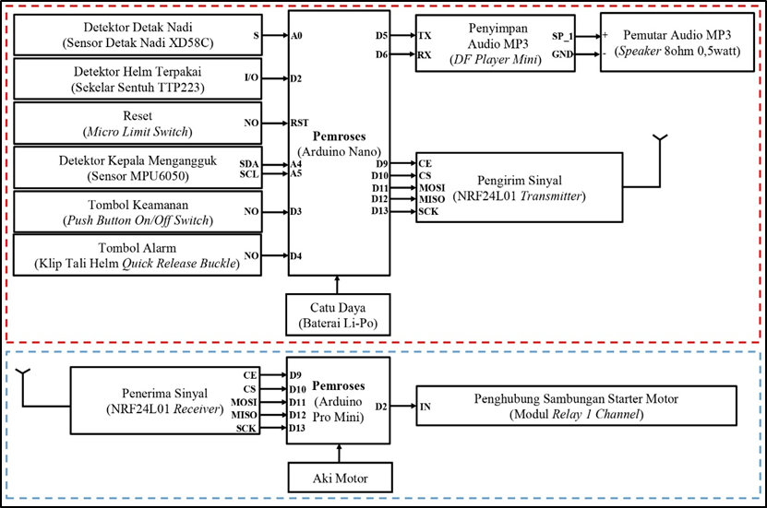

Fig 1. Block Charts

The input system used is the XD58C pulse sensor, MPU6050 sensor, TTP223 touch switch, NRF24L01 receiver, push button on/off switch, quick-release buckle helmet strap clip, and Micro limit switch. The processing systems used are Arduino Nano and Arduino Pro Mini. The output is a one-channel relay module, NRF24L01 transmitter, and an 8 ohm 0.5 watt speaker.

2.1 Pulse Detector

The pulse detector uses the XD58C pulse sensor to read a motorcyclist's pulse as BPM. The pulse sensor is placed on the right side of the neck. The required input voltage for the XD58C pulse sensor is 5Vdc.

2.2 Worn Helmet Detector

The helmet-worn detector uses a TTP223 touch switch. The TTP223 touch switch is located inside the top center of the helmet. The required input voltage for the TTP223 touch switch is 5Vdc. On the working principle of the TTP223 touch switch, when the driver's head touches the switch, the switch will change the condition from LOW to HIGH. This HIGH condition will be sent to the Arduino Pro Mini on the motor.

2.3 Reset

Reset uses a micro limit switch to reset the system's initial state. The input voltage required by the micro limit switch is 5Vdc. On the working principle of the micro limit switch, when the micro limit switch is pressed, the system will reset and run the program from the beginning.

*2.4 Head Nod Detector*

The head nod detector uses the MPU6050 sensor to read the tilt of a motorcycle rider's head in terms of angles. Access to the MPU6050 sensor uses the I2C data line. The input voltage required by the MPU6050 sensor is 5Vdc.

*2.5 Safety Button*

The safety button on the helmet uses the on/off push button. The input voltage required by the push button on/off switch is 5Vdc. The working principle of the on/off push button switch when the on/off push button switch is pressed will change the condition from LOW to HIGH, and the helmet enters active safety mode.

*2.6 Alarm Button*

The alarm button uses a quick-release buckle strap clip to detect whether the clip is on or off. The input voltage required for this helmet strap clip is 5Vdc. The working principle of this helmet strap clip is that the alarm on the helmet will sound when the clip is released.

*2.7 Signal Receiver*

The signal receiver uses the NRF24L01 receiver. The NRF24L01 receiver receives the signal sent by the NRF24L01 transmitter. Access this receiver's NRF24L01 using the SPI data line.

*2.8 Processor*

The Arduino Nano microcontroller contained in the helmet is used as a processor, which processes data from the TTP223 touch switch, XD58C pulse sensor, MPU6050 sensor, helmet strap clip, push button on/off switch, micro limit switch and provides output through the speaker and NRF24L01 transmitter. The Arduino Pro Mini microcontroller contained in the motor is used as a processor, which processes data from the receiver NRF24L01 and provides output via a one-channel relay module.

*2.9 MP3 Audio Storage*

Save MP3 audio using DF Player Mini to read a memory card containing .mp3 format files. Access DF Player Mini using a serial data line.

*2.10 MP3 Audio Player*

Playing MP3 audio using 8 ohm 0.5 watt speakers to play sound in the form of greetings, "Welcome, happy driving, be careful on the road," warnings to rest, and an alarm when a helmet is stolen.

*2.11 Signal Transmitter*

Send a signal to the NRF24L01 receiver located on the motorbike, using the NRF24L01 transmitter to connect the helmet to the motorbike. Access the NRF24L01 transmitter using the SPI data line.

*2.12 Connection to Starter Motor Connection*

Connect to the starter motor using a one-channel relay module. In the working principle of the one-channel relay module, when the relay is in HIGH condition, the dynamo rotates and activates the engine on the motor, which causes the motor starter to be ON.

*2.13. Power Supply*

The power supply used in the helmet is a polymer lithium battery that produces a voltage of 7.4V with 5000mAh as an energy source for Arduino Nano, TTP223 touch switch, XD58C pulse sensor, MPU6050 sensor, helmet strap clip, push button on/off switch, micro limit switches, speakers, and the NRF24L01 transmitter. The power supply used for the motor is AKI which produces 12V voltage with 12Ah as the energy source for Arduino Pro Mini, NRF24L01 receiver, and one channel relay module.

The short way of the block diagram in Figure 1 is as follows:

The helmet-to-motorcycle connection feature uses a TTP223 touch-only input, which is used to activate and activate the relay. Where the relay will be connected to the motor starter connection. The motor is ready to be activated if the starter motor connection is connected. The feature for detecting drowsiness while driving uses input from the XD58C pulse sensor and the MPU6050 sensor, which Arduino Nano will process. If the sensor detects a pulse of 20<BPM<60 and a slope of >30°, then the DF mini player will emit a warning to rest followed by an alarm sound. The safety feature on the helmet uses input in the form of a push button on/off switch to activate safety mode and a micro limit switch to reset the system to its initial state. If the helmet is not used, the safety mode is active. If someone steals a helmet by removing the helmet strap clip, the alarm will indicate that the helmet has been stolen. The alarm will go off if the micro limit switch is pressed and deactivates the security mode.

3. *Software Design*

Program Flow Chart on Helmet shown in Figure 2.

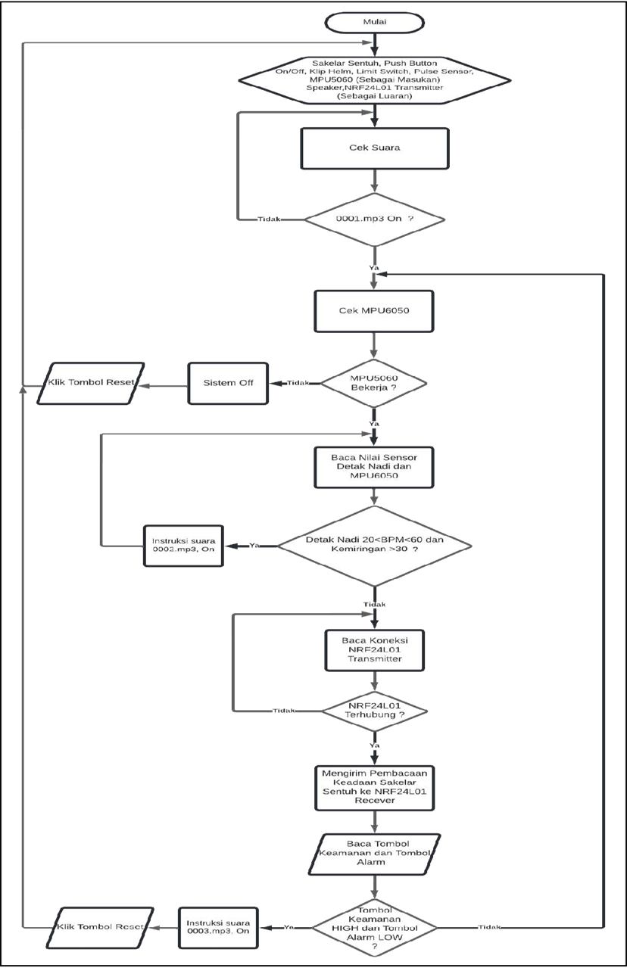

Fig 2. flow chart on the helmet

Program Flow Diagram on Motor shown in Figure 3.

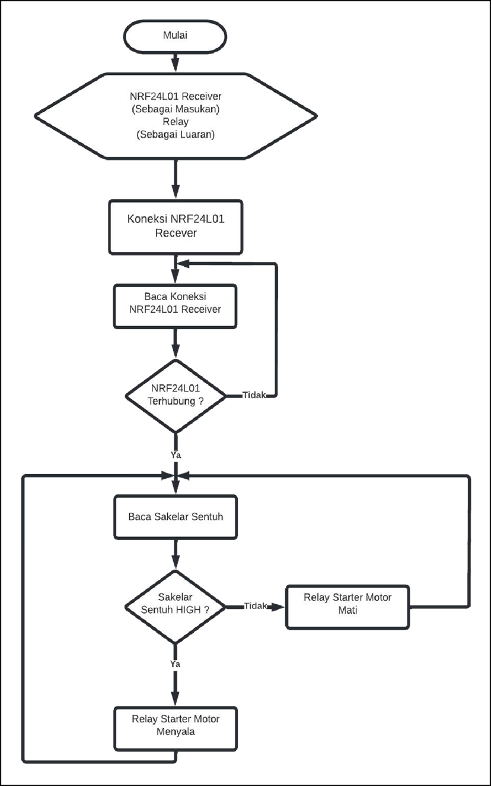

Fig 3. flow chart on motor

4. Result

*4.1 Pulse Detector*

The pulse detector uses the XD58C pulse sensor. The pulse sensor will read the accumulated beats against time into Beats per Minute (BPM).

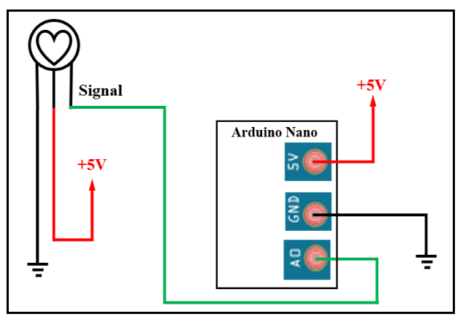

Fig 4. XD58C Pulse Sensor Pin Connection with Arduino Nano

When one pulse is read, one pulse will be read by the pulse sensor. The pulse detected by the sensor will enter pin A0 and be processed by Arduino Nano. Arduino nano reads pulse against time for a few seconds in BPM, which is processed through a pulse sensor library. The reading starts from 0 to the actual measured BPM. The first condition is that the drowsiness alarm sounds through the speaker if the detected pulse is 20<BPM<60. Figure 4 shows the relationship between the XD58C pulse sensor pin and Arduino Nano.

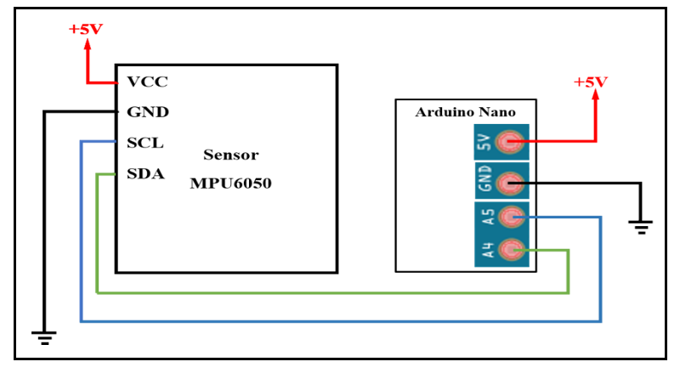

Fig 5. MPU6050 Sensor Pin Connection with Arduino

Nano

The head nod detector uses the MPU6050 sensor. Read the tilt when the head nods as an angle with units of degrees through the program in the MPU6050 library. If the reading angle is > 30°, the second condition is to turn the light sleeper alarm on. If two conditions are met, namely the sensor detects a pulse of 20<BPM<60 and the MPU6050 sensor detects a slope of >30°, the sleep detection alarm will sound through the speaker. In this reader, the MPU6050 is read via I2C communication. I2C communication is synchronous communication. Therefore, a clock is needed for communication. I2C communication uses two pins, namely Serial Data (SDA) and Serial Clock (SCL), as the communication medium. The data read by the MPU6050 in the form of an angle will be sent from the SDA MPU6050 pin to the Arduino Nano SDA pin. SCL functions so the data can be sent simultaneously, continuously, and predictably. Furthermore, the data received by Arduino Nano is processed and entered the conditions for hiding sleep alarms. Figure 5 shows the relationship between the MPU6050 sensor pin and the Arduino Nano.

*4.2 Worn Helmet Detector*

The worn helmet detector uses only the TTP223 touch. This touch switch is in the top center of the helmet. When the helmet is used, it will be touched by the head, changing the condition from LOW to HIGH. Pin 2 will receive the state of the condition of not touching TTP223, and then it will be processed by Arduino Nano. Silence status is entered into the NRF24L01 transmitter and sent to the NRF24L01 Receiver. Figure 6 shows the pin relationships except for touching TTP223 with Arduino Nano.

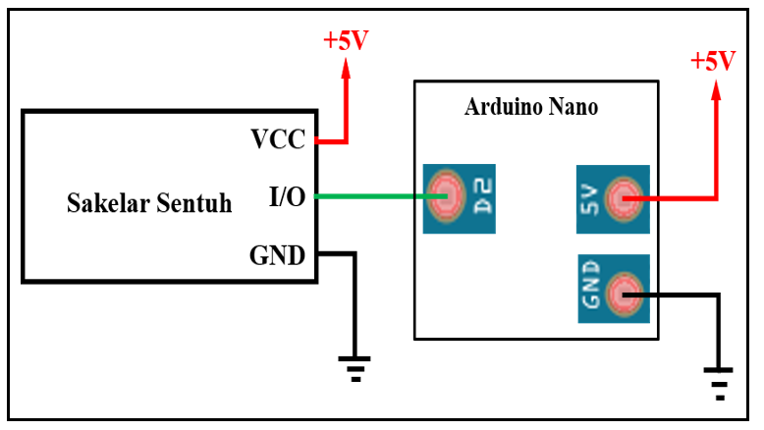

Fig 6. Connect the TTP223 Touch Switch Pins with Arduino Nano.

*4.3 MP3 Audio Storage*

Save .mp3 audio using DF player mini. DF player mini works via serial communication with the TX pin connected to pin D5 and RX to pin D6. Arduino nano will give commands from pin D6, which functions as the TX Arduino Nano and sends data to the RX pin of the DF mini player. The DF player mini will process the data received by the RX pin to play .mp3 audio according to what is passed through the speakers. Serial communication occurs quite slowly because this communication is asynchronous communication where data transmission does not use a clock and is carried out sequentially. Figure 7 shows the relationship between the Arduino Nano pin and the DF Player Mini.

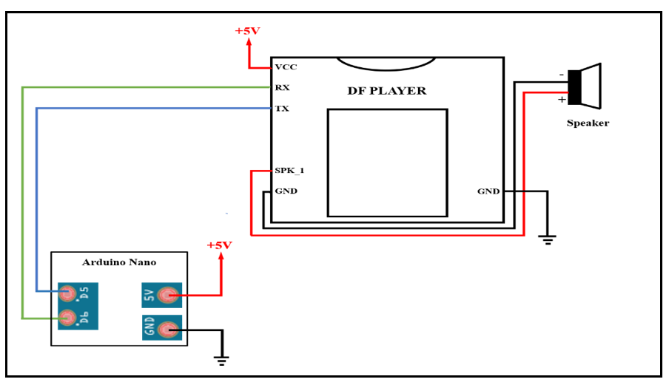

Fig 7. Connect Arduino Nano Pins with DF Player Mini

*4.4 Signal Transmitter*

The signal sender uses the NRF24L01 transmitter. It interfaces with the NRF24L01 transmitter adapter. Figure 8 shows the Arduino Nano pin connection with the NRF24L01 adapter. The NRF24L01 transmitter will send touch exception condition readings from the helmet to the bike via SPI communication. The mandatory touch state read on pin D2 will be sent via the MOSI pin by the NRF24L01 transmitter to the Arduino Pro Mini. Before sending data to the CE pin, the SPI communication line must be activated first. Then the condition on the CS pin will change from HIGH to LOW. SPI communication is included in synchronous communication, so it requires a clock for sending data contained on the SCK pin. The NRF24L01 transmitter acts as a sender, so the data on the MISO pin is always LOW because the NRF24L01 transmitter sends no data to the Arduino Nano. Data that enters the MOSI pin will be sent to the NRF24L01 receiver. The connection between the NRF24L01 adapter pin and the NRF24L01 transmitter can be seen in Figure 9.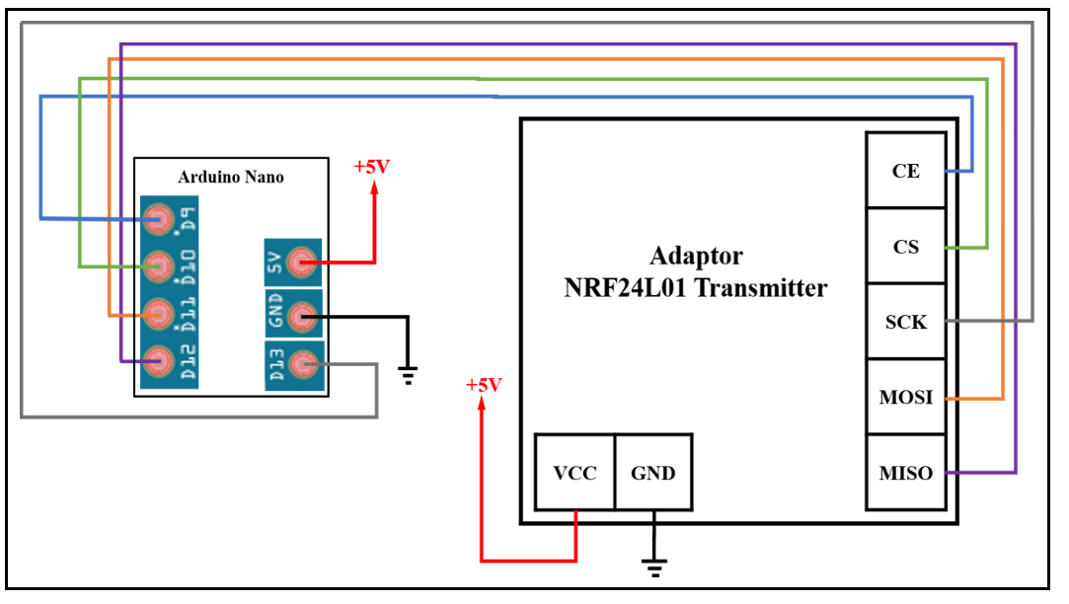

Fig 8. Arduino Nano Pin Connection with Adapter NRF24L01

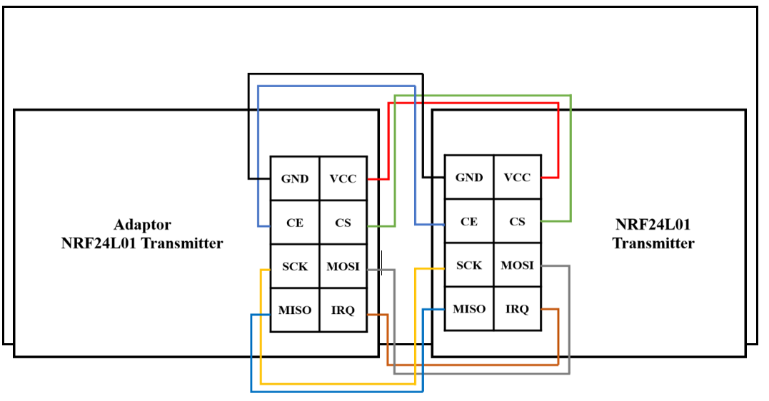

Fig 9. NRF24L01 Adapter Pin Connection with NRF24L01 Transmitter

*4.5 Signal Receiver*

The signal receiver uses the NRF24L01 receiver. Figure 10 shows the relationship between the receiver NRF24L01 pin and the NRF24L01 adapter. The receiver's NRF24L01 adapter connects the receiver's NRF24L01 so that it can be supplied with 5V voltage on the Arduino Pro Mini. The NRF24L01 receiver receives touch switch condition readings from the helmet to the motorcycle via SPI communication. The receiver NRF24L01 will receive the touch switch status sent by the NRF24L01 transmitter to Arduino Pro Mini via the MISO pin. When the Arduino Pro Mini processes incoming data, the CE pin activates the SPI communication line. Then the CS pin will change from HIGH to LOW. SPI communication is included in synchronous communication, requiring a clock to send data in the SCK pin. The NRF24L01 receiver acts as a receiver, so the data on the MOSI pin is always LOW because the NRF24l01 receiver receives no data from the Arduino Pro Mini. Furthermore, Arduino Pro Mini will process the data that enters the MISO pin. Processed switch status data is used to activate and deactivate the relay connected to pin D2 Arduino Pro Mini. The NRF24L01 adapter pin relationship with Arduino Nano can be seen in Figure 11.

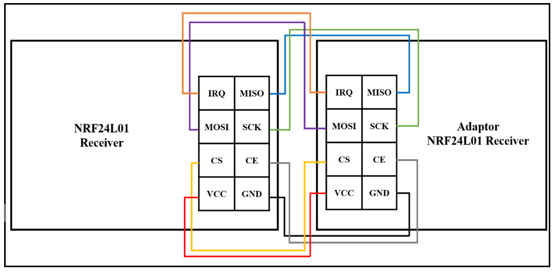

Fig 10. NRF24L01 Receiver Pin Connection with NRF24L01 Adapter

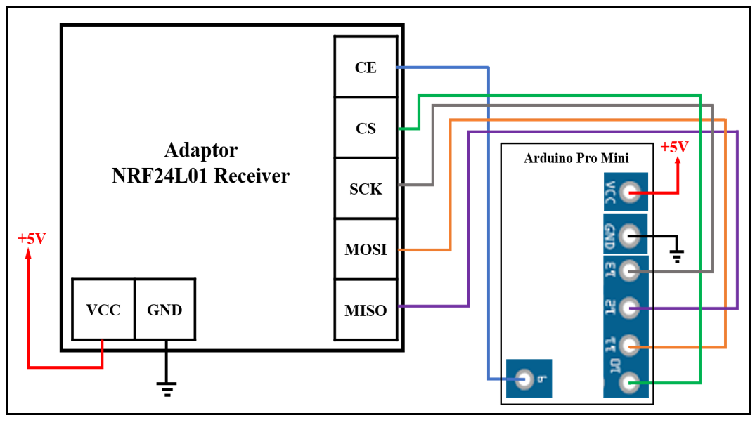

Fig 11. NRF24L01 Pin Adapter Connection with Arduino Nano

*4.6 Motor Starter Connection Connector*

The starter motor connection uses a one-channel relay module. The one-channel relay module processes the signal sent by the receiver NRF24L01 via the MOSI pin, which will control the condition of the relay. If the received signal is HIGH, pin D2 will activate the relay by giving a LOW input so that the motor starter connection is connected and the motor can be started normally. However, when the signal received is LOW, pin D2 will deactivate the relay so that the motor starter connection is disconnected and the motor cannot be started. Figure 12 shows the Arduino Pro Mini pin's relationship with the starter motor circuit.

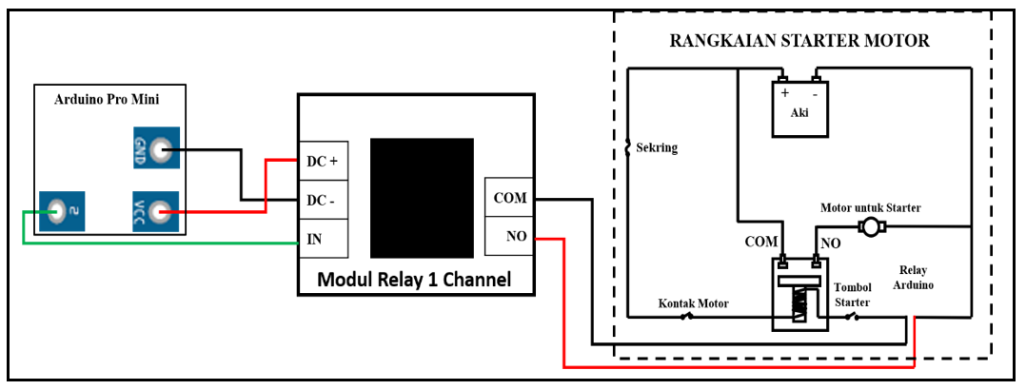

Fig 12. Arduino Pro Mini Pin Connection to the Starter Motor Circuit

*4.7 Security Button*

The safety button uses a push button on/off switch to activate the safety mode hidden on the helmet. When the push button is pressed, pin D3 is HIGH, and the helmet enters safety mode. An alarm in safety mode will sound if the helmet strap clip is released. Figure 13 shows the connection of the push button on/off switch pin with Arduino Nano.

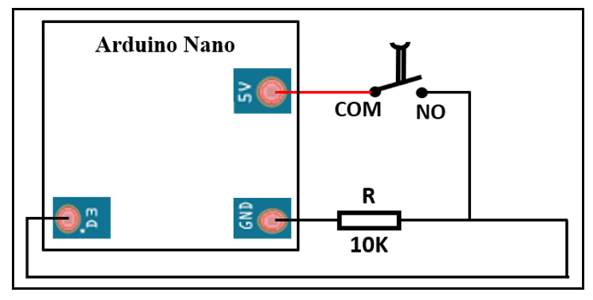

Fig 13. Pin Connection Push Button On/Off Switch with Arduino Nano

*4.8 Alarm Button*

The alarm button uses a quick-release buckle strap clip as a security system. When the helmet strap clip is released, the condition of the D4 pin is LOW, and the theft alarm on the helmet will sound. Figure 14 shows the relationship between the pins of the helmet strap clip and Arduino Nano.

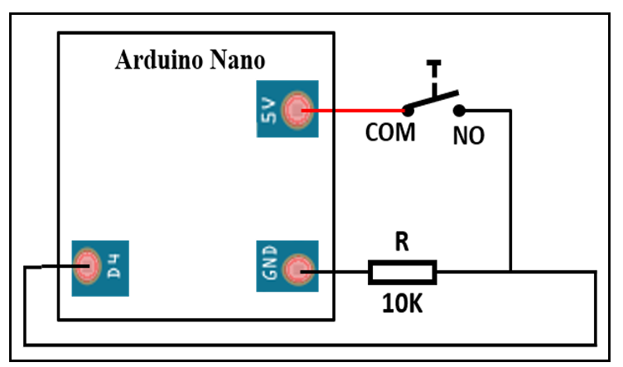

Fig 14. Connect the Helmet Strap Clip Pins to the

Arduino Nano

*4.9 Device Model Design Results*

In testing the smart helmet circuit scheme, it aims to determine the control or control of all components used. The results of the design of this device are expected to run well. Make the mechanical device on the helmet uses a cork 4 cm thick and 22 cm in diameter. The manufacturing process begins with determining all components' size, location, and placement, so they can work as desired. Manufacture of mechanical devices on the motor using a black component box. The manufacturing process begins with determining the location and placement point of the component box on the motor. The mechanical design of the helmet can be seen in Figure 15.

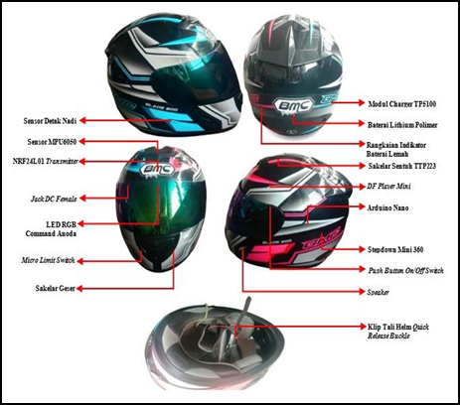

Fig 15. Mechanical Design on Helmets

The mechanical design of the component box on the motorbike can be seen in Figure 16.

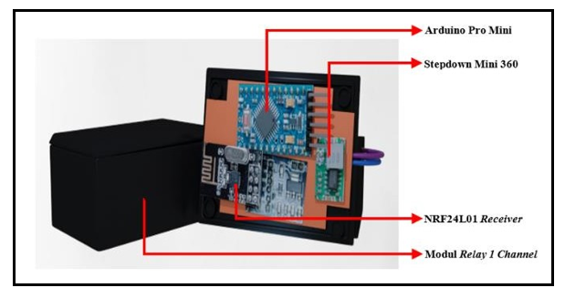

Fig 16. Component Box Design on the Motor

**5. Device Testing**

*5.1* Testing the Connection Distance of the Helmet with the Motor

Testing is done by adjusting the distance between the helmet and the motorbike using a meter. Testing the distance on the Polines telecommunication road is shown in Table 1. The distance test at Zefania's house is shown in Table 2. The distance test data on the road to the Polines green field is shown in Table 3.

Tabel 1. Distance Testing on Jalan Telkom Polines

|  |  |  |  |
| --- | --- | --- | --- |
| No | Distance | Motor Starters | Information |
| 1 | 0m | Connected | minimum distance |
| 2 | 10m | Connected | - |
| 3 | 20m | Connected | - |
| 4 | 30m | Connected | - |
| 5 | 40m | Connected | maximum distance |

Tabel 2. Distance Testing at Zefania's House

|  |  |  |  |
| --- | --- | --- | --- |
| No | Distance | Motor Starters | Information |
| 1 | 0 | Connected | minimum distance |
| 2 | 10 | Connected | - |
| 3 | 20 | Connected | - |
| 4 | 30 | Connected | - |
| 5 | 40 | Connected | - |
| 6 | 50 | Connected | maximum distance |

Tabel 3. Distance Testing on the Road to Polines Green Field

|  |  |  |  |
| --- | --- | --- | --- |
| No | Distance | Motor Starters | Information |
| 1 | 0 | Terkoneksi | minimum distance |
| 2 | 10 | Terkoneksi | - |
| 3 | 20 | Terkoneksi | - |
| 4 | 30 | Terkoneksi | - |
| 5 | 40 | Terkoneksi | - |
| 6 | 50 | Terkoneksi | - |
| 7 | 60 | Terkoneksi | - |
| 8 | 70 | Terkoneksi | maximum distance |

*5.2 Safety System Testing on Helmets*

Testing is done by pressing the safety button and attaching the helmet strap clip. This test was carried out by pressing buttons and attaching a helmet strap clip. The test data is shown in Table 4.

Table 4. Safety System Testing on Helmets

|  |  |  |  |  |  |  |  |
| --- | --- | --- | --- | --- | --- | --- | --- |
| No | Button | Clip | Testing | | | Alarm | Suitability |
| 1 | 2 | 3 |
| 1 | On | √ | √ | - | - | Off | Suitable |
| 2 | On | - | √ | - | - | On | Suitable |
| 3 | Off | √ | √ | - | - | Off | Suitable |
| 4 | Off | - | √ | - | - | Off | Suitable |
| 1 | On | √ | - | √ | - | Off | Suitable |
| 2 | On | - | - | √ | - | On | Suitable |
| 3 | Off | √ | - | √ | - | Off | Suitable |
| 4 | Off | - | - | √ | - | Off | Suitable |
| 1 | On | √ | - | - | √ | Off | Suitable |
| 2 | On | - | - | - | √ | On | Suitable |
| 3 | Off | √ | - | - | √ | Off | Suitable |
| 4 | Off | - | - | - | √ | Off | Suitable |

Description:

Clip √ = Clip attached

Clip - = Clip unattached

*5.3 Motorcyclist Drowsiness Test*

The test is carried out by recording the pulse sensor on the skin of the right neck. Then the pulse sensor starts calculating the pulse in BPM, and the MPU6050 reads the tilt of the rider's head in angles. Where is the sensor reading through the serial monitor. Data for testing the drowsiness of motorcyclists in the morning are shown in Table 5. Data for testing the drowsiness of motorcyclists during the day are shown in Table 6. Data for testing the drowsiness of motorcyclists at night is shown in Table 7.

Table 5. Morning Sleepiness Test

|  |  |  |  |  |
| --- | --- | --- | --- | --- |
| No | Name | Bpm | (°) | Alarm |
| 1 | Fahad | 71 | 50 | Off |
| 2 | Zulvan | 63 | 58,4 | Off |
| 3 | Panji | 62 | 46,6 | Off |
| 4 | Syah | 66 | 59,1 | Off |
| 5 | Iqbal | 65 | 55 | Off |
| 6 | Komar | 67 | 57 | Off |

Table 6. Midday Sleepiness Test

|  |  |  |  |  |
| --- | --- | --- | --- | --- |
| No | Name | Bpm | (°) | Alarm |
| 1 | Fahad | 116 | 38 | Off |
| 2 | Zulvan | 87 | 51,3 | Off |
| 3 | Panji | 67 | 31,3 | Off |
| 4 | Syah | 96 | 47,2 | Off |
| 5 | Iqbal | 87 | 64,1 | Off |
| 6 | Komar | 79 | 33 | Off |

Table 7. Night Sleepiness Test

|  |  |  |  |  |
| --- | --- | --- | --- | --- |
| No | Name | Bpm | (°) | Alarm |
| 1 | Fahad | 55 | 35 | On |
| 2 | Zulvan | 53 | 44 | On |
| 3 | Panji | 40 | 44,3 | On |
| 4 | Syah | 58 | 56,5 | On |
| 5 | Iqbal | 49 | 69 | On |
| 6 | Komar | 35 | 45,3 | On |

**6. Conclusion**

From the implementation of the Research "Smart Helmet as Driving Safety and Arduino-Based Safety," it can be concluded as follows.

1. Motorcyclists who are not wearing helmets can be noticed when the starter on the motorcycle cannot be activated.
2. Riders who are scaly while riding a motorcycle can be detected when an alarm with a call to rest on the helmet sounds.
3. The loud alarm on the helmet can detect a stolen helmet.
4. The maximum distance between the helmet and the motorcycle is 70 meters. However, it can change depending on the number of obstructions around the test site.
5. The safety system on the helmet gets an error value of 0% with a success of 100%, where the system can work according to the function of the security system on the helmet.
6. Overall, the system for detecting the drowsiness of motorcyclists can work well. The alarm sounds when it detects 20 < BPM < 60 with nodding head tilt > 30°.

References

1. Agustina F., dkk. (2020). Helm Pintar Berbasis Arduino Pro Mini untuk Mendeteksi Kecelakaan. Jurnal Simetris, 11(2), 352-362.
2. Amirullah, dkk. (2018). Sistem Peringatan Dini Menggunakan Deteksi Kemiringan Kepala pada Pengemudi Kendaraan Bermotor yang Mengantuk. Jurnal Teknik ITS, 7(2), 2337-3539.
3. Budiman, A.R., dkk. (2018). Desain Perancangan Helm Pintar dengan Notifikasi Keselamatan Berkendara untuk Pengendara Sepeda Motor. Universitas Telkom.
4. Edwinanto., dkk. (2019). Helm Cerdas untuk Keamanan Sepeda Motor Berbasis IoT. Jurnal Fidelitiy, 1(2), 12-30.
5. Faisal, I.F., dkk. (2019). Pengembangan Aplikasi Pendeteksi Kantuk pada Pengendara Kendaraan Bermotor dengan Menggunakan Sensor Detak Jantung pada Smartwatch. Jurnal Pengembangan Teknologi Informasi dan Ilmu Komputer, 3(10), 9568-9578.
6. Hidayat, A.M.N., & Akbar, M.N. (2020). Sistem Keamanan Sepeda Motor Menggunakan Arduino. Jurnal Informartika, 2(2), 30-38.
7. Nugroho, M.A., dkk. (2019). Desain dan Implementasi Helm Pintar dengan Fitur Bluetooth. Jurnal e-Proceeding of Engineering, (6)2, 2609-2616.
8. Prasetyawan, P., dkk. (2021). Internet of Things Menggunakan Firebase dan NodeMCU untuk Helm Pintar. Jurnal ELTIKOM, 5(1), 32-39.
9. Purwanto, E.H. (2015). Signifikan Helm SNI sebagai Alat Pelindung Pengendara Sepeda Motor dari Cidera Kepala. Jurnal Standardisasi, 17(1), 31-46.
10. Septiano, A., & Ghozali, T. (2020). NRF24L01 sebagai Pemancar/ Penerima untuk Wireless Sensor Network. Jurnal Tekno, 17(1), 26-34.
11. Suryono., dkk. (2022). Rancang Bangun Pengontrol Peralatan Listrik Menggunakan Sensor Sentuh dengan Pengunci Radio Frekuensi Identifikasi. 406-420.
12. Syahriza. (2019). Kecelakaan Lalu Lintas : Perlukah Mendapatkan Perhatian Khusus. Jurnal Averrous, 5(2), 89-101.
13. Rachmat, H.H., & Ambaransari, D.R. (2018). Sistem Perekam Detak Jantung Berbasis Pulse Heart Rate Sensor pada Jari Tangan. Jurnal Elkomika, 6(3), 344-356.
14. Trisnawati, F., & Prasetyawan, P. (2020). Selamat Mudik Menggunakan Helm Berbasis Internet of Things (IoT). Jurnal ICTEE, 1(1), 6-10.