Monitoring System Of Parking Land Availability And Number Of Cars In Web-Based Parking Place On The Smart Parking System

Miftavinda Farah Diba1, Sarono Widodo2, Sri Anggraeni Kadiran3

Sidiq Syamsul Hidayat4, Sindung Hadwi Widi Sasono5, Agus Rochadi6

1,2,3,4,5,6 Department of Electrical Engineering, Study Program of Telecommunication Engineering, State Polytechnic of Semarang, Semarang, Indonesia

[miftavinda@gmail.com1](mailto:miftavinda@gmail.com1), [sarwede@gmail.com2](mailto:sarwede@gmail.com2), [rinikadiran67@gmail.com3](mailto:rinikadiran67@gmail.com3), [sidiqsh@polines.ac.id4](mailto:sidiqsh@polines.ac.id4), ssindung@gmail.com5, ir_aro@yahoo.co.id6

Abstract—According to data obtained from the website www.bps.go.id, the total number of motorized vehicles in Indonesia in 2018 was 146,858,759. The result of the increase in the number of motorized vehicles is that it is increasingly difficult to find parking space. People also often experience difficulties when finding which parking lot is still empty because there is no information about the state of the parking lot. Based on these problems, people need a system to check the parking lots available by utilizing the Internet of Things (IoT). Smart Parking Monitoring System is a web-based parking monitoring system that displays real-time parking availability information. The data was collected by simulating parking the car in the parking lot. Monitoring data transmission from the sensor node to the server is done using Wireshark software. The test results of the propagation time that occur in the data transmission process for an interval of 1 minute 15 seconds and the 5-second data transmission interval are 5053 milliseconds. The average value of the propagation time that occurs in the process of receiving data from the server is 197 milliseconds.

Key Words—Smart Parking*,* IoT*,* monitoring system*,* web*,* propagation time.

1. Preliminary

The development of technology nowadays encourages the changing times which is getting faster. The impact of the change is that many technologies from various sectors use the internet as a communication link between users and objects, or what is called IoT (Internet of Things) [1]. IoT is a technology concept in which various things in everyday life are integrated with the internet [2]. This technology makes people easier and makes work more efficient and faster.

The parking lot service sector is facing a big challenge in being able to give parking space that can accommodate many motorized vehicles. According to data obtained from the website www.bps.go.id, the total number of motorized vehicles in Indonesia in 2018 was 146,858,759 [3]. This number can increase over time. The result of this increase in the number of motorized vehicles is that there is less parking space.

Apart from these problems, motorized vehicle drivers also often experience difficulties when finding which parking lot is still empty because there is no direct information about the state of the parking lot. This can also cause other problems, such as causing congestion, wasted fuel to find another parking space, time that we used for activities wasted just because we don't get a parking space.

The solution to the problem of finding a parking space today is to use a valet service. However, this valet service has several drawbacks, namely the limited number of valet employees, the valet rates are quite expensive, and only a few parking lots offer valet services. For this reason, parking service providers need a system that can help motorized vehicle drivers in finding available parking spaces. This system is more efficient than searching for empty parking spaces manually or by using a valet service because it can save costs, time, and prevent congestion.

2. Literature Review

The Smart Parking monitoring system uses a web-based interface that can be accessed safely, in which parking lots are empty. Several previous studies regarding Smart Parking monitoring using different sensors, microcontrollers, and interfaces. The research that discusses the smart parking system using the RFID tag as the entrance and exit of the parking lot and the microcontroller used is Atmega16 [4]. The parking lot status is monitored using a desktop-based application. However, this study has weaknesses that show the fact that the parking lot is still desktop-based so that readers still have difficulty accessing the land to be addressed.

Another study uses a proximity sensor to detect cars in an open parking lot (outdoor) using NodeMCU ESP8266 as a microcontroller [5]. Motorists can view information on parking availability on the website. The weakness in this study is that there is no information on how many cars are in the parking lot on the website display.

There is also research on Smart Parking which uses the MQTT Broker protocol for data transmission [6], [7]. This study uses the MQTT protocol because it can be used for network optimization with low bandwidth and minimum energy computing equipment. However, this study does not yet provide a display of the availability of web-based parking in the parking lot.

1. Research Methods
2. *Smart Parking Monitoring System Design*

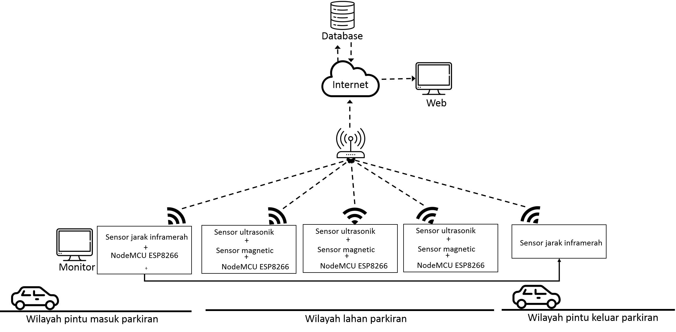

Figure 1. Smart Parking Monitoring System Block Diagram

This Smart Parking System consists of two design parts. The first part is part of the control system that controls the sensor node devices and the second part is a monitoring system that displays monitoring information on the availability of parking lots. The control system works to be able to detect cars in the parking lot. The sensor nodes in the control system will detect the car when the car is parked. The data that has been taken by the sensor node will be uploaded to the database and then displayed in the monitoring system.

The monitoring system performs data retrieval that enters the database. Data in the database is in the form of data on the number of cars and data on the status of parking lots. Information on the number of cars on the monitoring system web will increase if the detection sensor detects a car entering the parking lot. Then the information on the number of cars on the web will decrease by 1 if the sensor detects a car coming out of the parking lot. The display of the parking lot plan on the website when no cars are parked will be green. Conversely, if a car is parked, the parking lot color on the web will change to green. Figure 2 is a flow chart of the Smart Parking monitoring system.

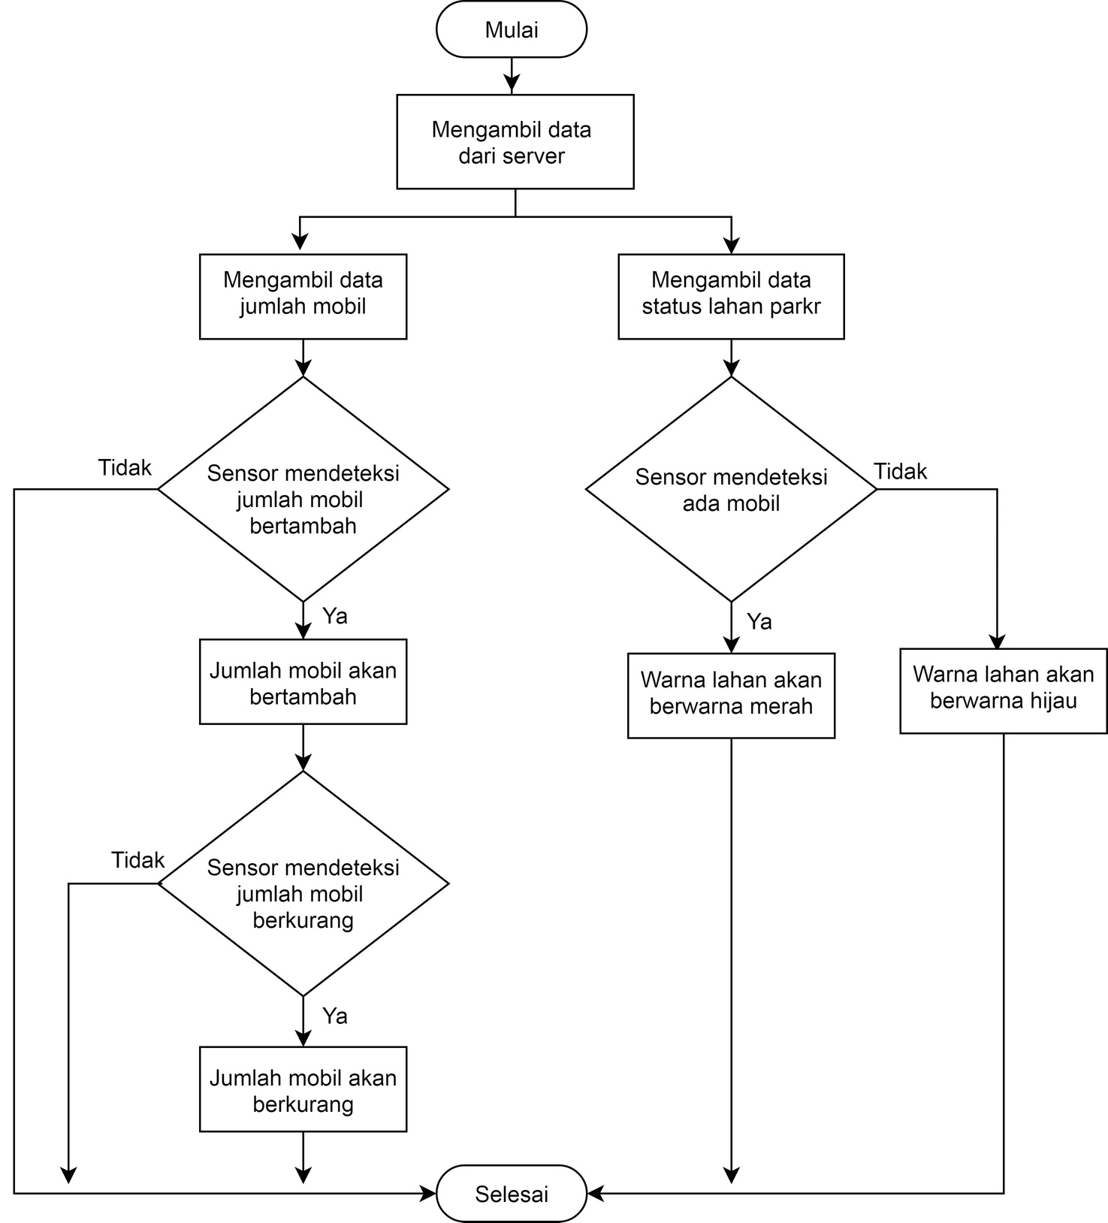

Figure 2. Smart Parking Monitoring System Flowchart

1. Web Monitoring System Design

This web monitoring will be designed into 3 pages, namely the home page, floor plan page, and contact page.

* Home page : The home page is the page that will appear first when users access the website. The home page design can be seen in Figure 3.

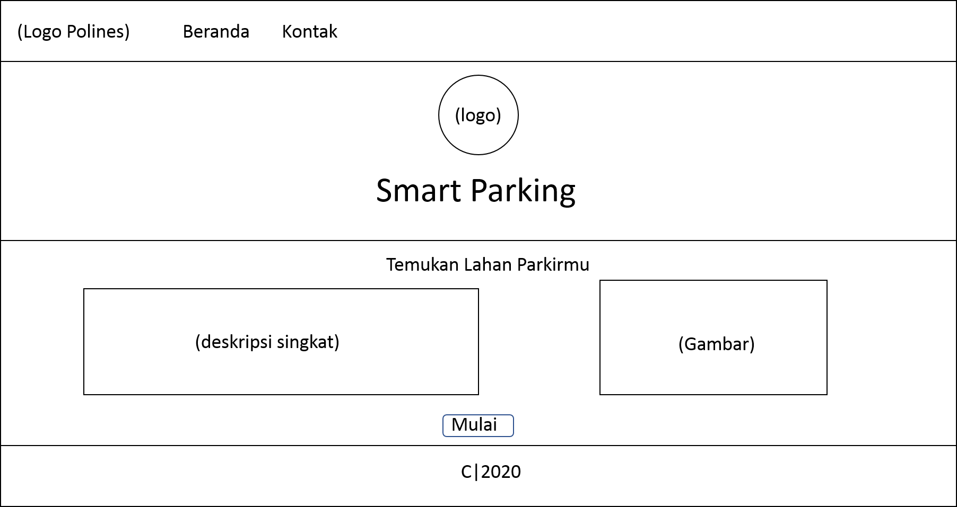

Figure 3. Web Homepage Design

* Parking area page : This page displays information on parking availability and the number of cars in the parking lot. The parking page design can be seen in Figure 4.

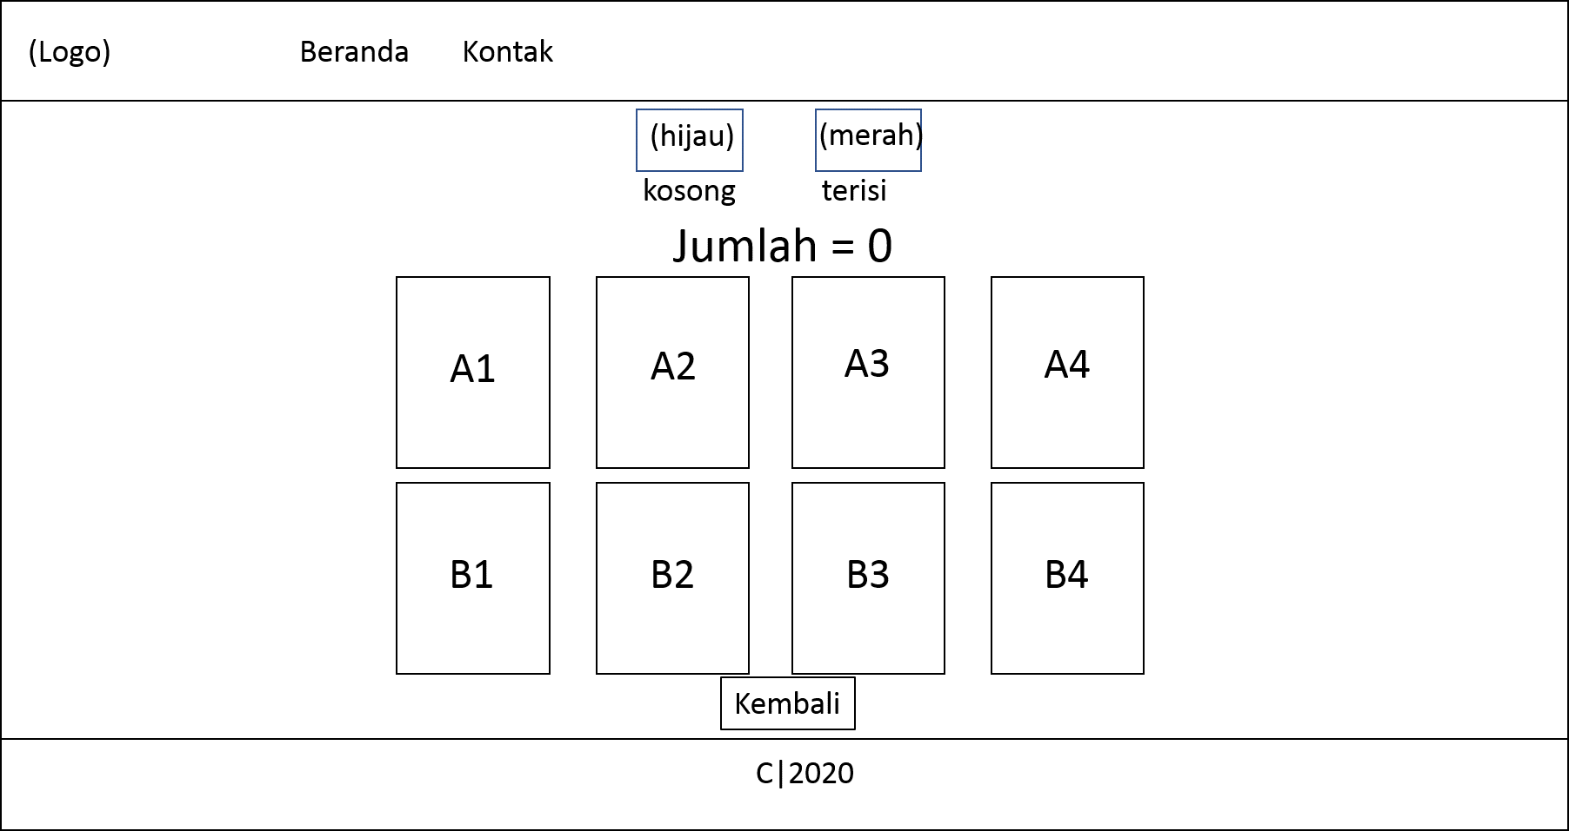

Figure 4. Web Parking Area Page Design

* Contact Page : The contact page is a page that displays developer contacts. The contact page design can be seen in Figure 5.

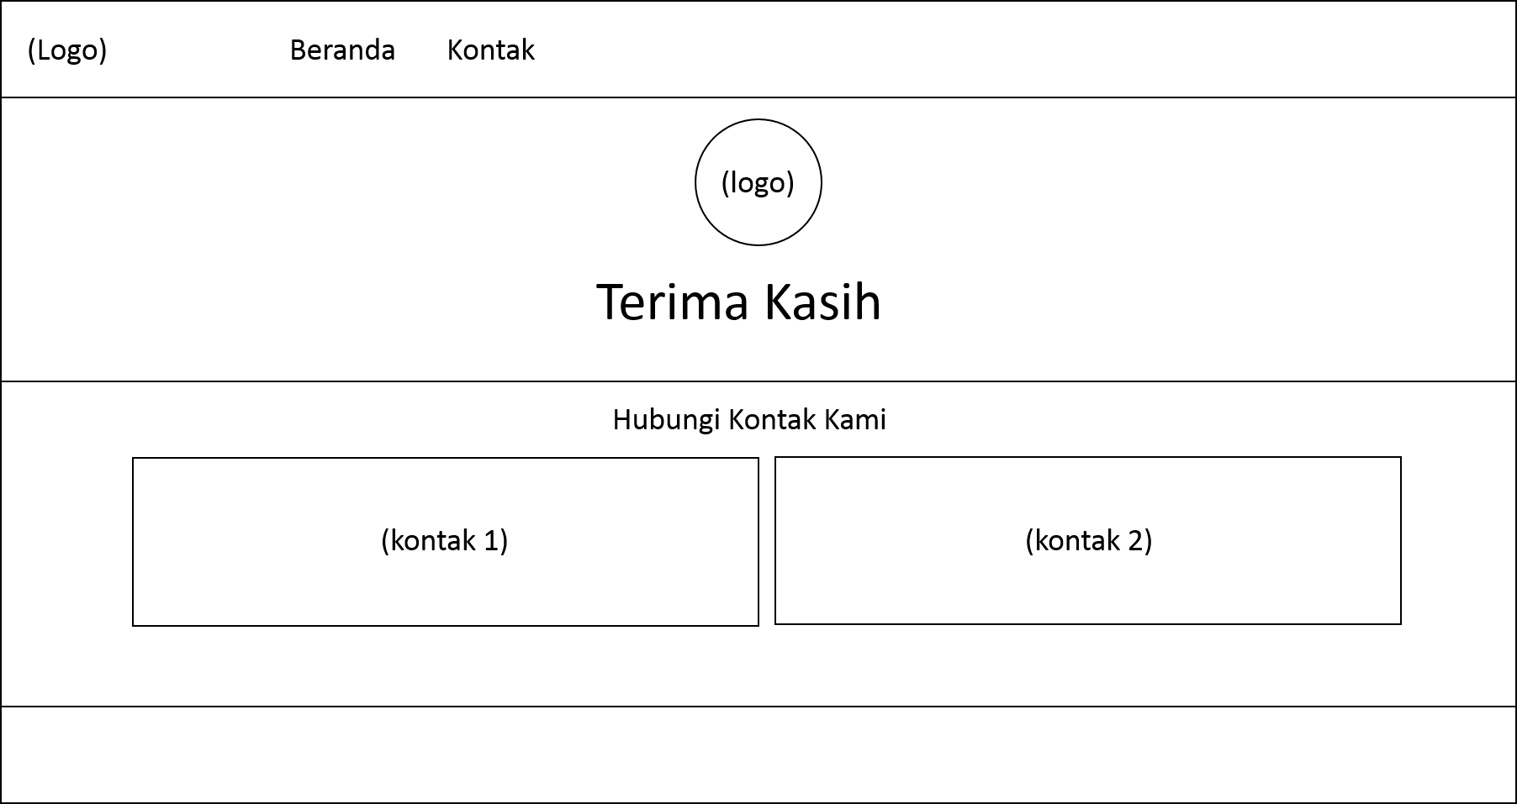

Figure 5. Web Contact Page Design

1. Results and Discussion

The purpose of testing in this study is divided into two, the first is to determine the propagation time during the process of sending data packets from the sensor node to Antares, and the second to test the results of the monitoring web display. The propagation time test indicates the length of time it takes for the system when the system works to send data packets [8]. While testing the results of this web monitoring display indicates that the web can display real-time monitoring information on parking lots according to conditions that occur in the field. Figure 6 shows the block diagram of the Smart Parking monitoring system testing.

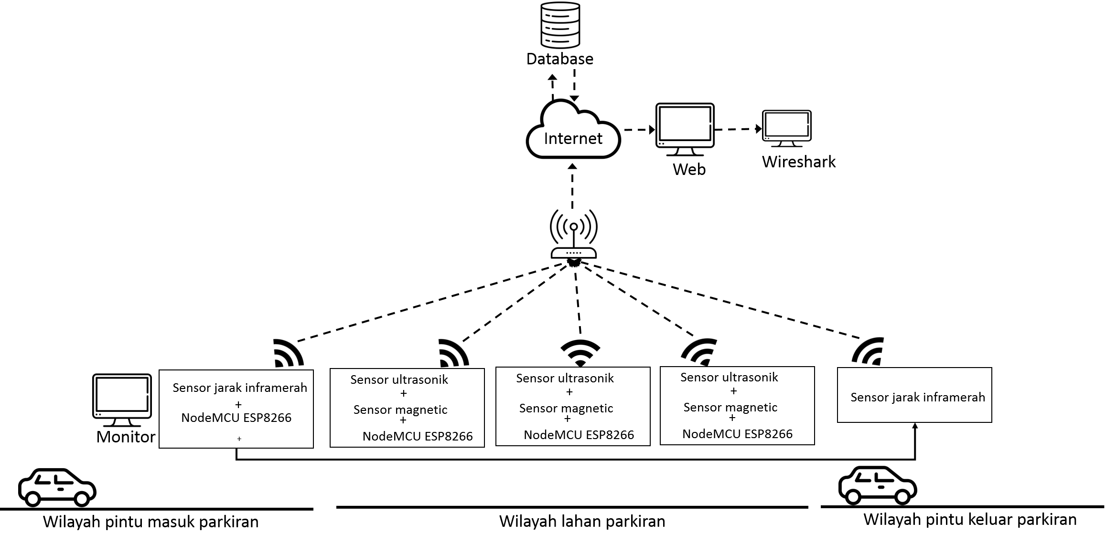

Figure 6. Smart Parking System Testing Block Diagram

In Figure 6, testing is carried out by performing a system simulation, simultaneously with the Wireshark software running on the computer. The data transmission process that occurs when this system is working will be monitored by the Wireshark software. As long as this system is working, testing of the web monitoring display is also carried out. The placement of the sensor nodes in this system is shown in Figure 7.

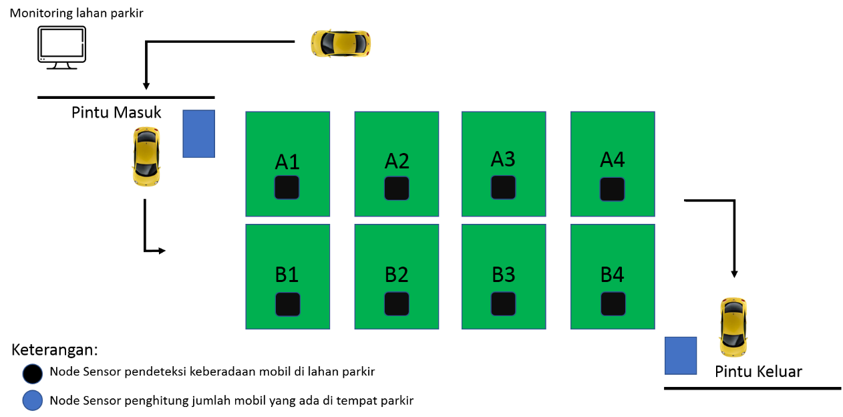

Figure 7. Placement of Sensor Nodes in Parking Areas

* 1. *Propagation Time Test Results*

Figure 8 is data with the status of no cars in the parking lot received by Antares from the sensor node. It is indicated that the status sent by the sensor node is absent. This data was received in Antares at 08:57:44.

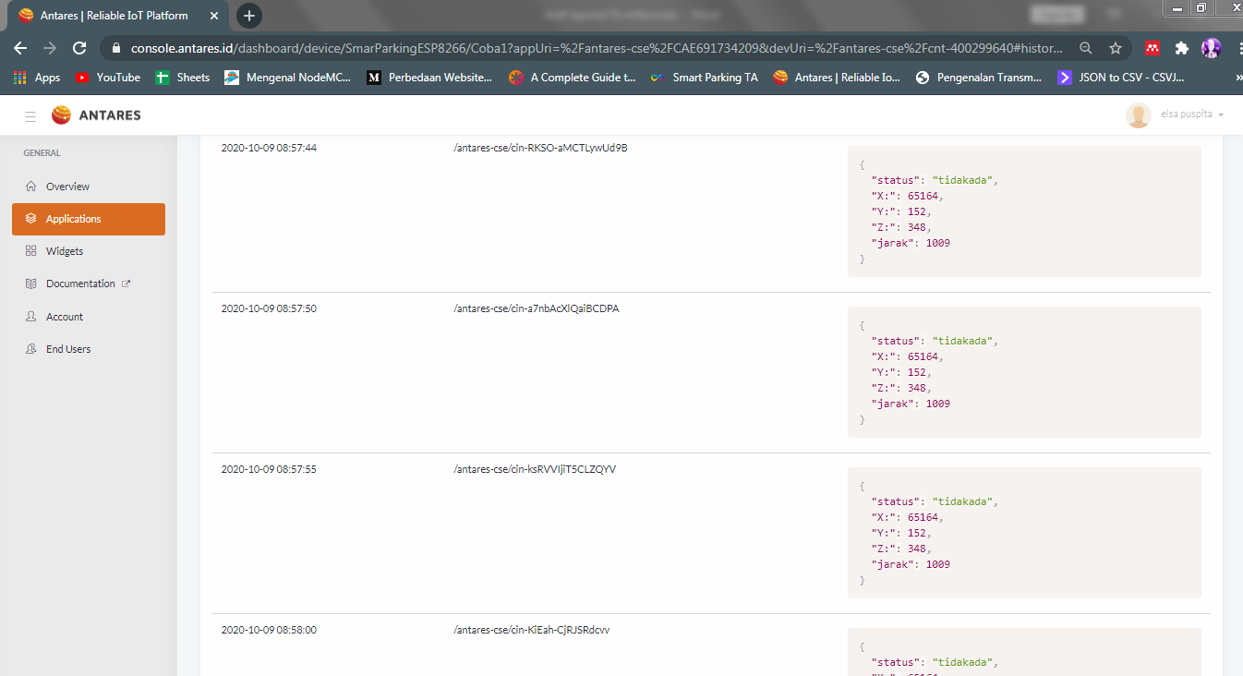

Figure 8. Data Received by Antares from Sensor Node

This data is then sent by Antares to the computer. Monitoring results when Antares sends data to a computer, on Wireshark, it is read as frame 3 at 08: 57: 49.223. This is shown in Figure 9.

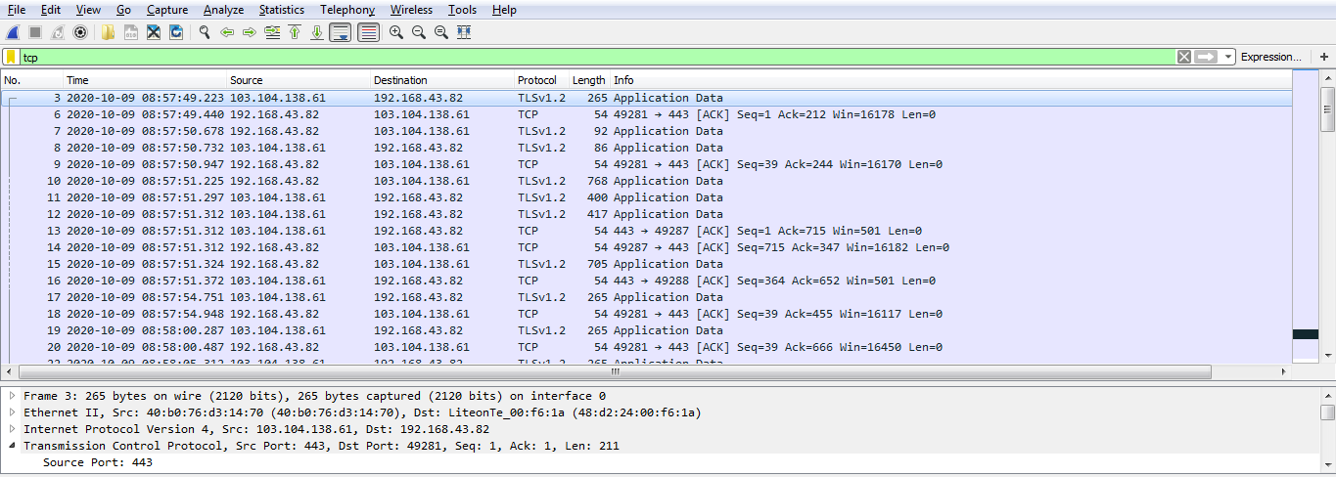

Figure 9. Capture Results when Antares Sending Data to the Computer Read as Frame 3

After the packet is received by the computer, the computer will send an ACK to Antares as a notification that the packet has been received. The result of monitoring when the computer sends ACK to Antares on Wireshark is read as frame 6 which is received at 08: 57: 49.440. This is shown in Figure 10.

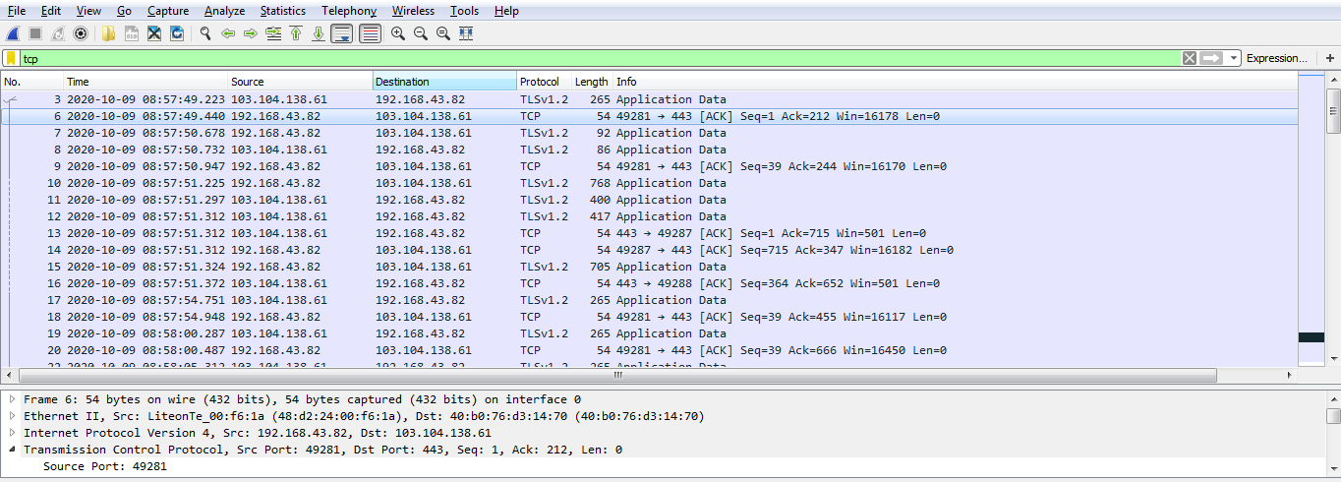

Figure 10. Capture results when the computer sends ACK to Antares is read as Frame 6

The results of data monitoring using Wireshark during the data transmission process are shown in Table 1.

Table 1. Wireshark Software Capture Result Data

| Data Received by Antares from Sensor Node | | Antares Sent Data to Computer | | | ACK sent by computer to Antares | | |
| --- | --- | --- | --- | --- | --- | --- | --- |
| Time | Status | Time | Frame no. | Length (bytes) | Time | Frame no. | Length (bytes) |
| 2020-10-09T08:57:44.000Z | tidak ada | 2020-10-09-08:57:49.223 | 3 | 265 | 2020-10-09-08:57:49.440 | 6 | 54 |
| 2020-10-09T08:57:50.000Z | tidak ada | 2020-10-09-08:57:54.751 | 17 | 265 | 2020-10-09-08:57:54.948 | 18 | 54 |
| 2020-10-09T08:57:55.000Z | tidak ada | 2020-10-09-08:58:00.287 | 19 | 265 | 2020-10-09-08:58:00.487 | 20 | 54 |
| 2020-10-09T08:58:00.000Z | tidak ada | 2020-10-09-08:58:05.312 | 22 | 265 | 2020-10-09-08:58:05.517 | 24 | 54 |
| 2020-10-09T08:58:06.000Z | tidak ada | 2020-10-09-08:58:11.032 | 26 | 258 | 2020-10-09-08:58:11.243 | 28 | 54 |
| 2020-10-09T08:58:11.000Z | ada | 2020-10-09-08:58:15.833 | 30 | 258 | 2020-10-09-08:58:15.878 | 32 | 54 |
| 2020-10-09T08:58:16.000Z | ada | 2020-10-09-08:58:21.122 | 41 | 258 | 2020-10-09-08:58:21.332 | 42 | 54 |
| 2020-10-09T08:58:22.000Z | ada | 2020-10-09-08:58:27.111 | 43 | 258 | 2020-10-09-08:58:27.319 | 44 | 54 |
| 2020-10-09T08:58:27.000Z | tidak ada | 2020-10-09-08:58:32.315 | 46 | 265 | 2020-10-09-08:58:32.525 | 48 | 54 |
| 2020-10-09T08:58:33.000Z | tidak ada | 2020-10-09-08:58:38.173 | 49 | 265 | 2020-10-09-08:58:38.380 | 50 | 54 |
| 2020-10-09T08:58:38.000Z | tidak ada | 2020-10-09-08:58:43.205 | 64 | 265 | 2020-10-09-08:58:43.415 | 65 | 54 |
| 2020-10-09T08:58:44.000Z | tidak ada | 2020-10-09-08:58:48.755 | 66 | 265 | 2020-10-09-08:58:48.966 | 67 | 54 |
| 2020-10-09T08:58:49.000Z | tidak ada | 2020-10-09-08:58:54.186 | 68 | 265 | 2020-10-09-08:58:54.394 | 69 | 54 |
| 2020-10-09T08:58:55.000Z | tidak ada | 2020-10-09-08:58:59.284 | 74 | 265 | 2020-10-09-08:58:59.492 | 75 | 54 |
| 2020-10-09T08:59:00.000Z | tidak ada | 2020-10-09-08:59:05.206 | 76 | 265 | 2020-10-09-08:59:05.416 | 77 | 54 |

The propagation time of sending data packets is obtained by calculating the difference between the time when the data is received by Antares and the time when Antares sends the packet to the computer. Based on the data from this test, the propagation time can be calculated as follows:

T1 = time of Antares sends data to the computer – time of Antares received data from the sensor node

= 08:57:49.223 – 08:57:44

= 5.223 seconds

T2 = time of the computer sends an ACK to Antares – time of Antares sends data to computer

= 08:57:49.440 – 08:57:49.223

= 217 miliseconds (ms)

T1 shows that the propagation time of sending data packets from Antares to the computer is 5,223 seconds. Then T2 shows the propagation time of ACK sending from the computer to Antares is 217 ms. The results of calculating the propagation time when Antares sends data to the computer (T1) are shown in Table 2.

Table 2. The Result of Calculation of Propagation Time when Antares Sends Data to the Computer

| No. | Time of Data Received in Antares from Sensor Node | Time of Antares Sending Data to Computer | Time of Propagation When Antares Sending Data to Computer (ms) |
| --- | --- | --- | --- |
| 1. | 2020-10-09T08:57:44.000Z | 2020-10-09-08:57:49.223 | 5223 |
| 2. | 2020-10-09T08:57:50.000Z | 2020-10-09-08:57:54.751 | 4751 |
| 3. | 2020-10-09T08:57:55.000Z | 2020-10-09-08:58:00.287 | 5287 |
| 4. | 2020-10-09T08:58:00.000Z | 2020-10-09-08:58:05.312 | 5312 |
| 5. | 2020-10-09T08:58:06.000Z | 2020-10-09-08:58:11.032 | 5032 |
| 6. | 2020-10-09T08:58:11.000Z | 2020-10-09-08:58:15.833 | 4833 |
| 7. | 2020-10-09T08:58:16.000Z | 2020-10-09-08:58:21.122 | 5122 |
| 8. | 2020-10-09T08:58:22.000Z | 2020-10-09-08:58:27.111 | 5111 |
| 9. | 2020-10-09T08:58:27.000Z | 2020-10-09-08:58:32.315 | 5315 |
| 10. | 2020-10-09T08:58:33.000Z | 2020-10-09-08:58:38.173 | 5173 |
| 11. | 2020-10-09T08:58:38.000Z | 2020-10-09-08:58:43.205 | 5205 |
| 12. | 2020-10-09T08:58:44.000Z | 2020-10-09-08:58:48.755 | 4755 |
| 13. | 2020-10-09T08:58:49.000Z | 2020-10-09-08:58:54.186 | 5186 |
| 14. | 2020-10-09T08:58:55.000Z | 2020-10-09-08:58:59.284 | 4284 |
| 15. | 2020-10-09T08:59:00.000Z | 2020-10-09-08:59:05.206 | 5206 |
| Rata-Rata Waktu Propagasi (ms) | | | 5053 |

Based on Table 2, it can be seen that the highest and lowest propagation times when Antares sends data to the computer. The highest propagation time is 5315 ms and the lowest propagation time is 4284 ms. The average time required to transmit data from Antares to this computer is 5053 ms.

The results of the calculation of propagation time when sending ACK from the computer to Antares (T2) are shown in Table 3.

Table 3. Results of the Calculation of Propagation Time Required by the Computer to Receive Data from Antares

| No. | Time of Antares Sending Data to Computer | Time of Computer Sent an ACK | Time of Propagation When Computer Receives Data from Antares (ms) |
| --- | --- | --- | --- |
| 1. | 2020-10-09-08:57:49.223 | 2020-10-09-08:57:49.440 | 217 |
| 2. | 2020-10-09-08:57:54.751 | 2020-10-09-08:57:54.948 | 197 |
| 3. | 2020-10-09-08:58:00.287 | 2020-10-09-08:58:00.487 | 200 |
| 4. | 2020-10-09-08:58:05.312 | 2020-10-09-08:58:05.517 | 205 |
| 5. | 2020-10-09-08:58:11.032 | 2020-10-09-08:58:11.243 | 211 |
| 6. | 2020-10-09-08:58:15.833 | 2020-10-09-08:58:15.878 | 45 |
| 7. | 2020-10-09-08:58:21.122 | 2020-10-09-08:58:21.332 | 210 |
| 8. | 2020-10-09-08:58:27.111 | 2020-10-09-08:58:27.319 | 208 |
| 9. | 2020-10-09-08:58:32.315 | 2020-10-09-08:58:32.525 | 210 |
| 10. | 2020-10-09-08:58:38.173 | 2020-10-09-08:58:38.380 | 207 |
| 11. | 2020-10-09-08:58:43.205 | 2020-10-09-08:58:43.415 | 210 |
| 12. | 2020-10-09-08:58:48.755 | 2020-10-09-08:58:48.966 | 211 |
| 13. | 2020-10-09-08:58:54.186 | 2020-10-09-08:58:54.394 | 208 |
| 14. | 2020-10-09-08:58:59.284 | 2020-10-09-08:58:59.492 | 208 |
| 15. | 2020-10-09-08:59:05.206 | 2020-10-09-08:59:05.416 | 210 |
| Rata-rata Waktu Propagasi (ms) | | | 197.1333333 |

Based on Table 3, it can be seen that the highest and lowest propagation times when sending ACK from the computer to Antares. The highest propagation time is 217 ms and the lowest propagation time is 45 ms. The mean propagation time that occurs is 197,133 ms.

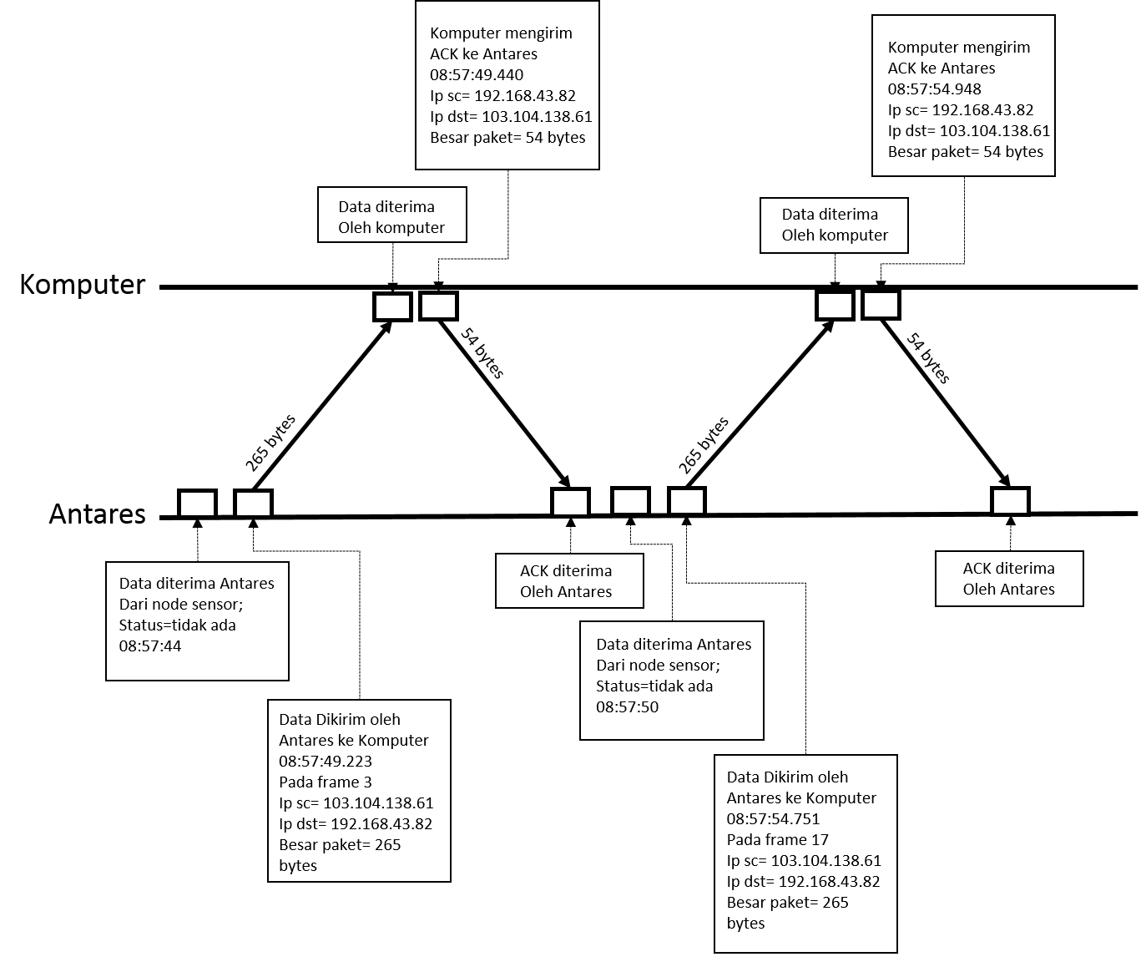

Figure 11. Data Transmission Process

Figure 11 describes the process of data transmission when Antares sends data to the computer until the computer sends an ACK to Antares. Data received by Antares from the sensor node at 08:57:44. Then Antares will send data to the computer. Data sent by Antares to the computer at 08: 57: 49,223 as frame 3. The size of the packet sent is 265 bytes. The source IP address is the Antares IP address 103.104.138.61 and the destination IP address is the computer IP address 192.168.43.82. The data is then received by the computer. After the computer receives data from Antares, the computer sends an ACK to Antares at 08: 57: 49,440 as frame 6. The size of the packet sent is 54 bytes*.*

1. *Web Monitoring Test Results for Smart Parking Systems*

This web monitoring system testing uses the black box method. This test aims to test the web functionality when the Smart Parking system is running [9]. The results of the black box web monitoring test are shown in Table 4.

Table 4. Black Box Web Monitoring Test Results

| **No** | **Detail Testing** | **Expected Results** | **Result Received** | **Conclusion** |
| --- | --- | --- | --- | --- |
| 1 | Users see the availability of parking space on the monitor screen before entering the parking lot | The web displays a parking area page that contains parking area information according to the conditions in the actual parking lot |  | Succeed |
| 2 | Cars entering the parking lot pass through sensor node 1 at the entrance | The number of cars on the web will increase by 1 | Before:    After: | Succeed |
| 3 | The user parks his car in the desired parking lot | The parking lot that the user wants will change color from green to red | Before:    After: | Succeed |
| 4 | The user has finished parking the car and has left the previously occupied parking lot | The parking lot that the user wants will change color from red to green | Before:    After: | Succeed |
| 5 | Cars exiting the parking lot pass through sensor node 1 at the exit | The number of cars on the web will decrease by 1 | Before:    After: | Succeed |

Based on table 4, the web-based monitoring system web testing is explained as follows:

1. When the parking lot is empty, the monitoring web display will display green parking plan information and the number of cars will display 0 (zero). The results of this condition are shown in Figure 12.

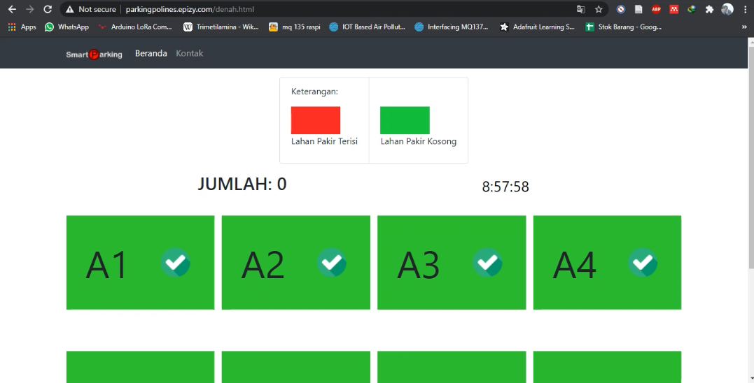

Figure 12. Monitoring Web Display When Parking Lot Are Empty

1. The driver passes the sensor node 1 at the parking entrance which functions to count the number of cars. Information on the number of cars on the web has increased by 1, as shown in Figure 13.

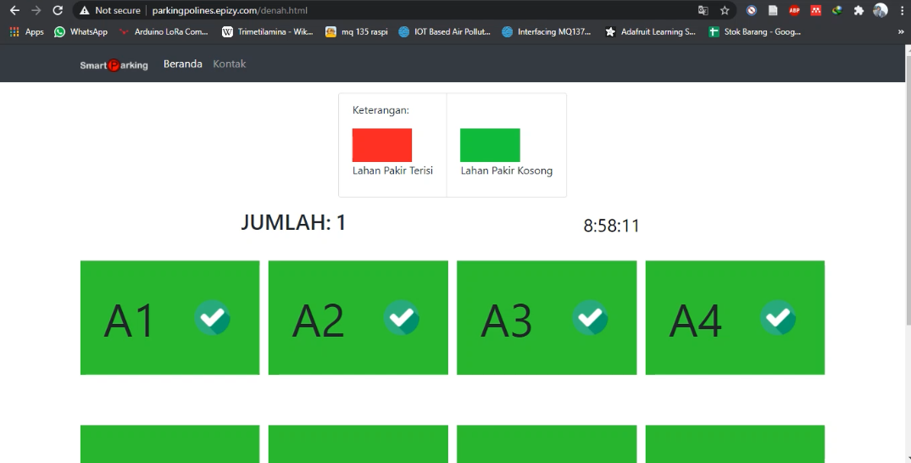

Figure 13. Display of the Number of Cars on the Monitoring Web Increases 1

1. Then the driver of the car will park his car in the desired parking lot. The color display of the parking lot plan on the monitoring web, which from green changes to red. Figure 14 shows the appearance of the monitoring web parking lot that is already filled with cars.

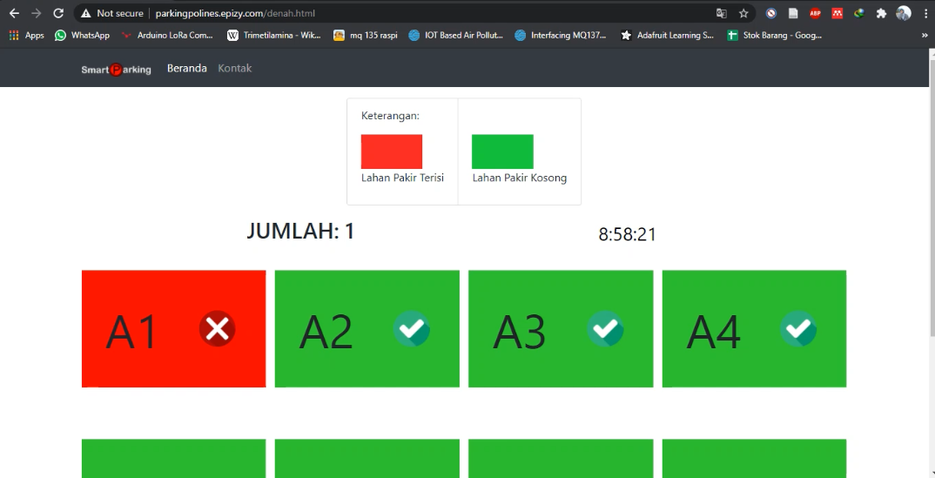

Figure 14. Display Color of the Parking Area Page on Web Monitoring when the Parking Lot Is Filled

1. After finishing parking, the driver will leave the parking lot. The color display of the parking lot plan on the web will change to green. Figure 15 shows the color display of the plan on the web monitoring when the parking lot is available again or is empty.

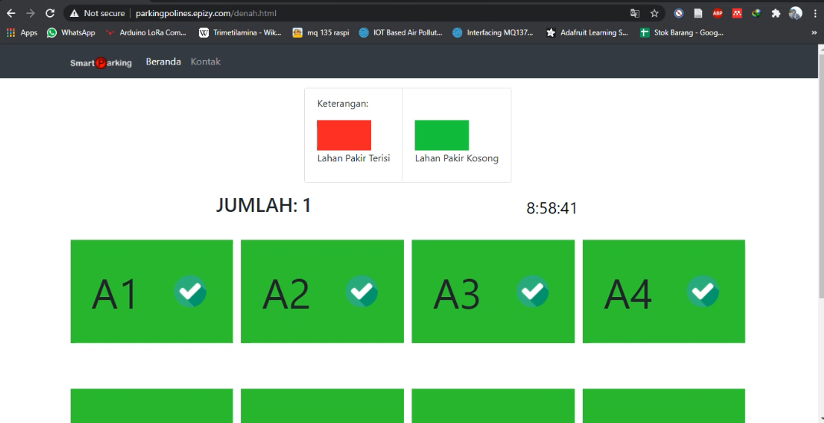 Figure 15. Display Color of the Parking Area Page on Web Monitoring when Parking Lot Is Available

1. Then when the car driver passes through the parking exit, the car driver will pass through sensor node 1 at the parking exit which serves to reduce the number of cars that leave the parking lot. The display of information on the number of cars on the monitoring web will decrease by 1, as shown in Figure 16.

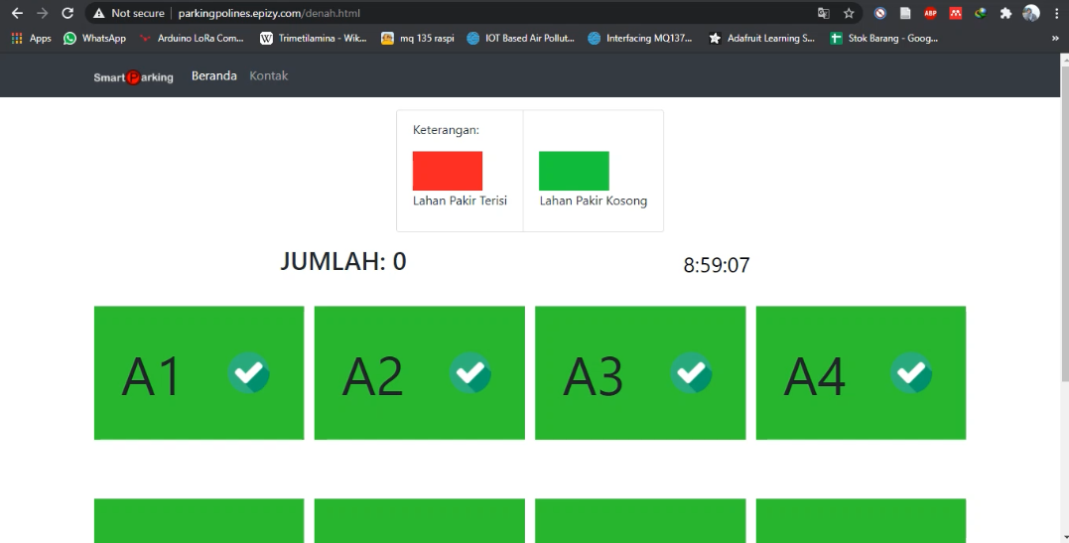

Figure 16. Display of the Number of Cars on the Monitoring Web Decrease 1

Based on the black box test on the 5 tests above, it explains the results of the monitoring system testing that can work following the functionality of the system. Testing the monitoring system as a whole gives the expected results.

1. **Conclusions and Suggestions**

Based on data collection, test results, and analysis that has been carried out, it can be concluded as follows:

1. The Smart Parking Monitoring System can run properly according to a design that can help motorists find empty parking lots.
2. Testing the propagation time that occurs during Antares sending data to the computer with the highest propagation time value of 5315 ms. The average propagation time that occurs during an interval of 1 minute 15 seconds and the data transmission interval of 5 seconds is 5053 ms.
3. Testing the propagation time that occurs during the process The computer receives data from Antares and sends ACKs to Antares with the highest propagation time value of 217 ms. The mean propagation time that occurs during an interval of 1 minute 15 seconds is 197,133 ms.

Some suggestions for improving this research are as follows :

1. The monitoring display needs to be added with other elements to make it look more informative, for example adding information on the image of a car number plate that occupies a parking area.
2. The monitoring system needs to be re-developed to a mobile-based monitoring system.

**Reference**

[1] R. Hafid Hardyanto, “Konsep Internet Of Things Pada Pembelajaran Berbasis Web,” *J. Din. Inform.*, vol. 6, no. 1, pp. 87–97, 2017.

[2] M. I. Mahali, “SMART DOOR LOCKS BASED ON INTERNET of THINGS CONCEPT WITH MOBILE BACKEND as a SERVICE,” vol. 1, no. November, pp. 171–181, 2016.

[3] “Badan Pusat Statistik.” [Online]. Available: https://www.bps.go.id/linkTableDinamis/view/id/1133. [Accessed: 16-Nov-2020].

[4] F. A. IMBIRI, N. TARYANA, and D. NATALIANA, “Implementasi Sistem Perparkiran Otomatis dengan Menentukan Posisi Parkir Berbasis RFId,” *ELKOMIKA J. Tek. Energi Elektr. Tek. Telekomun. Tek. Elektron.*, vol. 4, no. 1, p. 31, 2018.

[5] D. A. Limantara, Y. Cahyo, and S. W. Mudjanarko, “Pemodelan Sistem Pelacakan LOT Parkir Kosong Berbasis Sensor Ultrasonic Dan Internet Of Things ( IOT ) Pada Lahan Parkir Diluar Jalan,” *Semin. Nas. Sains dan Teknol.*, vol. 1, no. 2, pp. 1–10, 2017.

[6] A. Tidake, N. Doijad, P. Yelbhar, S. Koul, and P. Murkute, “The Smart Car Parking System Based on Iot Commanded by Android Application,” *IJSRD - Int. J. Sci. Res. Dev. Vol. 4, Issue 02, 2016*, vol. 4, no. 02, pp. 1649–1652, 2016.

[7] G. Y. Saputra, A. D. Afrizal, F. K. R. Mahfud, F. A. Pribadi, and F. J. Pamungkas, “Penerapan Protokol MQTT Pada Teknologi Wan (Studi Kasus Sistem Parkir Univeristas Brawijaya),” *Inform. Mulawarman J. Ilm. Ilmu Komput.*, vol. 12, no. 2, p. 69, 2017.

[8] “Qwords.” [Online]. Available: https://qwords.com/blog/apa-itu-latency/. [Accessed: 12-Nov-2020].

[9] M. Zia, “Penerapan Sistem Informasi Berbasis Web untuk Mendukung Pengelolaan Administrasi di Promusic Recording Studio Jepara,” *Siadin.Dinus.Ac.Id*, pp. 1–10, 2014.