Performance of Photovoltaic as Pump Drive for Alternator Characteristic Monitoring System

*Yusuf Dewantoro Herlambang*(1), Bono(1), Gatot Suwoto(1), Yanuar Mahfudz Safarudin(1), Ahmad Hamim Su’udy(1), Budhi Prasetiyo(1), Nanang Apriandi(1), Marliyati(2) ,*

*1Department of Mechanical Engineering, Politeknik Negeri Semarang, Indonesia*

*2Department of Accounting, Politeknik Negeri Semarang, Indonesia*

*Jl. Prof. H. Sudarto, SH., Tembalang, 50275, Semarang, Indonesia*

*Email address: *masyusufdh@polines.ac.id*

***Abstract*—The objectives of this research to generate electrical energy by making photovoltaic which utilizes the potential of solar radiation sources to drive the pump. There are 2 monocrystalline solar panels installed with a capacity of 100 Wp. Installation of solar panels at an angle of 7° based on geographic location in the Tambakboyo, Ambarawa, -7.263239"(Latitude) South Latitude and 110°42'06.82 (Longitude) East Longitude. The test is carried out by turning on the pump for 1 hour within a period of time until 7 days. The parameters measured in the test are solar radiation data (W/m²), voltage (V) and current (A) input from solar panels, battery input voltage, voltage and current input from the inverter, as well as the output voltage and current from the inverter. The results of test obtained the highest efficiency value of 12.854% at a voltage of 12.58 V and a current of 10.4 A.**

***Keywords—Efficiency, power density, voltage, electric current, Floating PV***

1. INTRODUCTION

Indonesia is a tropical country that receives sunlight throughout the year. Indonesia is located at the coordinates of 6°N - 11°08' N and 95°'E - 141°45' E, where based on these coordinates, Indonesia is right on the equator [1-3]. This location is very favourable because then Indonesia has an abundant source of solar energy. Solar energy entering the atmosphere has an average power density of 1.2 kW/m², but only 560 W/m² is absorbed by the earth. Based on the above figures, the solar energy that can be generated for the entire Indonesian land area of ± 2 million km² is 5,108 MW [4-5]. Related to energy sources, there are many sources of electrical energy in Indonesia, including Hydroelectric Power Plants (PLTA) which are sourced from water, Steam Gas Power Plants (PLTGU) which are derived from natural gas, Wind Power Plants (PLTB) which are sourced from wind, Waste Power Plants (PLTSA) which are sourced from waste and Solar Power Plants (PLTS) which are sourced from the sun. Solar Power Plant (PLTS) is a new innovation and solution to the problem of Indonesia's electricity needs. Solar radiation energy is converted into electrical energy by using solar power plants or also called photovoltaic technology made of semi-conductor materials, called solar cells [6-8]. The construction of PLTS can be on a small scale and can also be on a large scale.

This development is adjusted to the needs. PLTS development on a small scale is usually used to meet the electricity needs of housing or often called solar home system (SHS), water pumps, television communications, and others [9-11]. While the construction of PLTS on a large scale can be used to meet the electricity needs of 1 village. However, the greater the power generated, the greater the need for land for power plants [12-15]. Floating solar power systems can be one solution to overcome land requirements. One of the effective places for the construction of this floating PLTS is ponds. Ponds in fisheries are artificial ponds, usually in coastal areas filled with water and used as a means of aquaculture. The animals cultivated are aquatic animals, especially fish, shrimp, and shellfish [16-20]. The term "pond" is usually associated with brackish water or sea water. This is an advantage of floating solar power plants for Indonesia to be applied on a large scale because most of its territory is water because it can save land and not reduce residential land.

1. METHODS

The research method used is divided into several stages, including the observation method to obtain the materials and tools needed in the process of making testing equipment, the literature study method to collect theoretical foundations and previous research related to floating type solar power plants. Literature studies are carried out by looking for books, journals in libraries and on the internet or other places that can support the writing of this research. The next method is the application method, which is to carry out the stage of working on the tool Then in the testing section there is a performance test method, which is a method where the stages of working on the tool have been completed and are ready for testing to find out the extent to which the tool can work.

The parameters measured are current (Ampere) and voltage (Volt) on the panel, battery inlet voltage (Volt), current (Ampere) and voltage (Volt) inverter input, current (Ampere) and voltage (Volt) inverter output, and sunlight radiation (W/m²). Then the parameters in data processing include [21-23]:

1. Solar panel cross-sectional area

A = p x l

where, A = Panel cross-sectional area (m²), p = Panel length (m), and l = Panel width (m).

1. Solar panel input power

P_in = Ir x A

where, P_in = Input power of solar panel (W), Ir = Measured solar intensityDescription: P_in = Input power of solar panel (W), Ir = Measured solar intensity (W/m²), A = Effective area of photovoltaic module (m²), A = Effective area of photovoltaic module (m²)

1. Total load in Watt-hour

EB = Pin x length of use the pump

EB = Total load (Watt-hour), Pin = Input power (W), pump usage time = 1 hour

1. System load supplied

EA = 33,3 % x EB

EA = System load (W hour), EB = Total load (W hour)

1. Assumptions of loss

The assumption of losses in the system is considered 15% because the system used is still new. (Abdul Hafid et al, 2017)

ET = EA + System losses

ET = EA + (15% x EA)

ET = Total energy consumption (W hour), EA = System load (Watt-hour)

6. Solar Panel Output Power

Pout = V x I

where, P_out = Panel output power (W), V = Panel voltage (V), I = Panel current (A)

7. Efficiency of solar panel

η = P_out/Pin x 100%

where, η = Solar panel efficiency (%), P_out = Solar panel output power (W), P_in = solar panel input power (W).

The research stages are shown in a research flow chart to make it easier to understand the stages of research work. The research stages start from literature search, design, manufacture, testing, calculation of test result data, and analysis.

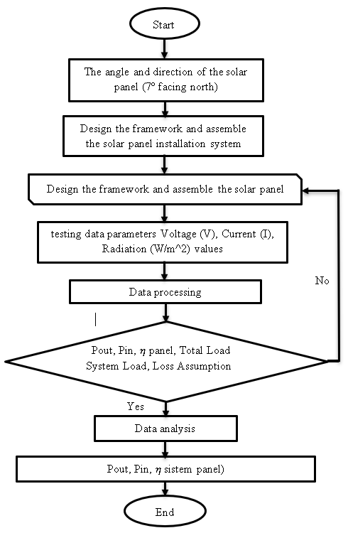

Figure 1. Flow chart for testing of floating solar panel

1. RESULTS AND DISCUSSION

Testing was carried out for 1 hour of pump start-up at 12.15-13.15 WIB with a period of 7 days, starting from 25 Juli until 4th August 2023, in Table 1.

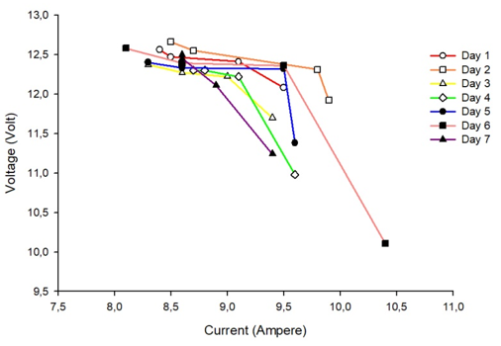

Figure 2. Characteristic relationship between voltage and current on the panel

Figure 2 shows that the amount of voltage coming out of the panel is proportional to the current generated. Where the highest voltage value achieved was 12.66 Volts with a current of 9.9 Amperes on 26 July. While the lowest voltage value generated from the panel was 10.11 Volts with a current of 8.1 Amperes on 1 August (day 6). The above is influenced by the factor of irradiation of solar panels by sunlight which produces electrical energy and is then supplied to the inverter, but the current and voltage produced are not constant due to the influence of sunlight radiation that illuminates the solar panels unstable. From this statement it can be concluded that the greater the value of solar radiation, the higher the value of voltage and current because it is influenced by the heat of the panel surface which if the radiation is high, the heat of the panel surface is higher. The voltage and current of the panel output only depends on the amount of radiation intensity received by the panel surface, but changes in temperature on the surface of the solar panel can also affect the decrease in the output voltage of the solar cell.

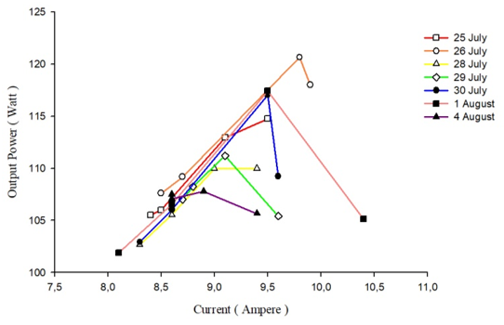

Figure 3. Characteristics output power and electric current

The relationship between output power and current on the panel in figure 3 shows that the output power and current changes are proportional to the current, because through the theory of calculating the output power is obtained from the multiplication of voltage and current so that if with the same voltage value and different currents, the amount of output power depends on the value of the current, what happens is the greater the value of the current. This is proven directly through testing the Floating Solar Power Plant in the field and the results of the graph show the same thing that is between the output power and the current value is comparable, if the current value is getting smaller than the output power value is also small and vice versa. One of the graphs that experienced the biggest change and was different among other graphs was the graph on 1 August, namely from 12.15 sequentially until 13. 15 with an interval of 15 minutes, namely with a current value of 10.4 Amperes with a panel output power value of 130.832 W; 9.5 Amperes with an output power value of 117.705 W; 8.6 Amperes with an output power value of 106.296 Amperes; and with a current of 8.1 Amperes with an output power value of 81.891 W. The highest current value occurred at 12.15-12.30 with a value of 10.4 Amperes and the lowest current value occurred at 13.00-13.15 with a value of 8.1 Amperes. Too drastic an increase at this time will affect the value of efficiency, because the output power is very influential on the value of efficiency.

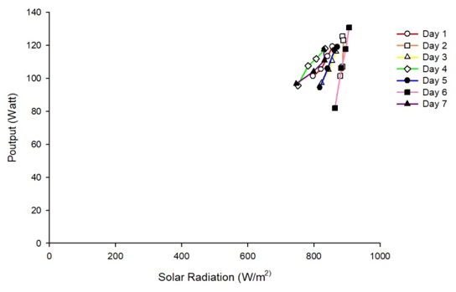

Figure 4. Characteristics of output power and solar radiation

The relationship between output power and solar radiation shown in figure 4. The graph tends to rise, so it can be concluded that the value between output power and solar radiation is directly proportional. However, on the graphs of 26 July (2nd day) and 4 August (7th day), the latter increase is inversely proportional, namely the output power is getting higher but the solar radiation decreases, resulting in the same thing as the output power occurs in large efficiency. This is because at the time of testing, the increase in the graph occurred due to the cloud factor that covered the sun for a moment, so that the radiation value was reduced but the current and voltage values were still high, resulting in a high output power value. This helps the panel reduce the temperature on its surface so that the conversion performance from solar radiation to voltage and current is more optimal.

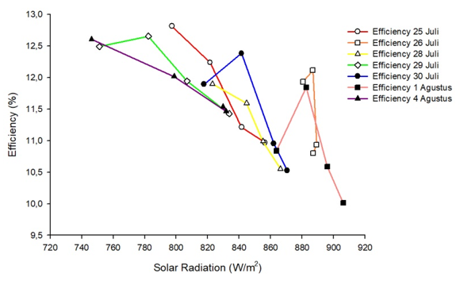

Figure 5. Characteristics of efficiency and solar radiation

Figure 5 shows the relationship between efficiency and solar radiation, the graph tends to rise, so it can be concluded that the value between efficiency and solar radiation is directly proportional. However, on the graphs of 26 July (2nd day) and 4 August (7th day), the latter increase is inversely proportional, i.e. the efficiency is getting higher but the solar radiation is decreasing. This is because at the time of testing, the increase in the graph occurred due to the cloud factor that covered the sun for a moment, so that the radiation value was reduced but the current and voltage values were still high. This helps the panel reduce the temperature on its surface so that the conversion performance from solar radiation to voltage and current is more optimal. This is reinforced by several previous studies which state that the output voltage of the panel does not only depend on the amount of radiation intensity received by the panel surface, but changes in temperature on the surface of the solar panel can also reduce the output voltage of the solar cell.

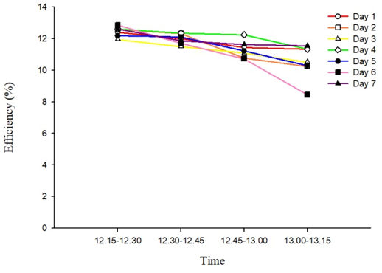

Figure 6. Characteristics of efficiency and time

The relationship between panel efficiency and time as shown in figure 6. It is clear that testing from 12.15 to 13. with an interval of 15 minutes the resulting efficiency decreases. This is because the longer the use of 15 pumps, the voltage and current on the panel decreases due to the decreasing radiation factor. In the graph above there is one very drastic decrease in efficiency which occurred on 1 August (day 6) with the highest value of 12.854% and the lowest value of 8.441%, thus affecting the overall average efficiency value on that day and the lowest average efficiency data occurred on 1 August (day 6). This is because the sharpness of the graph on this date is the highest, therefore for the calculation of average daily efficiency produces the lowest value of 10.89%.

1. CONCLUSION

Based on the results of data collection and analyses that have been carried out, the following conclusions are obtained: (1) Based on the planning that has been done, the floating PLTS test equipment is produced in accordance with the calculations both in terms of flotation and a tilt angle of 7 °; (2) Based on the tests that have been carried out, the highest voltage value coming out of the panel was obtained on 1 August (day 6) at 12.15-12.30 at 12.58 Volts and the highest current of 10.4 Amperes. So as to produce an output power of 130.832 W with an efficiency value of 12.854%. This is influenced by the weather which affects the value of solar radiation, namely the greater the radiation value, the better the ability of the panel to convert and produce higher system efficiency; (3) Floating Type Off-Grid Solar Power Plant with a Capacity of 200 Wp is able to turn on a 125 W water pump for 1 hour.

ACKNOWLEDGMENT

The authors would like to thank P3M Politeknik Negeri Semarang for funding the Penelitian Terapan Pratama (PTP) 2023. This programme was assisted by 4 students (Feni Fidiyani, Ifafah Khoirinah, Marnoto, and Michael Carlos).

REFERENCES

[1] H. Kristiawan, I. N. S. Kumara, and I. A. D. Giriantari, “Potensi Pembangkit Listrik Tenaga Surya Atap Gedung Sekolah di Kota Denpasar,” J. SPEKTRUM, vol. 6, no. 4, p. 66, 2019, doi:10.24843/spektrum.2019.v06.i04.p10.

[2] Ö. Gönül, A. C. Duman, B. Barutçu, and Ö. Güler, “Techno-economic analysis of PV systems with manually adjustable tilt mechanisms,” Eng. Sci. Technol. an Int. J., vol. 35, 2022, doi:10.1016/j.jestch.2022.101116.

[3] Herlambang, Y.D., Supriyo, S., Prasetiyo, B., Improved Savonius double blade performance using modified blade shaped with variations of the wind flow ratios on the blade inlet and outlet side. IOP Conf. Series: Materials Science and Engineering, Proceeding of International Conference on Innovation in Science and Technology (ICIST); 17-18 Desember 2019; Indonesia, IOP Publishing; 1108 (1). p 012041.

[4] Herlambang, Y.D., Supriyo, S., Prasetiyo, B., Wahyono, W., dan Mulud, T.H., Model turbin angin airfoil NACA 4418 terhadap variasi bukaan sudut sudu pada kecepatan angin berbeda. Jurnal Integrasi. 2019 Oktober; 11 (2): p. 97-102. [6] Herlambang, Y.D., Margana, M., Safarudin, Y.M., Yosintaska, Y., Yusarindra, N., Wibowo, R.R., Cahya, Y.T.I., Model alat ukur kecepatan angina rah angin dan intensitas radiasi matahari. Eksergi Jurnal Teknik Energi. 2020 Mei: 16 (2): p. 80-91.

[5] Herlambang, Y.D., Hendrawati, D., Agustin, A.D., Kusuma, K.A., Wahyuningsih, S., Wigiantoro, W., Model turbin angin Savonius untuk meningkatkan kinerja PLTB. Eksergi Jurnal Teknik Energi. 2020 Januari; 16 (1): p. 35-39.

[6] S. Home, S. Shs, O. Grid, F. Dan, and D. Solusi, “Solar Home System Off Grid (SHS ),” no. 021.

[7] S. Oliveira-Pinto and J. Stokkermans, “Assessment of the potential of different floating solar technologies – Overview and analysis of different case studies,” Energy Convers. Manag., vol. 211, no. November 2019, pp.112747, 2020, doi: 10.1016/j.enconman.2020.112747.

[8] Harmini, T. Nurhayati, A. K. N, and A. Margiantono, “Instalasi Solar Home Sistem Pembangkit Listrik Tenaga Surya Sebagai Sumber Energi Alternatif di SMK Palapa Semarang,” E-Prosiding Semin. Nas. Has. Pengabdi. Kpd. Masy., vol. 4, no. 1, pp. 119–122, 2022.

[9] Herlambang, Y.D., Wahyono, W., Rancang bangun turbin angin poros horizontal 9 sudu flat dengan variasi rasio lebar sudu top dan bottom untuk meningkatkan kinerja turbin. Eksergi Jurnal Teknik Energi. 2019 Mei; 15 (2): p. 70-76.

[10] Herlambang, Y.D., Surindra, M.D., Safarudin, Y.M., Pembuatan turbin double Spherical sebagai upaya memperbaiki kinerja turbin Spherical. Eksergi Jurnal Teknik Energi. 2018 September; 14 (3): p. 59-65.

[11] B. Shyam and P. Kanakasabapathy, “Feasibility of floating solar PV integrated pumped storage system for a grid-connected microgrid under static time of day tariff environment: A case study from India,” Renew.Energy, vol. 192, pp. 200–215, 2022, doi: 10.1016/j.renene.2022.04.031.

[12] N. R. Alham, F. H. Rumawan, M. Muslimin, R. M. Utomo, and A.Maulana, “Aplikasi Photovoltaic Cell (Pv) Terhadap Variasi Beban Elektrik Sebagai Energi Alternatif,” J. Tek. Elektro Uniba (JTE UNIBA), vol. 5, no. 2, pp. 123–129, 2021, doi: 10.36277/jteuniba.v5i2.92.

[13] F. Ayu, F. Sugiono, P. D. Larasati, and A. Karuniawan, “PENGARUH SUDUT KEMIRINGAN PANEL SURYA TERHADAP POTENSI PEMANFAATAN PLTS ROOFTOP DI BENGKEL TEKNIK MESIN , POLITEKNIK NEGERI SEMARANG,” vol. 01, no. 01, pp. 1–8, 2022.

[14] B. Sutanto, Y. D. Herlambang, B. Bono, A. S. Alfauzi, and D. A. Munawwaroh, “Optimalisasi Arah Sudut Tilt Dan Sudut Azimuth Dari Alat Pemanen Energi Radiasi Matahari Di Semarang, Jawa Tengah,”12 A. B. One and X. Y. Two, Journal of Engineering Science and Technology Month Year, Vol. XX(Y)Eksergi, vol. 17, no. 2, p. 145, 2021, doi: 10.32497/eksergi.v17i2.2545.

[15] F. Husnayain, “Analisis rancang bangun PLTS ON-Grid hibrid baterai dengan PVSYST pada kantin teknik FTUI,” Electrices, vol. 2, no. 1, pp.21–29, 2020, doi: 10.32722/ees.v2i1.2846.

[16] Herlambang, Y. D. & Suwarti, (2013). Model Turbin Savonius 1-Tingkat Sebagai Penggerak Mula Pompa Air tanpa Bahan Bakar untuk Pengairan. Eksergi Jurnal Teknik Energi. 9 (1): 18-23.

[17] Herlambang, Y.D., Hendrawati, D., Sudjito, S., Turbin angin vertical sudu aerofoil NACA 0018 series berbasis konstruksi helical/twist terhadap variasi sudut sudu. Eksergi Jurnal Teknik Energi. 2017 September; 13 (3): p. 92-101.

[18] Herlambang, Y.D., Suwarti, S., Model turbin Savonius 1-tingkat sebagai penggerak mula pompa air tanpa bahan bakar untuk pengairan. Eksergi Jurnal Teknik Energi. 2013 Januari; 9 (1): p. 18-23.

[19] Z. Arifin, A. J. Tamamy, and N. Islahu, “Perancangan Mesin Pompa Air Tenaga Surya untuk Mengurangi Konsumsi Listrik Skala Rumahan,” J.Nas. Tek. Elektro, vol. 9, no. 2, p. 79, 2020, doi:10.25077/jnte.v9n2.758.2020.

[20] M. P. Hamzah; Halilintar, “Penggunaan Solar Home System (Shs) Pada Sistem Kelistrikan Fakultas Teknik Universitas Lancang Kuning Pekanbaru,” pp. 1–59, 2016.

[21] D. D. Behera, S. S. Das, S. P. Mishra, R. C. Mohanty, A. M. Mohanty, and B. B. Nayak, “Simulation of solar operated grass cutting machine using PVSYST software,” Mater. Today Proc., vol. 62, pp. 3044–3050, 2022, doi: 10.1016/j.matpr.2022.03.175.

[22] J. Qin and E. Hu, “The Impact of Solar Radiation on the Annual Net Solar to Power Efficiency of a Solar Aided Power Generation Plant with Twelve Possible ‘configuration-operation’ Combinations,” Energy Procedia, vol.105, pp. 149–154, 2017, doi: 10.1016/j.egypro.2017.03.294.

[23] D. Govindasamy and A. Kumar, “Experimental analysis of solar panel efficiency improvement with composite phase change materials,” Renew.Energy, vol. 212, no. January, pp. 175–184, 2023, doi:10.1016/j.renene.2023.05.028.