[1]

Effectiveness of Brackish Water Desalination Using Reverse Osmosis System for Industrial Water Treatment at PLTU PT Bintan Alumina Indonesia

**Yosia Putra Saroha Simanjuntak1, M.Prihadi Eko Wahyudi2**

1Politeknik Negri Batam, Batam, Indonesia

*Email: yosiaputra25@gmail.com

***Abstract- Demineralized water is water that does not contain high minerals or chemicals, and is used as feed to the boiler to produce steam. Demineralized water is very important in the PLTU (Steam Power Plant) industry because steam is produced through the process of changing the phase of water to steam. Natural water tends to be corrosive because it contains minerals such as high calcium and magnesium, which can cause scale in the boiler and reduce energy efficiency. Therefore, these minerals must be removed from the water so that they can be used as boiler feed. To produce demin water, PT. BAI uses a Water Treatment Plant (WTP) system which consists of several stages, such as a clarifier, a three-layer filter, an automatic cleaning filter, ultra-filtration and reverse osmosis. After going through these processes, demin water is stored in tanks and then flowed to the main plant. There are several factors that can interfere with the demin water production process at PT. BAI, including changes in water quality, problems with WTP equipment, and disturbances in the water distribution system. This study aims to maintain the reliability and efficiency of the demin water production process, by carrying out routine maintenance on equipment, monitoring water quality by checking conductivity, pH levels, and produced water. Then from the data obtained it can be seen that the efficiency of demin water has met the operating standards and procedures set by PT.BAI, namely desalination levels above 90%. The division must also always be ready to deal with problems that occur and take preventive actions to prevent disruption to the production process.***

***Keywords-* *Demineralized water, boiler feed, PLTU, Water Treatment Plant, reverse osmosis.***

1. INTRODUCTION

In the PLTU industry, the use of demineral water is a basic need. This type of water is used as feed to the boiler to produce steam to drive the turbine pump. Demineralized water has plays

# a vital role because steam is produced through the process of changing the water phase to vapor or water vapor. Reverse osmosis is a filtering method that can filter large molecules and ions from a solution by applying pressure to the solution when the solution is on one side of the selection membrane (filter layer). Osmosis is the process of moving water from a solution with a low concentration to a solution with a high concentration due to osmotic pressure.[6] This transfer process is through a semi-permeable membrane, where the process of water transfer will stop after the concentration of the two solutions is equal. RO requires a hydrostatic pressure greater than the difference in osmotic pressure so that water can flow from a solution with a higher concentration through a semipermeable membrane [1]

# II. METODE

This research was designed according to the theoretical basis that has been stated, where these leading theories have become a guide in conducting this research. The design of this research cannot be separated from the regulations of PT Bintan Alumina Indonesia as the location for the research. This flowchart contains a description of the steps that need to be taken to complete this research.

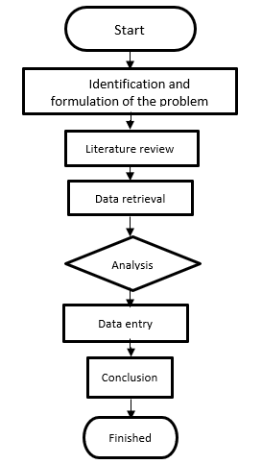

Fig. 1. Research flow chart

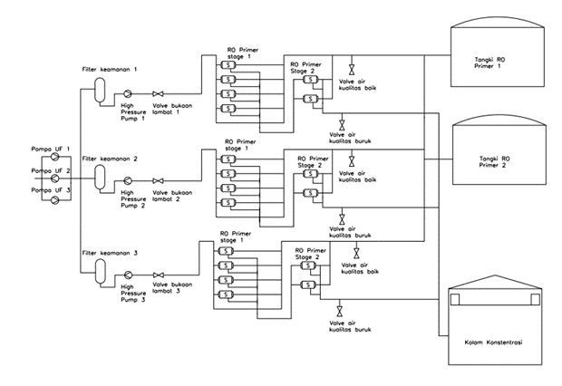

Fig. 2. Primary RO production system

From the Primary Reverse Osmosis pump it flows into the security filter then flows again to the High Pressure Pump, after from the High Pressure Pump water through a slow opening Valve is then flowed to the first stage Secondary RO. water that meets the standards will enter the Secondary RO tank and water with poor quality will be sent back to the Primary RO tank

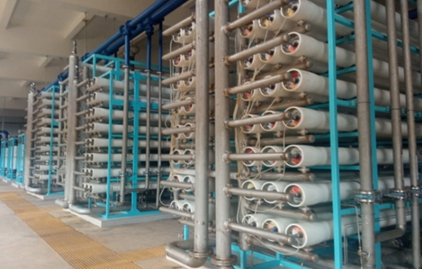

Fig. 3. Reverse Osmosis at PLTU PT BAI

# III.RESULTS AND DISCUSSION

The results obtained in this study include several stages, starting from the stages of data collection, data processing and data analysis. These results can be seen as follows:

*Table 1. Average of High Pressure Pump*

|  |  |  |  |  |
| --- | --- | --- | --- | --- |
| Variable | Research date | *Mean* of one week of research | Deviation | Squared Deviation |
| High Preassure Pump | 1 | 0,79 | 0,04 | 0,0016 |
| 2 | 0,67 | -0,07 | 0,0049 |
| 3 | 0,80 | 0,05 | 0,0025 |
| 4 | 0,73 | -0,01 | 0,0001 |
| 5 | 0,76 | 0,008 | 0,000064 |
| 6 | 0,74 | -0,007 | 0,000049 |
| K=6 | | 4,52 | 0,011 | 0,009 |
| Xbar | | 0,75 |

Absolute error = $\sqrt{\frac{0,009}{6-1}}=0,0018$

Relative error = $\frac{0,0018}{0,75}x100\%=0,24$%

The measurement results of the conductivity of RO inlet water are obtained: $x=\overline{x}+S_{x}$

$x=\left(0,75±0,0018\right) atau x=($ 0,75 $±0,24\%$)

Based on the data above, the average High Pressure Pump is 0.75 MPa and the maximum pressure is on the 3rd day with a value of 0.8 MPa and the minimum pressure value is on the 2nd day, which is 0.67 MPa. The data above is still within the minimum pressure limit of 1.03 Mpa.

Table 2. Average of RO inlet water Conductivity

|  |  |  |  |  |
| --- | --- | --- | --- | --- |
| Variable | Research date | Mean of one week of research | Deviation | Squared Deviation |
| RO inlet water conductivity | 1 | 36,34 | 4,66 | 21,74 |
| 2 | 30,03 | -1,64 | 2,71 |
| 3 | 34,34 | 2,66 | 7,09 |
| 4 | 30,05 | -1,62 | 2,64 |
| 5 | 29,7 | -1,97 | 3,90 |
| 6 | 29,6 | -2,07 | 4,31 |
| K=6 | | 190,1 | 0,02 | 42,41 |
| Xbar | | 31,68 |

Absolute error = $\sqrt{\frac{42,41}{6-1}}=$ 8,48

Relative error = $\frac{8,48}{31,68}x100\%=26,76$%

The measurement results of the conductivity of RO inlet water are obtained: $x=\overline{x}+S_{x}$

$x=\left(31,68±8,48\right) atau x=($ 31,68 $±26,76\%$)

The average RO inlet water conductivity above can be seen that the highest RO inlet water conductivity is on the 1st production day and on the 4th – 6th production day the RO inlet water conductivity is normal. Days 1-2 there was a significant decrease and on days 2-3 there was an increase and days 3-4 there was a decrease. This decrease occurs because the pressure from the high pressure pump is not stable.

Table 3. Average of Conductivity of RO exit water

|  |  |  |  |  |
| --- | --- | --- | --- | --- |
| Variable | Research date | *Mean of one week of research* | Deviation | Squared Deviation |
| konduktiviti air keluar RO | 1 | 1,84 | -0,27 | 0,073 |
| 2 | 2,32 | 0,20 | 0,043 |
| 3 | 2,14 | 0,02 | 0,00080 |
| 4 | 2,09 | -0,02 | 0,00046 |
| 5 | 2,09 | -0,02 | 0,00046 |
| 6 | 2,19 | 0,07 | 0,0061 |
| K=6 | | 12,67 | -0,02 | 0,12 |
| Xbar | | 2,11 |

Absolute error = $\sqrt{\frac{0,12}{6-1}}=0,024$

Relative error = $\frac{0,024}{2,11}x100\%=1,13$%

The measurement results of the conductivity of RO inlet water are obtained: $x=\overline{x}+S_{x}$

$x=\left(2,11±0,024\right) atau x=($ 2,11 $±1,13\%$)

The average RO water conductivity above can be seen that the highest RO water conductivity is on the 2nd production day and on the 1st – 2nd production day the RO water conductivity increases. Days 2-5 there was a significant decrease and on days 5-6 there was an increase. This decrease occurs because the pressure from the high pressure pump is not stable.

Tabel 4. Hasil monitoring RO bulan Oktober

|  |  |  |  |  |
| --- | --- | --- | --- | --- |
| **RO** | **Parameter** | **Limitation** | **Average** | **information** |
| Air *input* RO Primer | FRC *Feed* (ppm) | <0,1 | 0,02 | within limits |
| Kekeruhan (NTU) | <0,5 | 0,38 | within limits |
| SDI μ | <4 μ | 0,98 | within limits |
| *Feed Flow (m3/h)* | - | 267,18 | within limits |
| *Air hasil Produksi (m3/h)* | 196 | 179 | 91% from maximum capacity |
| *Recovery%* | 40 | 45,2 | within limits |
| *TDS Feed (ppm)* | 1000 | 789 | within limits |
| *TDS Permeate (ppm)* | 500 | 344,64 | within limits |
| *Salt rejection%* | 98 | 98,81 | within limits |
| *Differential Pressure (bar)* | 2,07 | 1,91 | within limits |
| *FRC Feed (ppm)* | <0,1 | 0,03 | within limits |
| Air input RO sekunder | Kekeruhan (NTU) | <0,5 | 0,18 | within limits |
| SDI | <4 | 0,88 | within limits |
| *Feed Flow* (m3/h) | - | 267,18 | within limits |
| Air hasil Produksi (m3/h) | 175 | 159 | 90,85% from maximum capacity |
| *Recovery %* | 40 | 51,2 | within limits |
| *TDS Feed (ppm)* | 1000 | 859 | within limits |
| *TDS Permeate (ppm)* | 500 | 316,84 | within limits |
| *Salt rejection%* | 98 | 98,11 | within limits |
| *Differential Pressure* (bar) | 2,07 | 1,41 | within limits |

From the data above, in October the Primary RO unit and Secondary RO unit operated well or produced an average of 91% for Primary RO and 90.85% for Secondary RO from design capacity. On non-October primary and secondary ROs do not operate every day because not all boilers operate so sometimes the RO system is only in a standby state.

Table 5. Perbandingan nilai Efesiensi dari konduktivitas

|  |  |  |  |
| --- | --- | --- | --- |
| Incoming water conductivity | Water conductivity out | Actual Efficiency | theoretical |
| 36,34 | 1,84 | 95% | 90% |
| 30,03 | 2,32 | 92% | 90% |
| 34,34 | 2,14 | 93% | 90% |
| 30,05 | 2,09 | 93% | 90% |
| 29,7 | 2,09 | 93% | 90% |
| 29,6 | 2,19 | 93% | 90% |

In table 5 the actual efficiency value is obtained and the average value of 6 days of production achieves a desalination rate above 90% with an actual efficiency value 3% higher. So it can be concluded that the reverse osmosis system has increased efficiency. Based on the research that has been done, the increase in efficiency occurs because there are several factors that are maintained by the rate of water entering, the rate of water leaving and also the addition of anti-scale drugs. Anti-scale is dispersive, which increases the Langelier index LST index in raw water from 0 to 2.6, by controlling the input of 3mg/L anti-scale is sufficient to ensure that scale does not occur.

Fig. 4. Permeate flow chart

Based on the Permeate Flow chart above, it can be explained that the minimum production water value is on the 7th day with a production water value of 131 m3/h and the maximum production water value is on the 19th day with a production water value of 189 m3/h. So based on the minimum and maximum values ​​that can be seen in the graph above, the value of water produced by PT Bintan Alumina Indonesia has met the specification standards set by the company with a predetermined standard value of 196 m3/h.

# IV. CONCLUSION

1. The actual efficiency value is obtained and the average value of 6 days of production reaches a desalination rate above 90% with an actual efficiency value higher by 3%. So it can be concluded that the reverse osmosis system has increased efficiency.

2. The influence of the high pressure pump, conductivity, and pH are in accordance with PT.BAI operational standards.

3. If the conductivity is bad or below the standard desired by PT Bintan Alumina Indonesia, it must be backwashed..

REFERENCES

[1] Malik Maulana, Abdul and Widodo, Ariyanto S (2009) Pengolahan Air Produk Reverse Osmosis Sebagai Umpan Boiler Dengan Menggunakan Ion exchange.

[2] M. Ivan Mahdi, “ Kualitas air Indonesia memburuk pada 2021”

[3] Rositayanti Hadisoebroto, “KAJIAN POLA PEMAKAIAN AIR BERSIH DI TIGA APARTEMEN DI JAKARTA” Trisakti, Jakarta Barat, 2009.

[4] ELSYA ARILY YUNANDA,” DESALINASI AIR PAYAU MENJADI AIR BERSIH

DENGAN MENGGUNAKAN METODE REVERSE OSMOSIS”ITS, Surabaya, 2017.

[5] Suryadi, “Analisa Teknis Ekonomis Perencanaan Sistem Reverse Osmosis Untuk Kebutuhan,” ITS, Surabaya, 2011.

[6] Lanxess, principle of reverse osmosis membrane separation, Deutschland, 2013.

[7] I. n. w. Linda A.Yoshi, “Sistem Desalinasi Membran Reverse Osmosis (RO) untuk Penyediaan air bersih,” 2016.

[8] Horas Tiopan Sanjaya “PERANCANGAN SISTEM DESALINASI MENGGUNAKAN METODE REVERSE OSMOSIS PADA KAPAL RO-RO FERRY 5000 GT” ITS, 2018.

[9] Aan Sefentry, Rully Masriatini “PEMANFAATAN TEKNOLOGI MEMBRAN REVERSE OSMOSIS (RO) PADA PROSES PENGOLAHAN AIR LAUT MENJADI AIR BERSIH” , Universitas PGRI Palembang, 2020.

[10] Muhammad Ali Irfan, Djoko Wahyudi, Indro Wicaksono “Analisis Pengaruh Tekanan Membran Terhadap Kinerja Reverse Osmosis PLTU Paiton Unit 9”,Universitas Panca Marga, 2017.

[11] Suardi, Rudi.2001. Sistem Manajemen Mutu ISO 9000:2000 , PPM, Jakarta.

[12] Iqbal, Farid. 2014. Reverse Osmosis. Water treatment plant, Jakarta.e Limited.

[13] C.B. Rasrendra & Hanggara Sukandar, 2002, Desalinasi dengan Reverse Osmosis Tekanan Rendah, Departemen Teknik Kimia Institut Teknologi Bandung.

1.