Study of solar power plants as an aerator driver based on the Internet of Things (IoT)

Margana*(1), Wahyono (2), Baktiyar Mei Hermawan (3), Wiwik Purwati W (4) , Suwarti (5), Nur Fatowil Aulia (6) Akhmad Riadzus Solikhin (7)

1,2,3,4,5,6 Department of Mechanical Engineering, Politeknik Negeri Semarang, Semarang, Indonesia

Email address : **\*** **margana@polines.ac.id**

***Abstract – The use of solar power plants is now developing, for example aerator drives with the Internet of Things. The purpose of designing aerators with the Internet of Things is to utilize programming instructions that each command can generate interaction with fellow devices and connect automatically without user intervention, even remotely. This research method begins with the study of literature, manufacture, installation of components, as an analysis carried out testing and data collection. The results of the tests conducted on day 5 include, the best solar radiation intensity power of 886.786 W/m2, the power produced by solar cells of 473.099 W and aerator power of 75.843 W, solar panel efficiency of 14.749%. and PLTS system efficiency of 4.275%.*** ***In this test, it was found that the addition of aeration can increase oxygen concentration and pH value of water.***

***Keywords- Aerator, PLTS, Performance***

1. INTRODUCTION

Solar Power Plant (PLTS) is one type of plant produced from new renewable energy (EBT) derived from solar energy. Solar energy is easily available in nature and environmentally friendly because it does not produce CO2 emissions. Indonesia is a country with sunlight that irradiates almost all year round.

According to the Meteorology, Climatology and Geophysics Agency (BMKG) the level of radiation that falls on the Indonesian region, especially the Java Island area is 2.0 – 6.4 kWh m2. [1] The use of PLTS can be applied to fish pond aerators. The aerator has a function to add oxygen to the fish pond. One of the factors that can affect fish ponds is the level of happiness (pH). If the value of carbon dioxide concentration is high, the pH value of the waters is lower, and vice versa [2].

Previous research on solar power plants conducted [3] with a capacity of 100 Wp showed solar panels are more efficient when compared to using generators. Research conducted [4] utilizes IoT to turn on the lights and turn on the lights simultaneously. Previous research conducted [5] showed that the aeration method was able to set aside the COD concentration of palm oil mill liquid waste. Research conducted [6] shows that the aerator is able to produce dissolved oxygen for vaname shrimp pond cultivation. Research conducted [7] shows the highest current value that solar panels are able to absorb is 2.40 amperes. Research conducted [8] utilizes IoT to determine the temperature of pool water using smartphones. Research conducted [9] showed the average energy yield produced by PLTS amounted to 316.84 Wh. Previous research conducted [10] showed the results that the system can maintain water temperature in the range of 25-27 degrees Celsius. Previous research conducted [11] showed that the system could monitor oxygen levels as well as temperature. Research conducted [12] shows Iot helps cultivators for water quality monitoring. Research conducted [13] when the eyes are bright the intensity is 384.75 W/m. Research conducted [14] 300 Wp solar panel and 48Vdc bldc motor as paddle wheel drive can work 145 minutes. Research conducted [15] for aerator loads in a day requires 18 Ah. The use of aerators equipped with IoT serves to utilize programming instructions where each of the commands produces an interaction with fellow devices and is automatically connected to without any user intervention. The purpose of this IoT application is to facilitate the operation of aerators in fish ponds and analyze the performance of aerators with solar power.

1. RESEARCH METHOD

The first step is designing solar aerators. The second step of the components and equipment that has been designed is then assembled to become a single unit as in fig 1. The third step is to calculate the power intensity of solar radiation received by solar cells, the power generated by solar cells and loads, the efficiency of solar cells and solar systems, calculate the relationship between time to solar radiation intensity battery output power and panel output power, efficiency of solar cells and solar systems using a constant load aerator of 12 W. Next step make a graph of the performance of solar panels that have been tested.

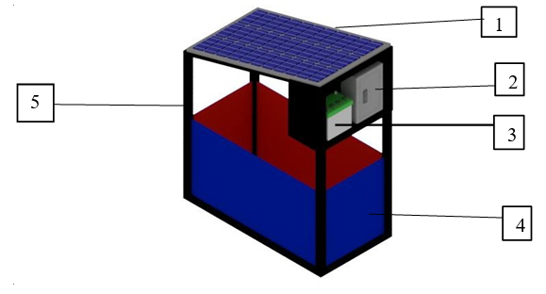

1. Solar Panel 2. Panel Box 3. Battery 4. Pool 5. Frame

**Fig 1**. Solar Aerator Design

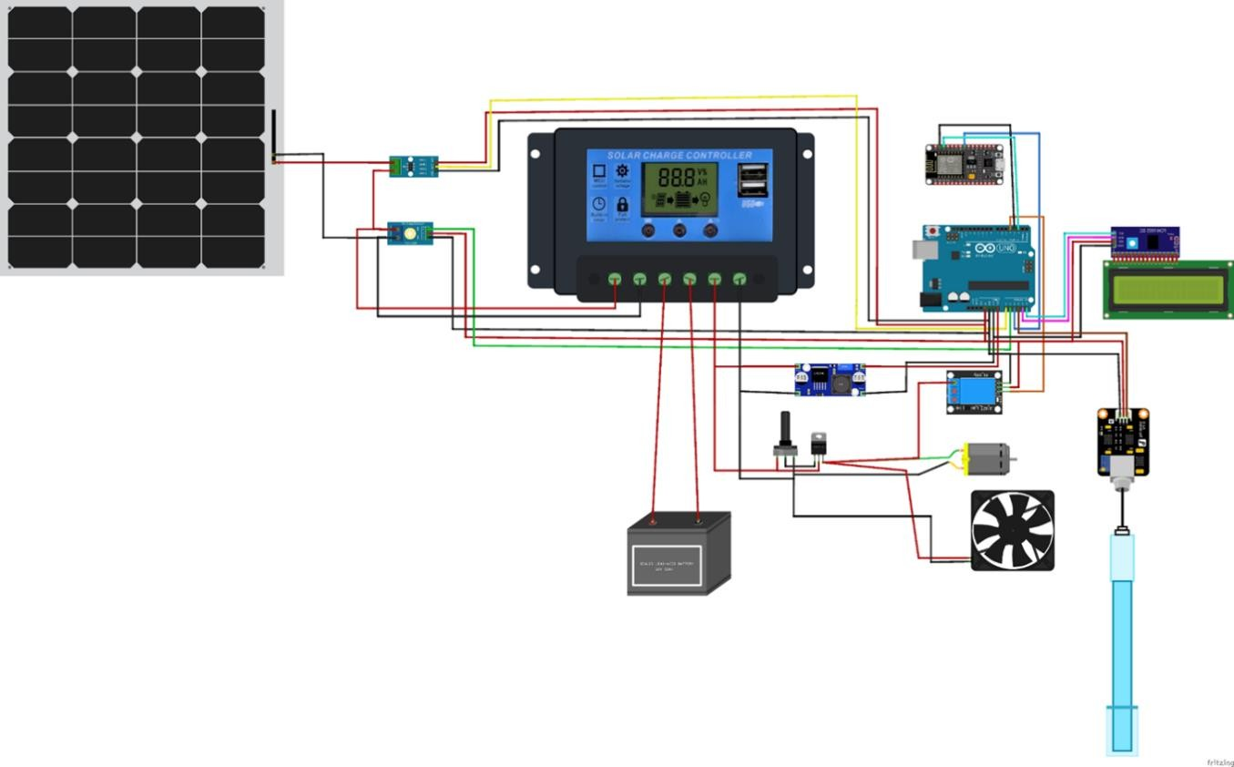

**Fig 2.** Circuit In Testing

1. RESULTS AND ANALYSIS

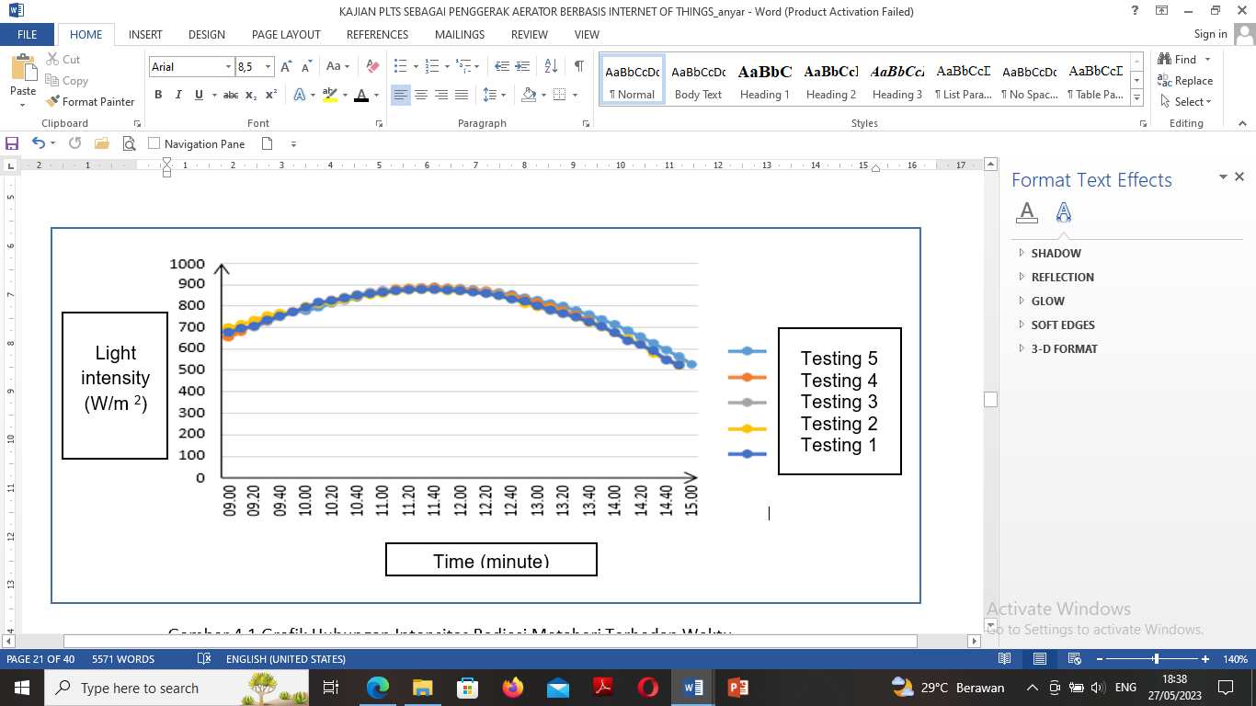

**Fig 3.** Relationship The Relationship of Solar Radiation Intensity to Time

Fig 3. shows the relationship between solar radiation intensity and time. The chart above has a downward curved trendline. Testing on July 27, 2022 showed radiation intensity the highest produced sun at 11.40 WIB amounted to 875 W/m2. The lowest value at 15.00 WIB was 523 W/m2 . Testing on date July 28, 2022 the intensity of solar radiation produced is highest at o'clock 11.40 WIB amounted to 872.16 W/m2 and the lowest value at 15.00 WIB of 519.57 W/m2 . Testing on July 30, 2022 of solar radiation intensity the highest result at 11.40 WIB was 877.07 W/m2 and value he lowest at 15.00 WIB was 527.17 W/ m2 . Testing date July 31, 2022 the intensity of solar radiation produced is highest at 11:50 am WIB of 883.88 W/ m2 and the lowest value at 15.00 WIB of 527.17 W/ m2 . Testing on August 1, 2022 solar radiation intensity the highest output at 11.50 WIB amounted to 886.57 W/m2 and value the lowest at 15.00 WIB was 526 W/m2 . Daylight hours of intensityThe sun is highest compared to the morning and evening, with values highest at solar radiation intensity of 886.5 W/m2

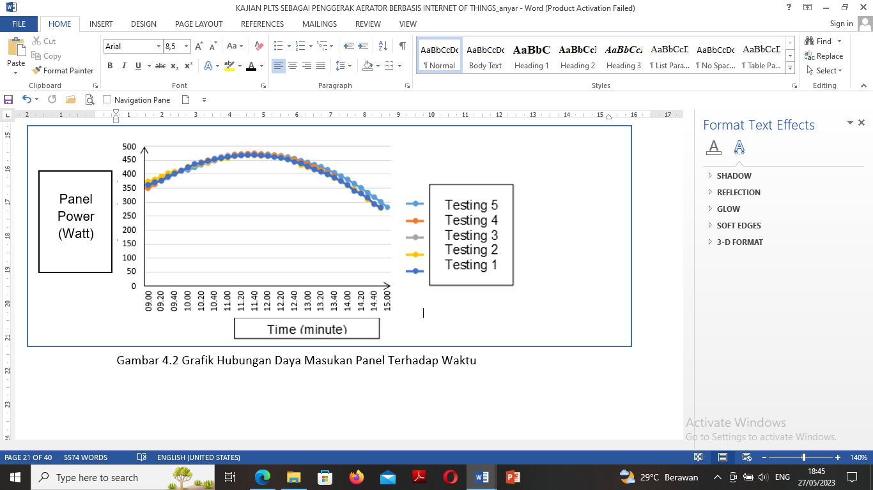

**Fig. 4** relationship of Panel Input Power to Time

Fig 4 shows the relationship of Panel Input Power to Time. The curve above has a curved trendline from low to high back to low. The test on July 27, 2022 (1st update) resulted in the lowest panel input power at 15.00 WIB at 279.488 W and the highest at 11.40 WIB at 466.978W. The test on July 28, 2022 (test 2) resulted in the lowest panel entry power at 15:00 WIB at 277,257W and the highest at 11:40 WIB at 465,409 W. The test on July 30, 2022 (3rd test) resulted in the lowest panel entry power at 15:00 WIB at 281,313 W and the highest at 11:40 WIB of 468.029 W. The test on July 31, 2022 (4th test) resulted in the lowest panel entry power at 15.00 WIB of 281.313 W and the highest at 11.50 WIB of 471.663 W. The test on August 1, 2022 (the 5th test) resulted in the lowest panel entry power at 15.00 WIB of 280.688 W and the highest at 11.40 WIB of 473.099 W. The test above on August 1, 2022 (5th test) is the best test result data and on July 27, 2022 (1st test) is poor test result data. Panel inlet power is influenced by weather when testing sunlight is covered by clouds, the intensity of solar radiation received by the panel will decrease, resulting in decreased panel current and voltage and the amount of panel inlet power is influenced by the area of the solar module per square meter.

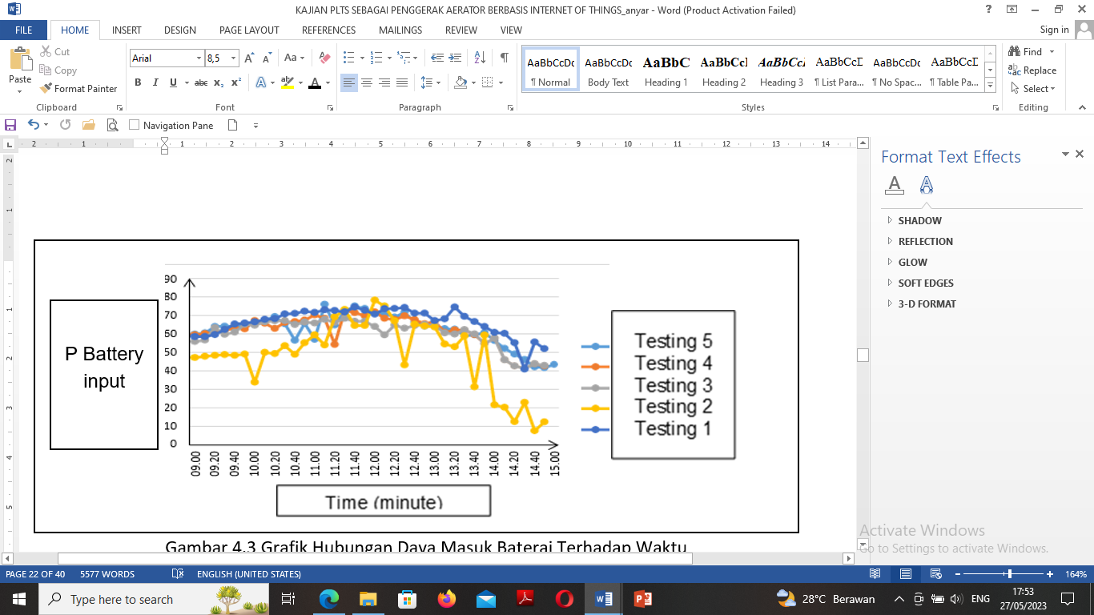

**Fig 5.** Relationship of battery inlet power to time

Fig 5. shows the relationship of battery inlet power to time. The curve shows the relationship between battery inlet power against time, the curve has a curved trendline from low to high back again to low, the chart is relatively up. The test on July 27, 2022 (test 1) produced the lowest battery input power at 15.00 WIB at 51.94 W and the highest at 12.40 WIB at 74.1 W. The test on July 28, 2022 (test 2) produced the lowest battery inlet at 14:50 WIB at 7,696 W and the highest at 12.10 WIB at 78.069 W. Testing on July 30, 2022 (3rd test) resulted in the lowest battery power inlet WIB at 14.40 WIB at 41.30 W and the highest at 11.40 WIB at 68.30 W. The test on July 31, 2022 (4th test) resulted in the lowest battery inlet power at 14.40 WIB at 41.30 W and the highest at 11.40 WIB at 72.70 W. The test on August 1, 2022 (the 5th test) resulted in the lowest battery inlet power at 14.50 WIB at 41.676 W and the highest at 11.10 WIB at 75.843 W. It was recorded that August 1, 2022 (the 5th test) was the test that produced the best battery inlet power and on July 27, 2022 (the 1st test) was the test result data was not good. Starting from 09.00 WIB to 15.00 WIB, at 10.40 WIB experienced a very rapid decrease from 65.312 W to 56.472 W then rose rapidly to 65.626 W and then fell again to 56.94 W. The decrease and increase is due to when the clock is covered by clouds so that the sunlight received by the panel is not optimal, when the intensity of solar radiation is high the current generated for the battery charging process will be greater so that charging is faster and vice versa

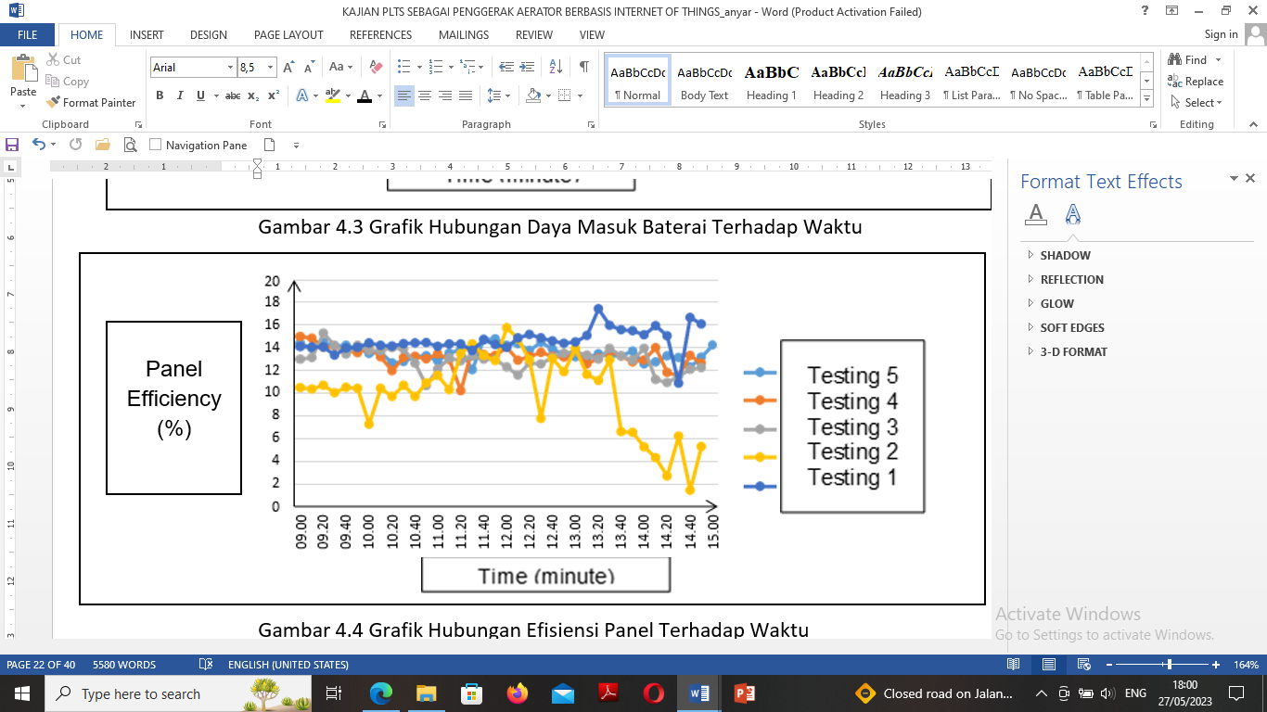

**Fig 6.** relationship Panel Efficiency Against Time

Fig 6. shows the relationship**.** relationship panel efficiency Against Time. The curve shows the test on July 27, 2022 (test 1) resulted in the lowest panel efficiency at 14.40 WIB at 10.852 % and the highest at 13.30 WIB at 17.394 %. The July 28, 2022 test (2nd test) resulted in the lowest panel efficiency at 14.30 WIB at 3.212 % and the highest at 12.10 WIB at 15.747 %. The test on July 30, 2022 (3rd test) resulted in the lowest panel efficiency at 11.00 WIB at 10.628 % and the highest at 09.30 WIB at 15.247 %. The test on July 31, 2022 (4th test) resulted in the lowest panel efficiency at 11:30 at 10.186 % and the highest at 09.10 WIB at 14.953 %. The test on August 1, 2022 (the 5th test) resulted in the lowest panel efficiency at 11:30 at 12.041 % and the highest at 11.50 WIB at 14.749 %. The curve above has a downward straight trendline, the chart is relatively constant with the highest difference of 2%. It was recorded that August 1, 2022 (5th test) was the best test day and on July 27, 2022 (1st test) was not good test result data. Starting from 09.00 WIB to 15.00 WIB for the reason that the effective time of sunlight in producing radiation rays is 6 hours. The increase and decrease in the curve is influenced by the power produced by solar panels and the amount of radiation intensity received by solar panels, the higher the intensity of radiation, the higher the power produced by the panel so that the percent produced will be better.

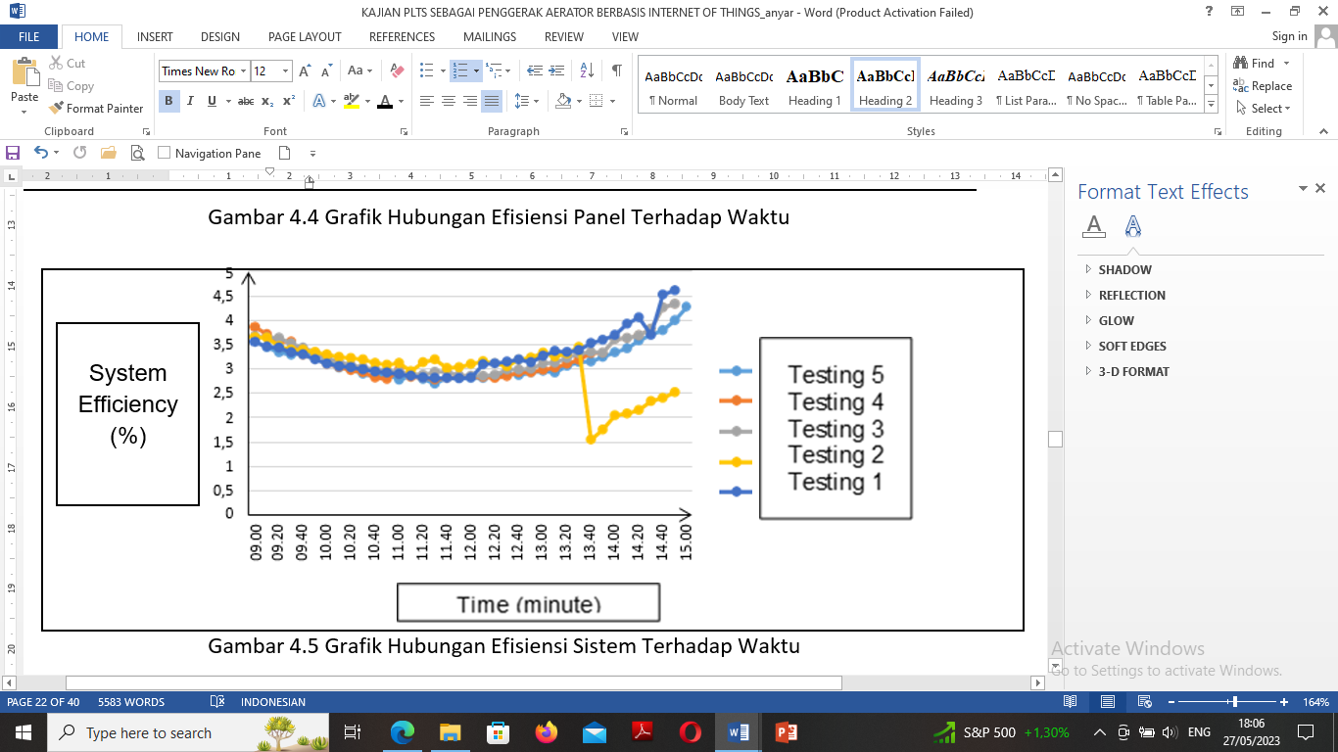

**Fig 7**. relationship of System Efficiency to Time

Fig 7. shows the relationship of system efficiency to time. The curve shows he test on July 27, 2022 (1st update) resulted in the lowest system efficiency at 12.00 WIB at 2.800 % and the highest at 15.00 WIB at 4.616 %. The test on July 28, 2022 (the 2nd test) resulted in the lowest system efficiency at 13.50 WIB at 1.532 % and the highest at 09.00 WIB at 3.6454 %. The test on July 30, 2022 (3rd test) resulted in the lowest system efficiency at 12.10 WIB at 2.851 % and the highest at 14.40 WIB at 3.823 %. The July 31, 2022 test (4th test) resulted in the lowest system efficiency at 12.30 WIB by 2.805% and the highest at 15.00 WIB by 4.337%. The test on August 1, 2022 (the 5th test) resulted in the lowest system efficiency at 11.50 WIB at 2.800 % and the highest at 15.00 WIB at 4.275 %. The testing curve of August 1, 2022 (5th test) has an increase and decrease curve with the trendline curving downward with a curve. Changes in system efficiency are more regular than other tests because they are influenced by the intensity of solar radiation at certain hours and the power required by the load also affects the amount of system efficiency because in the calculation of system efficiency, the output power divided by the incoming power of the panel is multiplied by one hundred percent. When the power entering the panel is too large and the condition of the battery is full and the load power is not too large, the efficiency of the system will be low because the power produced by the panel is wasted.

IV. CONCLUSION

After testing on " Solar power plants as an aerator driver based on the Internet of Things (IoT) ", it can be concluded that on July 27, 2022 - August 1, 2022 obtained the best overall value in the test on August 1, 2022 with the highest panel power of 473,099 W, battery input power of 69,716 W, aerator inlet power of 13,330 W, panel efficiency of 14,749% and system efficiency of 4,275% at 11:40 WIB. The use of aeration for fish ponds has an impact on increasing the pH value of water gradually with certain time intervals. Before aeration, the water in the pond has a pH value of 3.09 and after aeration for 120 minutes the pH value changes to 6.72.

REFERENCE

|  |  |
| --- | --- |
| [1] | Badan Meteorologi Klimatolgi dan Geofisika. (2021). *Leaflet BMKG Informasi Iklim Untuk Sektor Energi*. Diakses pada 21 Mei 2022 |
| [2] | Izzati, et all. 2012. Perubahan Konsentrasi Oksigen Terlarut dan pH Perarian Tabah setelah Penambahan Rumput Laut Sargassum Playophyllum dan Ekstraknya. *Buletin Anatomi Dan Fisiologi dh Sellula Vol 16, No 2*, 60-69. |
| [3] | Bambang Hari Purwoto, J. M. 2018. Effisiensi Penggunaan Panel Surya Sebagai Sumber Energi Alternatif. *Jurnal Teknik Elektro Vol.18 No. 01* , 10-14. |
| [4] | Efendi, et all 2018. Internet of Things (IoT) Sistem Pengendali Lampu Menggunakan Raspberry PI Berbasis Mobile. *Jurnal Ilmiah Ilmu Komputer Vol 4*, 19-26. |
| [5] | Dewi Putro Yuniarti, et all. 2019. Pengaruh Proses Aerasi Terhadap Pengolahan Limbah Cair Pabrik Kelapa Sawit di PTPN VII Secara Aerobik. *Jurnal Redoks Volume 4, Nomer 2*, 7-16. |
| [6] | Gaffar, R. A. 2023. Aplikasi Aerator Dengan Supercharger Mobil Bertenaga Surya Berbasis Sistem IoT (Internet Of Thing) Untuk Budidaya Udang Vaname (Doctoral dissertation, Institut Teknologi Sepuluh Nopember). |
| [7] | Dwiansyah, et all. 2021. *Rancang Bangun Monitoring IoT Pada Aerator Berbasis Tenaga Surya Di Tambak Udang Wachyuni Mandira.* Palembang: Universitas Muhammadiyah Palembang. |
| [8] | Sihombing, P. M., Adelisa, S., Siregar, M. A., Putra, D., Lubis, D. T., Mawardi, M., & Siregar, M. Z. (2023). Prototipe pengawasan dan pengontrolan aerator untuk budidaya udang berbasis IOT. *Jurnal VORTEKS*, *4*(1), 264-272. |
| [9] | Devrifqi, U. M., & Mowaviq, M. I. 2021. Rancang Bangun Pembangkit Listrik Hybrid Tenaga Surya dan Bayu Untuk Simulasi Pompa Aerator Kolam 25 W. *SUTET*, *11*(1), 36-50. |
| [10] | Solihin, R. 2020. Peningkatan Budidaya Udang Galah Melalui Pemantauan dan Pengendalian Kualitas Air Secara Otomatis Berbasis IoT. In *Prosiding-Seminar Nasional Teknik Elektro UIN Sunan Gunung Djati Bandung* (pp. 275-286. |
| [11] | Sumardiono, A., Rahmat, S., Alimudin, E., & Illahi, N. A. 2020. Sistem Kontrol-Monitoring Suhu dan Kadar Oksigen pada Kolam Budidaya Ikan Lele. *JTERA (Jurnal Teknologi Rekayasa)*, *5*(2), 231-236. |
| [12] | Rohadi, E., Adhitama, D. W., Ekojono, E., Ariyanto, R., Asmara, R. A., Ronilaya, F., ... & Setiawan, A. (2018). Sistem Monitoring Budidaya Ikan Lele Berbasis Internet Of Things Menggunakan Raspberry Pi. *Jurnal Teknologi Informasi Dan Ilmu Komputer*, *5*(6), 745-750. |
| [13] | Putu Pawitra Teguh Dharma Priatam, dkk. 2021. Analisa Radiasi Sinar Matahari Terhadap Panel Surya 50 WP. *RELE (Rekayasa Elektrikal dan Energi ) : Jurnal Teknik Elektro*, 48-54. |
| [14] | Mulyadi, M., & Yunus, A. S. 2018. Pengembangan Desain Aerator Terapung Sistem Panel Surya. In *Seminar Nasional Hasil Penelitian & Pengabdian Kepada Masyarakat (SNP2M)* (Vol. 2, No. 1). |
| [15] | Setyawan, I., & Suprianto, B. 2019. Rancang Bangun Prototype Solar Cell Buck Boost Converter Menggunakan Kontrol Fuzzy Di Implementasikan Pada Aerator Tambak Udang. *Jurnal Teknik Elektro*, *8*(3). |