The Influence Of Using A Sleeve Machine On The Production Cost Of Brake Shoe Products In The Die Casting Department Of PT XYZ

Timotius Anggit Kristiawan1*, Andryana Dwiandara Wibowo 2, Trio Setiyawan3, Nanang Apriandi4

1,3,4 Jurusan Teknik Mesin, Politeknik Negeri Semarang, Semarang, Indonesia

2 Master Student of Mechanical Engineering Department, National Kaohsiung University of Science and Technology, Kaohsiung City, Taiwan

Email address : [*anggit.kristiawan@polines.ac.id](mailto:*anggit.kristiawan@polines.ac.id)

***Abstract*—** **The process of finishing brake shoe products in PT XYZ's die casting department experienced waste using M steel shot 230 sand which reached 4,125 kg throughout 2020 and the amount of sand that fell to the floor was 36 kg per shift. The reason is that the unloading process is still manual by shaking the brake shoe jig for 2 seconds/jig then immediately pouring the brake shoe into the polybox which has holes and does not have a sand container. The use of a sieving machine is expected to reduce lost sand so that productivity can increase. The test parameters are the rotation of the motor which is regulated through an inverter of 5.5 Hz, 6 Hz, and 6.5 Hz for the time of the brake shoe sifting process, as well as the amount of sand scattered and carried by the brake shoe against the cost of purchasing sand. The results showed that productivity increased by 5.56%, the cost down of purchasing sand by up to 75.40%, and environmental cleanliness increased by 92.87%. The increase above based on Pareto analysis is included in the significant category because it meets the 20/80 rule.**

***Keywords— Brake shoe, Costdown, M Steel shot 230, Sieving machine.***

I. INTRODUCTION

PT. XYZ is a company whose main business is the Manufacturing of Aluminum Casting Parts and Component Brake for Automotive. One of the company's main products is brake shoes. Brake shoes are an important component of the braking mechanism on vehicles that have a high friction coefficient to slow down and stop the vehicle [1]. The working principle of the brake system is to convert the kinetic energy and potential energy of the moving parts into heat by friction and this heat is lost in the surrounding atmosphere to stop the vehicle [2].

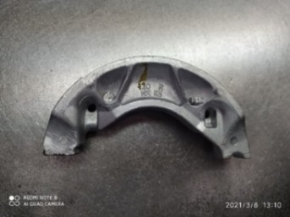

Fig. 1. Breke shoe

The brake shoe production process is carried out by the Die Casting Department, starting from smelting the material, supplying homes, injecting parts, finishing, and delivery. The problem was found in the finishing stage, namely the process of unloading shot blasting of brake shoes. Shot blasting is one of the most frequently used surface treatments to obtain a rough surface [3]. The problems were caused by the polybox enrichment process manually and without sand storage, so the M steel shot 230 sand material was wasted and could no longer be used.

Company data shows that the use of sand material M steel shot 230 is wasteful in its use because as much as 200 grams of sand is lost and carried by the brake shoes to the Lining Bonding Department. Sand scattered on the floor reaches 36 kg per shift. Based on sand usage history data from the Report Material Use Transfer Finishing Section of PT. XYZ is very high, in one year the amount of sand used reaches 4,125 kg during 2020 or Rp. 52,283,797.50.

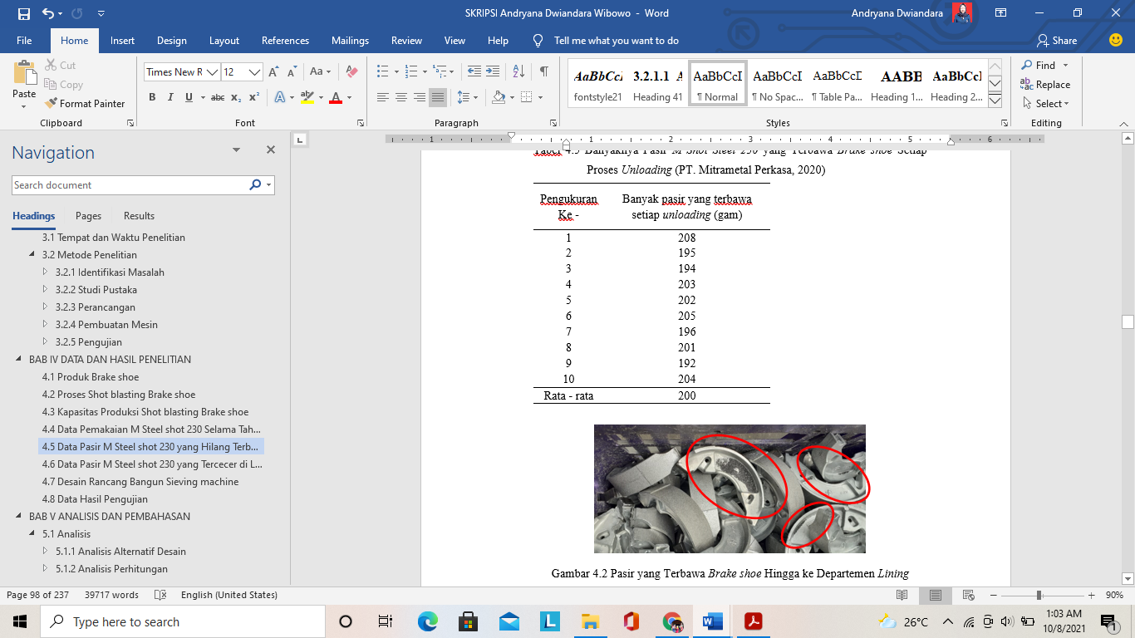

Fig. 1. Sand carried Brake shoe

The high production cost of the unloading shot blasting brake shoe process requires an enrichment mechanism for the brake shoe product to reduce the wastage of sand. Sieving is the process of separating a product with a certain size range into several products with different sizes through a single-deck or multi-deck screen that has a sieving mesh with uniform holes [4]. Sieving is done so that the M steel shot 230 sand material can be reused in the shot blasting process. The purpose of this study is to determine the effect of using a sieving machine that has been made and whether it has an impact on the production costs of brake shoe products.

II. METHODS

This research uses the following objects and measuring instruments:

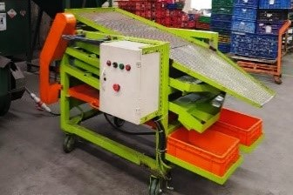

Fig. 2. *Sieving machine*

The sieving machine was created to assist in the process of unloading shot blasting of brake shoes. The working principle of this sieving machine uses a camshaft and crankshaft driven by a motor connected to a pulley and v-belt transmission. The cam will move the first sieve up and down while the crank and connecting rod will move the second and third sieve back and forth. The slope of the first sieve is made at 10° to facilitate the process of lowering the brake shoes. The pitch of the second and third sieve is made at 8° to facilitate the process of removing dirt and sand M Steel shot 230. This sieving machine is equipped with a collector for dirt, sand, and dust so that the sand that is sifted and separated with dirt and dust can be collected directly into each of them. Each container, thus making it easy for the operator to remove dirt and dust when it has accumulated and retrieves sand that can still be used again. The sieving machine is also equipped with an inverter which is helpful in adjusting the rotational speed of the motor. In an electric motor, the rotation speed can be adjusted by changing the frequency using an inverter [5].

**Testing**  
a. Sieving Speed Test

The sieving speed test aims to find the length of time the brake shoe sieving process takes by paying attention to the sieving movement so as not to cause dent problems on the brake shoes. This test was carried out by adjusting the motor speed of the inverter at 5.5 Hz, 6 Hz, and 6.5 Hz for three tests at each frequency. Zulfikar, in his research, said that if the frequency is changed to be greater, the measured power will also be greater, and the resulting rotation will be faster [6]. Frequency variations affect the voltage and rotational speed of the shaft [7]. This. test requires a stopwatch to measure the sieving time.

b. Cycle Time Testing

The cycle time test [8-9] aims to determine the length of the unloading process with a sieving machine. Cycle time testing is carried out by observing, recording, and calculating the time required for the unloading process with a sieving machine after knowing the speed of the motor used based on the test  
results of 3 speed parameters.

c. Product Quality Testing

Quality Control Finishing carried out quality testing by taking 1,500 pieces of brake shoes as a result of sifting with a sieving machine and observing the entire profile of the brake shoes visually to see if there were any dents on the product during screening.

d. Data analysis

Analysis of the results of testing using a sieving machine includes analyzing data calculations and comparing the data obtained from the sieving speed test and cycle time test. The final result of this analysis is statistical analysis using the paired sample t-test with Excel [10-11], the one sample t-test with SPSS [12], and Pareto analysis.

**Shot blasting process Brake shoe**

Shot Blasting Process Steps Brake shoe goes through the stages of loading, shot blast and un loading. The stages of the process and the length of time the process takes are as follows.

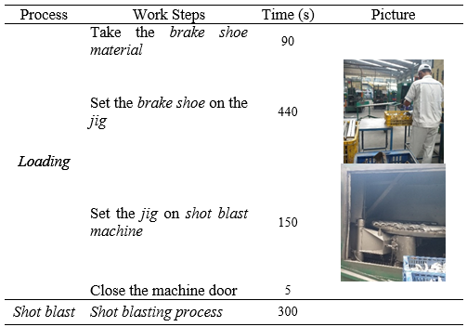

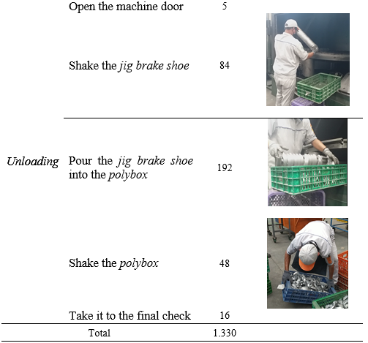

III. RESULTS AND DISCUSSION

**A. Production Data Before Sieving Machine Usage**

The shot blasting brake shoe process is carried out in 3 shifts, with a working time of 7 hours per shift. In each shift, the shot blasting process is carried out 18 times and is able to produce 13,608 pcs of shot blasting products per  shift, so that the daily capacity is 40,824 pcs per day or 979,776 pcs per month. The use of M Shot Steel 230 material during 2020 and the amount of costs incurred by PT XYZ for purchases are shown in tables 1 and tables 2.

Table 1. Use of M-Shot Steel 230 in 2020

|  |  |  |  |  |  |  |  |  |  |
| --- | --- | --- | --- | --- | --- | --- | --- | --- | --- |
| **Month** | **Use of M Steel Shot 230 (Kg)** | | | | | | | | **Total**  **(Kg)** |
| **1** | **2** | **3** | **4** | **4** | **6** | **7** | **8** |
| January | 75 | 50 | 75 | 50 | 75 | 75 | 75 | 50 | 525 |
| February | 100 | 50 | 75 | 50 | 75 | 75 |  |  | 425 |
| March | 75 | 50 | 50 | 75 | 75 | 50 |  |  | 375 |
| April | 75 | 50 | 75 | 50 | 50 | 75 |  |  | 375 |
| May | 50 | 50 | 50 | 50 | 50 |  |  |  | 250 |
| June | 75 | 75 | 75 | 50 | 75 |  |  |  | 350 |
| July | 50 | 50 | 75 | 50 | 25 | 75 |  |  | 325 |
| August | 75 | 50 | 75 | 50 | 75 |  |  |  | 325 |
| September | 100 | 75 | 75 | 50 | 50 |  |  |  | 350 |
| October | 100 | 50 | 75 | 50 | 50 |  |  |  | 325 |
| November | 75 | 75 | 75 | 50 | 50 |  |  |  | 325 |
| December | 50 | 75 | 50 |  |  |  |  |  | 175 |
| Total Usage of M Shot 230 in 2020 | | | | | | | | | 4.125 |

**Table 2**. Cost of purchasing M-Shot Steel 230 material during 2020

|  |  |  |  |
| --- | --- | --- | --- |
| **Month** | **Total (kg)** | **Price/kg** | **Total cost of purchase** |
| January | 525 | Rp 12.674,86 | Rp 6.654.301,50 |
| February | 425 | Rp 12.674,86 | Rp 5.386.815,50 |
| March | 375 | Rp 12.674,86 | Rp 4.753.072,50 |
| April | 375 | Rp 12.674,86 | Rp 4.753.072,50 |
| May | 250 | Rp 12.674,86 | Rp 3.168.715,00 |
| June | 350 | Rp 12.674,86 | Rp 4.436.201,00 |
| July | 325 | Rp 12.674,86 | Rp 4.119.329,50 |
| August | 325 | Rp 12.674,86 | Rp 4.119.329,50 |
| September | 350 | Rp 12.674,86 | Rp 4.436.201,00 |
| October | 325 | Rp 12.674,86 | Rp 4.119.329,50 |
| November | 325 | Rp 12.674,86 | Rp 4.119.329,50 |
| December | 175 | Rp 12.674,86 | Rp 2.218.100,50 |
| Total purchase cost of M *Steel shot* 230 in 2020 | | | Rp 52.283.797,50 |

Data for lost M Steel shot 230 sand particles carried away by the brake shoes and scattered on the floor before using the sieving machine are shown in tables 3 and ne are shown in tables 3 and table 4.

**Table 3.** The Amount of M-Shot Steel 230 Sand Carrying the Brake Shoe for Each Unloading Process

|  |  |
| --- | --- |
| **Measurement** | **Sand carried per unloading (Gram)** |
| 1 | 208 |
| 2 | 195 |
| 3 | 194 |
| 4 | 203 |
| 5 | 202 |
| 6 | 205 |
| 7 | 196 |
| 8 | 201 |
| 9 | 192 |
| 10 | 204 |
| **Average** | **200** |

**Table 4.** Amount of M-Shot Steel 230 Sand that Falls and Scatters on the Floor in Each Unloading Process

| **Measurement** | **Sand that falls scattered every unloading (Kg)** |
| --- | --- |
| 1 | 2,38 |
| 2 | 1,72 |
| 3 | 2,49 |
| 4 | 2,27 |
| 5 | 2,19 |
| 6 | 1,94 |
| 7 | 2,85 |
| 8 | 4,60 |
| 9 | 2,11 |
| 10 | 2,00 |
| **Average** | 2,46 |

**B. Testing Data and Use of Sieve Machines**

The screening speed test is shown in Table 5.

Table 5. Sieving Speed Test Data for Sieving Time

|  |  |  |
| --- | --- | --- |
| Sieving speed (Hz) | measurement | Sieve time (s) |
| 5,5 | 1 | 320 |
| 2 | 308 |
| 3 | 315 |
| 6 | 1 | 258 |
| 2 | 245 |
| 3 | 251 |
| 6,5 | 1 | 194 |
| 2 | 190 |
| 3 | 192 |

Data from quality testing results on 1500 brake shoes showed that there was not a single dent due to sieving using a sieving machine. This shows that the use of a sieving machine to sieve the brake shoes in the process of unloading shot blasting brake shoes is safe. The enrichment speed test data and quality testing above show that at a frequency of 6.5 Hz, it produces the fastest sifting time and brake shoe products without dents due to sifting. After the sieving speed was determined, the unloading process time test was carried out using a sieving machine, and the average unloading time was 253 seconds. The shot blasting process time with the new unloading time with the sieving machine shows a decrease in processing time of 92 seconds/process, as shown in Figure 3.

Fig. 3. Cycle time of the shot blast process Brake shoe before and after sieving machine

If calculated in one shift, the decrease in brake shoe unloading process time is:

$$\text{Time Drop }\text{ = 92} \frac{\text{second}}{\text{proses}}\text{×18}\frac{\text{proses}}{\text{shift}}\text{ = 1.656} \frac{\text{second}}{\text{shift}}$$

A reduction in time of 1,656 seconds per shift can increase the shot blast brake shoe process by 1 time, or up to 19 processes per shift, so the brake shoe production capacity for each shift becomes:

$$\text{E}\text{nhancement}\text{ = 756} \frac{\text{pcs}}{\text{proses}}\text{×19}\frac{\text{proses}}{\text{shift}}\text{= 14.364} \frac{\text{pcs}}{\text{shift}}$$

$$\text{P}\text{ercentage}\text{ = }\frac{\left(\text{14.364 -13.608}\right)\text{ pcs}}{\text{13.608 pcs}}\text{×100\%} \text{= 5,56 \%}$$

|  |  |
| --- | --- |
| **Measurement** | **Sand that falls scattered every unloading (Kg)** |
| 1 | 0,135 |
| 2 | 0,132 |
| 3 | 0,233 |
| 4 | 0,198 |
| 5 | 0,208 |
| 6 | 0,108 |
| 7 | 0,122 |
| 8 | 0,287 |
| 9 | 0,150 |
| 10 | 0,179 |
| **Average** | 0,175 |

Table 6. Data of M-Shot Steel 230 Sand that Falls and Scatters on the Floor of Each Unloading Process After Using a Sieving Machine

**Cycle time test data analysis**

Formulating Hypothesis [11]:

Ho: The design of the sieving machine does not affect the process time for unloading shot blasting brake shoes.  
Ha: The design of the sieving machine affects the process time for unloading shot blasting brake shoes.

Table 7. Results of Cycle Time T-test Analysis with Microsoft Excel



Based on the t-test shown in Table 7, with a confidence value of 95%, the t count value is -116.631, while the t table (t crit) value is -1.8331 or 1.8331. If the value of t count > the value of t table (t crit), then Ho is rejected and Ha is accepted, which means that the design of the sieving machine affects the process time of unloading shot blasting brake shoes.

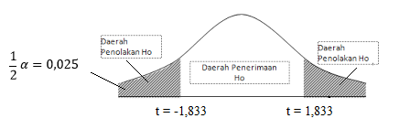

Fig. 4. Ho Acceptance Area and Ho Rejection Cycle Time Testing

Table 8. Analysis Results of the One Sample T-Test Cycle Time Test

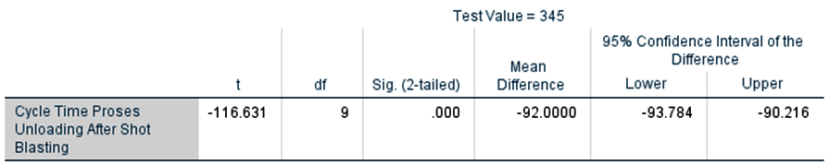

Based on the results of the one-tailed t-test [12], with a confidence value of 95% and a standard error value of 5% or  = 0.05, if the value of Sig. (2-tailed) which appears in Table 8 has a value of 0.05, Ho is rejected and Ha is accepted, which means the hypothesis that the process of unloading shot blasting of brake shoes using a sieving machine has an effect on decreasing the cycle time of the process of unloading shot blasting of brake shoes.

A comparison of the amount of sand scattered on the floor before and after the sieve machine is shown graphically in Figure 5.

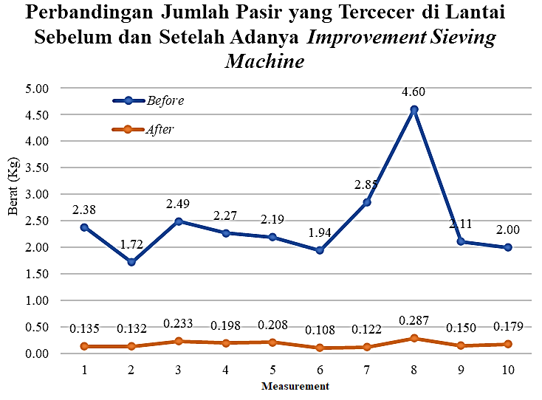

Fig. 5. Graph of Comparison of Sand Scattered on the Floor Before and After the Sieving Machine

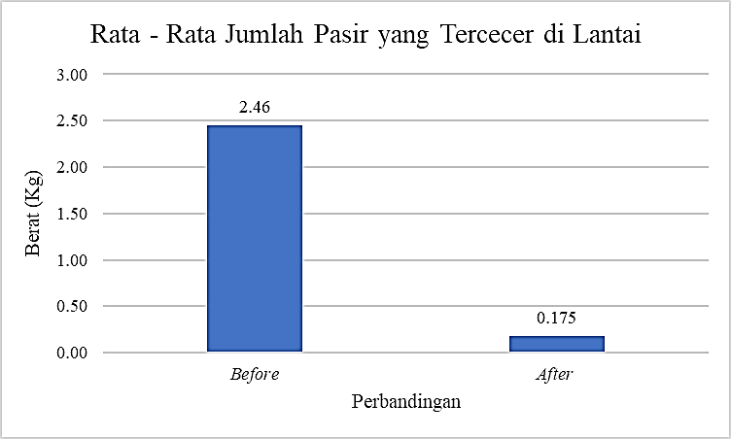

Fig. 6. Comparison of the average amount of sand scattered on the floor before and after the sieving machine

$$\text{Percentage of Reduction = }\frac{\text{2,285 kg}}{\text{2,46 kg}}\text{×100\% = 92,87 \%}$$

**Scattered Sand Data Analysis**

Formulating Hypothesis [11]:

Ho: The design of the sieving machine does not affect the amount of scattered sand.

Ha: The design of the sieving machine affects the amount of scattered sand.

Table 9: Results of Cycle Time T-test Analysis with Microsoft Excel

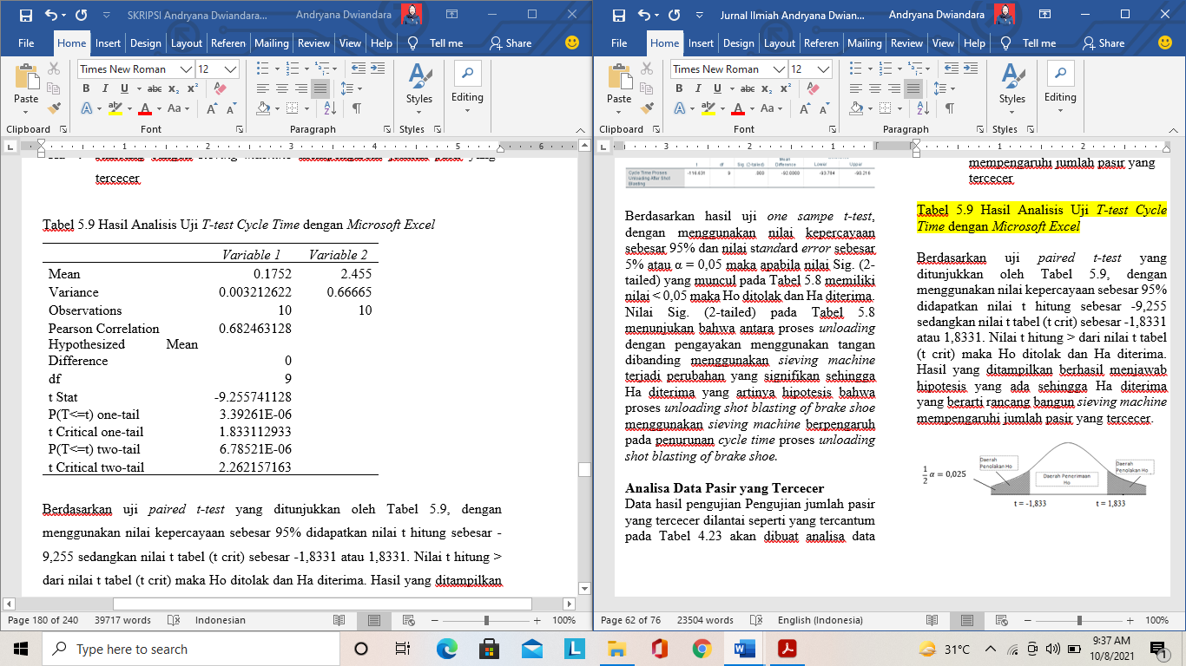

Based on the paired t-test shown in Table 9 with a confidence value of 95%, the t count value is -9.255, while the t table (t crit) value is -1.8331 or 1.8331. If the value of t count is greater than the value of t table (t crit), then Ho is rejected and Ha is accepted, which means that the design of the sieving machine affects the amount of scattered sand.



Figure 7. The area of acceptance of Ho and rejection of Ho Testing the amount of scattered sand

Table 10: Results of the Analysis of the Scattered Sand Paired Sample T-Test

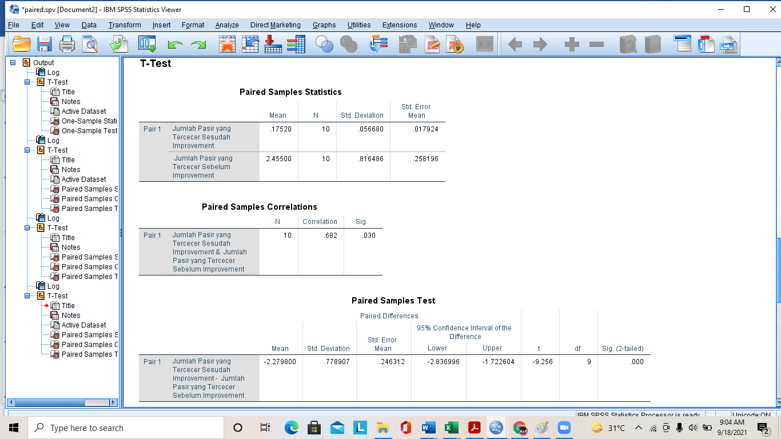

Based on the results of the paired sample t-test [12], with a confidence value of 95% and a standard error value of 5% or  = 0.05, if the value of Sig. (2-tailed) that appears in Table 10 has a value of 0.05, Ho is rejected and Ha is accepted, which means the hypothesis that the process of unloading shot blasting of brake shoes using a sieving machine has an effect on reducing the amount of sand scattered on the floor in each unloading shot blasting process of brake shoes.

**Analisis Cost Reduction**

Cost reduction is the simplest way to increase profitability and improve cash flow [13-14]. A cost reduction analysis was carried out to find out how much the use of a sieving machine affects the brake shoe production costs.

PT XYZ, of Rp. 5,000,000/month. The company gets an average PO of 979,776 pieces /month. The time required for manual production is:

$$\frac{\text{979.776 pcs}}{\text{13.608 }\frac{\text{pcs}}{\text{shift}}\text{×3}\frac{\text{shift}}{\text{day}}}\text{ = 24 day}$$

The time required for the use of a sieving machine is:

$$\frac{\text{979.776 pcs}}{\text{14.364 }\frac{\text{pcs}}{\text{shift}}\text{×3}\frac{\text{shift}}{\text{day}}}\text{ = 22,73 ≈ 23 day}$$

Production time savings = 24 day -23 day

= 1 day

$$\text{Cost }\text{reduction}\text{/}\text{month}\text{ = 1 hari×}\frac{\frac{\text{Rp 5.000.000}}{\text{month}}}{\text{24 day}}$$

$$\text{= Rp 203.333,33/month}$$

$$\text{Cost }\text{reduction}\text{/year } \text{= }\frac{\text{Rp 203.333,33}}{\text{month}}\text{×}\frac{\text{12 month}}{\text{year}}$$

$$\text{= Rp 2.440.000/year}$$

The amount of sand that is lost due to being carried by the brake shoes in each unloading process is an average of 200 grams/process.

= $\frac{\text{3 shift}}{\text{ day}}\text{×}\frac{\text{18 proses}}{\text{shift}}\text{×}\frac{\text{200 gam}}{\text{proses}}$

$$\text{= 10.800 g}\text{r}\text{am}\text{s}\text{/day }$$

$$\text{= }\frac{\text{10,8 }\text{kg} }{\text{day}}\text{×}\frac{\text{24 day}}{\text{month}}$$

= 258,2 kg/month

If the price for 1 kg of M Steel shot 230 sand based on Material Used Transfer Finishing Section data is IDR 12,674.86 per kg, then:

$$\text{Cost }\text{reduction}\text{/}\text{month} \text{ = 259,2 Kg×}\frac{\frac{\text{Rp 12.674,86}}{month}}{kg}$$

$$\text{ = }\text{Rp 3.285.323,71/}\text{month }$$

$$\text{Cost }\text{reduction}\text{/}\text{year} \text{ = }\frac{\text{Rp 3.285.323,71}}{\text{month}}\text{×}\frac{\text{12 month}}{\text{year}}$$

$$\text{ = Rp39.423.884,52/year}$$

The decrease in the purchase cost of sand reached IDR 39,423,885.52 per year. The percentage reduction in the cost of purchasing Sand M Steel Shot 230 is:

$$\text{P}\text{ercentage}\text{ = }\frac{\text{Rp 39.423.885,52}}{\text{Rp 52.283.797,50}}\text{×100\%} \text{= 75,40 \%}$$

**Pareto analysis**

A Pareto chart is used to show the results of using a sieving machine. Pareto analysis is an analytical method that adheres to the principle of the "80/20" rule, where 80% of the effects arise from 20% of the causes (15). The results of the analysis are shown in the graphic below:

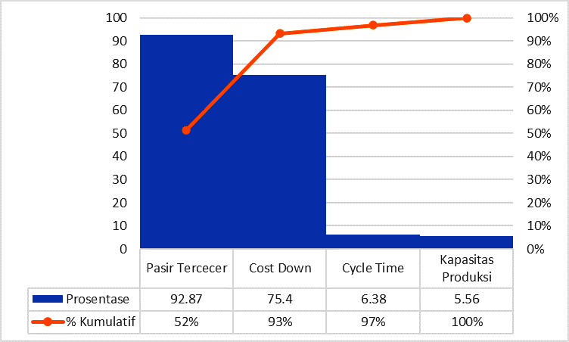

Fig. 8. Graph Pareto diagram using a sieving machine

Based on Pareto salt analysis, the most significant profit is the one that is greater than the effort or more than 20%. The most significant advantage is the reduction of sand spills by up to 92.87% and the cost of purchasing sand by up to 75.40%. The use of a sieving machine has an effect on reducing cycle time and production capacity, but it is not significant because the values are 6.38% and 5.56%, or less than 20%.

IV. CONCLUSION

The conclusion from the use of a sieving machine in the shot blast process is as follows:

1. able to reduce shot blasting process time by 6.38% and increase production capacity by 5.56%. The decrease in cycle time is due to the loss of the process of shaking the jig and sifting the brake shoes in the polybox by hand.
2. Able to reduce the amount of sand scattered on the floor by 92.87% because the sand carried by the jig and brake shoes falls into the sieving machine and is then sieved, separated between dirt, sand, and dust, and accommodated in each container.
3. Able to reduce the cost of purchasing M Steel shot 230 sand by IDR 39,423,885.52 per year, or 75.40% per year. The decrease in the purchase cost of sand is because sand is no longer carried by the brake shoes and is scattered.

REFERENCES

[1] Kulkarni, M. P. S., & Student, B. E. A. M. I. E. “Design of Advanced Electromagnetic Emergency Braking System. International.” Journal of Engineering Research and General Science. Vol. 3 No.3, 2015, ISSN 2091-2730.

[2] Gopinath, G., & Murali, P. “Analysis of Redesigned Brake shoe. Materials Today.” Proceedings vol. 22, pp. 507-513. 2019.

[3] Gil, F. J., Planell, J. A., Padrós, A., & Aparicio, C. “The effect of proses shot blastand heat treatment on the fatigue behavior of titanium for dental implant applications”. Journal Dental Materials, Vol. 23, No. 4, pp. 486-491, 2017.

[4] Zhang, B., Gong, J., Yuan, W., Fu, J., & Huang, Y. “Intelligent Prediction of Sieving Efficiency in Vibrating Screens. Shock and Vibration”. 2016.

[5] Evalina, N., Aziz, A, Zulfikar. “Pengaturan kecepatan Putar Motor Induksi 3 fasa Menggunakan Programmable Logic Controller”, Journal of Electrical Teknology Vol. 3 No. 2, pp. 73-80, Juni 2018.

[6] Zulfikar, Evalina, N., Arfis, A., “ Penggunaan Inveter 3G3MX2 untuk Merubah Kecepatan Piutar Motor Induksi 3 Phasa.” Jurnal of Electrical Technology, Vol. 4, No. 2, pp. 93-96, Juni 2019.

[7]

[8] setyawan, L., “ Peningkatan Cycle Time proses mesin Drawing Tembaga dengan Metodelogi SMED pada Industri kabel di Tanggerang.” Jurnal PASTI, Vol. XXI, No. 2, pp. 184-194, 2018.

[9] Kristiawan, T.A., Abidin, Z., Laksono, P.S., Nugroho, W.I., “Rancang Bangun Mesin Pemasang Snap Ring untuk Mengurangi Cycle Time pada Assembling Transmission FF di PT. AWI.” Jurnal Rekayasa Mesin, Vol 16, No. 1, pp. 39-47, April 2021.

[10]

[11] Prameswari, A.P., Rahayu, T.S., “ Efektifitas Model Pembelajaran Cooperative Learning Tipe make a match dan Numbered head Together: Kajian Meta-Analisis.” Jurnal Ilmiah Pendidikan Profesi Guru, Vol. 3 No. 3, pp. 202-210, April 2020.

[12] Magdalena, R., Krisanti, M.A., “ Analisa Penyebab dan Solusi rekonsiliasi Finished Goods menggunakan Hipotesis Statistik dengan Metode Pengujian Independent Simple T-test di PT. Merck, Tbk.” Jurnal TEKNO, Vol 16, No. 1 pp. 35-48, April 2019.

[13] Bragg, Steven M. 2010. Cost Reduction Analysis. New Jersey: John Wiley and Sons.

[14] Nikmatullah, M.I., “Analisis Penerapan Cost reduction dalam Peningkatan laba.” Jurnal Riset Akutansi dan Keuangan, Vol. 2 No. 2, pp. 352-363, 2014.

[15] Putri, L.N., ‘analisis pareto.” [www.ukmindonesia.id](http://www.ukmindonesia.id), 11 Juni 2022