Performance Characteristics of Savonius Wind Turbines With Variations Air Gaps in Supporting the Development of Renewable Energy

Baktiyar Mei Hermawan(1),, F. Gatot Sumarno * (2), Totok Prasetyo (3), Sahid (4) , Anis Roihatin(5), Nur Fatowil Aulia (6), M. Denny Surindra(7) , Mulyono(8), Gizella Sofiani(9), Tania Prameswari Putri (10), Wahyu Ariyanto(11)

1,2,3,4,5,6,7,8,9,10,11 Jurusan Teknik Mesin, Politeknik Negeri Semarang, Semarang, Indonesia

Email address : **\*** **fgatots@gmail.com**

***Abstract – To overcome the occurrence of an energy crisis in the future, an innovation / invention of energy that is environmentally friendly and energy sources will not run out in the future. Energy sources that are environmentally friendly and their potential when developed is very large, one of which is energy sources derived from wind energy.*** ***This study aims to determine the effect of wind speed on the performance of wind turbines. To find out the performance characteristics of wind turbines with variations in air gaps. The research method begins with the design / design of the wind turbine, then continues the manufacturing stage, the assembling and installation stage, the testing of tools and analysis, the tests carried out include testing the performance characteristics of the wind turbine. The parameters measured in this study are rotation, torque as well as calculating the kinetic power produced, TSR and CP. The test results conducted showed that the 200 mm air gap Savonius wind turbine with a value of CP = 0.02480-0.15658 had optimum work at low wind speeds (4 m / s). Meanwhile, the 170 mm airborne Savonius wind turbine with a value of CP = 0.00593-0.14668 has optimum work at high wind speeds (8 m / s to 9 m / s).***

***Keywords- wind turbine savonius, air gap, coefficent of power.***

1. INTRODUCTION

The continuous use of fossil energy sources as a fuel source for power generation without the discovery of alternative energy sources that are environmentally friendly will result in fossil energy sources continuing to decline and will result in a scarcity of fuel sources for future generation. To overcome the occurrence of an energy crisis in the future, an innovation / invention of energy that is environmentally friendly and energy sources will not run out in the future. Energy sources that are environmentally friendly and their potential when developed is very large, one of which is energy sources derived from wind energy.

Basically, there are two kinds of wind turbines, namely wind turbines with horizontal axes and vertical axis wind turbines. In horizontal axis wind turbines, basically wind turbines must be directed in the direction of the wind blowing, while in vertical axis wind turbines wind turbines do not need to be directed to the blowing wind. Previous research on wind turbines [15] related to the use of Savonius turbines with CFD (Computational Fluid Dynamics) and PIV (Particle Image Velocimetry) methods in non-constant wind directions and low wind speeds obtained results that Savonius wind turbines have the ability to produce more optimal power than turbines with horizontal axes. In the previous study, namely research belonging to Dicky Rizaldi et al. have conducted research related to three-level savonius turbines with 2 variations in rotating angles of 0º and 120º dimensions of 0.5 m x 0.6 m using an air gap of 170 mm. Savonius wind turbines with an air gap of 170 mm as a basic reference for this study to further examine the variations in air gaps. This study used variations in the width of the gap below and above the air gap value of 170 mm. Looking at some of the studies above, researchers are still doing slight variations in air gaps so that researchers are interested in varying air gaps to improve the performance of savonius wind turbines, so the title of this study is the performance characteristics of savonius wind turbines with variations in air gaps

1. RESEARCH METHOD

The first step is to design a wind turbine with a savonius type for wind power generation. At this stage, a model of a wind turbine will be produced that will be used for wind power plants. The second step is the design of wind turbine components and others connected into one unit. At this stage the construction of the wind turbine frame along with the wind turbine.

The next step is to test the savonius wind turbine on variations in wind speed, blade variations, data collection is carried out by measuring turns, measuring torque, and calculating the kinetic power produced, TSR and CP. After the test data is completed, the performance data of the wind turbine as a wind power plant is then made and then a graph of the performance characteristics of the wind turbine is made.

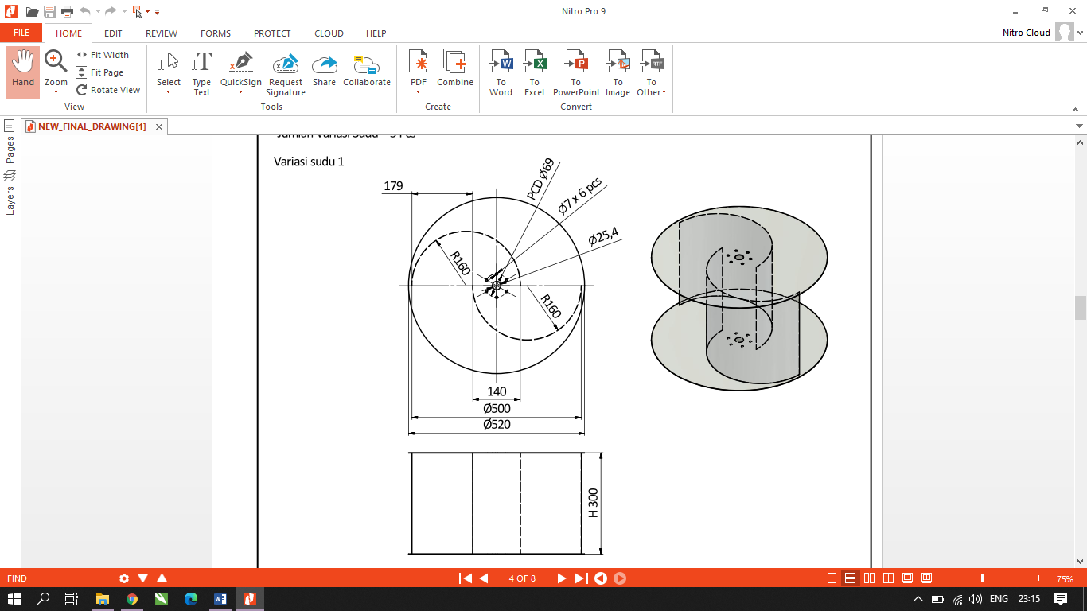



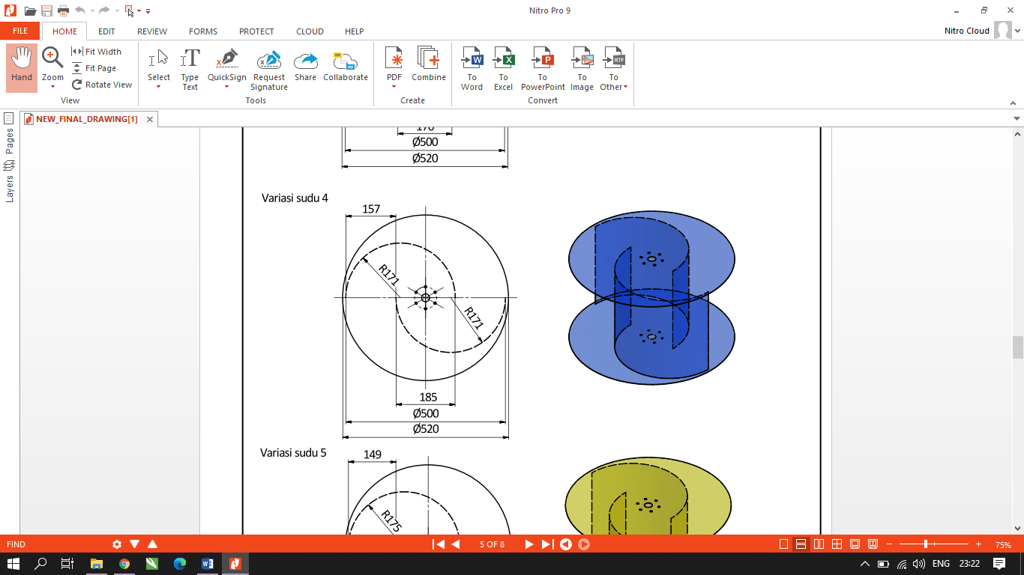

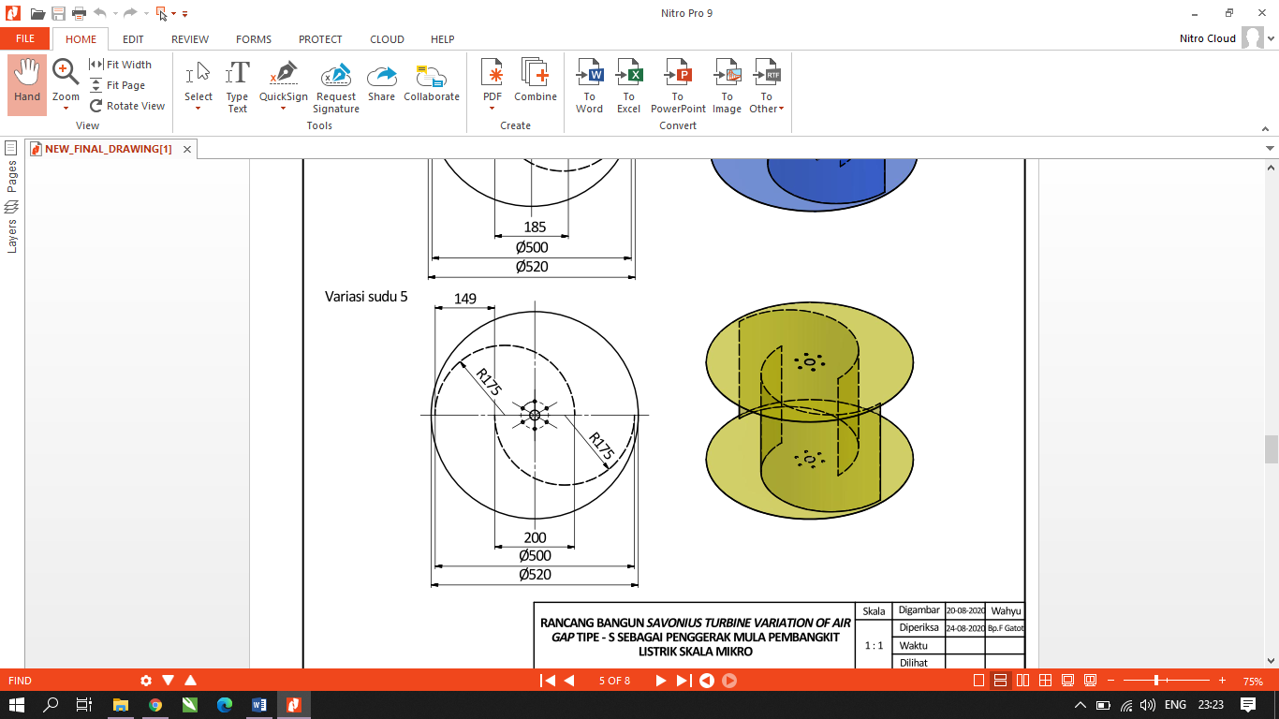

**Fig 1**. Savonius Wind Turbine With 5 Variation Air Gap

In the performance data collection of the waterwheel the parameters measured are wind speed, shaft rotation speed. After obtaining the parameters, the results of the performance of the wind turbine are obtained. The test result data is processed to obtain torque, mechanical power, kinetic power, TSR and CP. The processing results are then represented in the form of a wind turbine performance graph. The analysis will result in the performance of the wind turbine.

III. RESULTS AND ANALYSIS

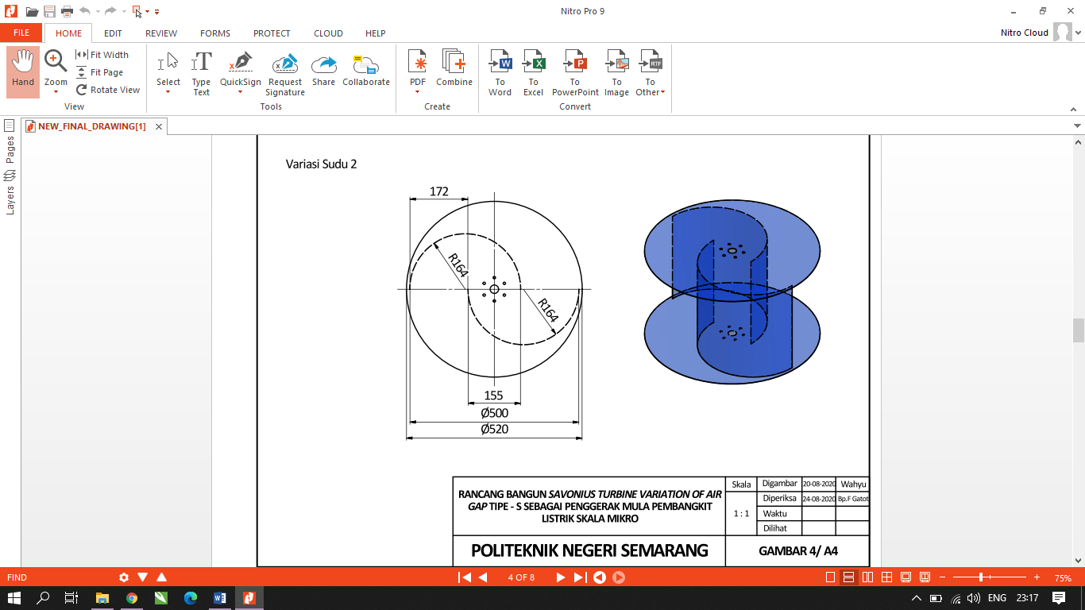

**Fig 2.** Relationship between power coefficient (CP) of Savonius wind turbines and TSR at all five variations of 4 m/s wind speed air gap

Fig 2. shows the relationship of Coefficient of Power (CP) to tip speed ratio (TSR) with a wind speed of 4 m/s. The curve with the most optimum line is shown on a wind turbine with an air gap of 200 mm. After all curves with each variation of the air gap reach the optimal value of the curve between CP and TSR then the curve will decrease in value. This is in accordance with the characteristics of the Savonius wind turbine in the CP diagram with TSR, where the Savonius wind turbine will experience an optimum value at a certain speed and then experience a decrease in the curve as the given loading value increases for torque or braking testing.

**Fig. 3** relationship between power coefficient (CP) of Savonius wind turbine and TSR at all five variations of 5 m/s wind speed air gap

Fig 3 shows the relationship of Coefficient of Power (CP) to tip speed ratio (TSR) with a wind speed of 5 m/s. The curve with the most optimum line is shown on a wind turbine with an air gap of 140 mm. After all curves with each variation of the air gap reach the optimal value of the curve between CP and TSR then the curve will have a decrease in value. This is in accordance with the characteristics of the Savonius wind turbine in the CP diagram with TSR, where the Savonius wind turbine will experience an optimum value at a certain speed and then experience a decrease in the curve as the loading value given for torque testing or braking increases.

**Fig 4.** Relationship between power coefficient (CP) of Savonius wind turbine and TSR at all five variations of 6 m/s wind speed air gap

Fig 4. shows the relationship of Coefficient of Power (CP) to tip speed ratio (TSR) with a wind speed of 6 m/s. The curve with the most optimum line is shown on a wind turbine with an air gap of 185 mm. After all curves with each variation of the air gap reach the optimal value of the curve between CP and TSR then the curve will have a decrease in value

**Fig 5.** relationship between power coefficient (CP) of Savonius wind turbine and TSR at all five variations of 7 m/s wind speed air gap

Fig 5. shows the relationship of Coefficient of Power (CP) to tip speed ratio (TSR) with a wind speed of 7 m/s. The curve with the most optimum line is shown on a wind turbine with an air gap of 200 mm. After all curves with each variation of the air gap reach the optimal value of the curve between CP and TSR then the curve will have a decrease in value.

**Fig 6**. relationship between power coefficient (CP) of Savonius wind turbine and TSR at all five variations of 8 m/s wind speed air gap

Fig 6. shows the relationship of Coefficient of Power (CP) to tip speed ratio (TSR) with a wind speed of 8 m/s. The curve with the most optimum line is shown on a wind turbine with an air gap of 170 mm. After all curves with each variation of the air gap reach the optimal value of the curve between CP and TSR then the curve will have a decrease in value.

**Fig 7**. relationship between power coefficient (CP) of Savonius wind turbine and TSR at all five variations of 9 m/s wind speed air gap

Fig 7. shows the relationship of Coefficient of Power (CP) to tip speed ratio (TSR) with wind speed speed of 9 m/s. The curve with the most optimum line is shown on a wind turbine with an air gap of 170 mm. After all curves with each variation of the air gap reach the optimal value of the curve between CP and TSR then the curve will have a decrease in value.

**Fig 8.** relationship between power coefficient (CP) of Savonius wind turbine and TSR at all five variations of 10 m/s wind speed air gap

Fig 8. shows the relationship of Coefficient of Power (CP) to tip speed ratio (TSR) with a wind speed of 10 m/s. The curve with the most optimum line is shown on a wind turbine with an air gap of 155 mm. After all curves with each variation of the air gap reach the optimal value of the curve between CP and TSR then the curve will have a decrease in value.

IV. CONCLUSION

After testing on "Performance Characteristics of Savonius Wind Turbines With Variations in Air Gaps in Supporting the Development of Renewable Energy", it can be concluded that the Savonius wind turbine model of air gap variation has dimensions of 500 mm in diameter with a turbine blade height of 300 mm. The variations of the air gap are 140 mm, 155 mm, 170 mm, 185 mm and 200 mm. The tests were conducted using wind speed variations of 4 m/s to 10 m/s. Loading performed for braking or torsion testing uses ballast load variations (m1) from 0 kg (free) to 1.5 kg. The test results conducted showed that the 200 mm air gap Savonius wind turbine with a value of CP = 0.02480-0.15658 had optimum work at low wind speeds (4 m / s). Meanwhile, the 170 mm airborne Savonius wind turbine with a value of CP = 0.00593-0.14668 has optimum work at high wind speeds (8 m / s to 9 m / s).

REFERENCE

|  |  |
| --- | --- |
| [1] | Anonim. Potensi Energi Angin Indonesia 2020. https: //p3tkebt.esdm.go.id, diakses 15 Februari 2022 |
| [2] | Chandra, Daniel, et al. Rancang Bangun Turbin Aangin Savonius-Darrieus Tipe Cebong.. *Prosiding Seminar Nasional NCIET*. Vol. 1. No. 1. 2020. |
| [3] | Fadila Anisa, dkk. 2019. Rancang Bangun Turbin Darrieus Tiga Sudu Rangkap Tiga dengan Profil NACA 0006. Jurnal Teknik Energi Vol 15 No.3 September 2019; 102- 114 |
| [4] | Hicary, H., Suwandi, S., & Qurthobi, A. 2016. *Analisis Pengaruh Jumlah Sudu Pada Turbin Angin Savonius Sumbu Vertikal Terhadap Tegangan Dan Arus Di Dalam Proses Pengisian Akumulator*. eProceedings of Engineering, 3(3). |
| [5] | Lysen, E. H, 1983. Introduction to Wind Energy, Basic and Advance Introduction to Wind Energy With Emphasis on Water Pumping Windmills. Development Cooperation Departement. Netherland. |
| [6] | Pamungkas, Stephanus Fajar. dkk. 2017.Pengaruh Variasi Penambahan Fin Terhadap Cut In Speed Turbin Angin Savonius Tipe S. [Vol. 2, No. 1 (2017)](http://jurnal.untirta.ac.id/index.php/vanos/issue/view/265) . |
| [7] | Pangestu, R. Sandri, A. A. H. 2017. *Perancangan Turbin Angin Peros Vertikal Tipe Savonius Bertingkat dengan Variasi Blade “Savonius Helical L Rotor”.* 10.13140/Research Gate.2.2.14852.73600. |
| [8] | Prasetyo, Yuli, and Nur Asyik Hidayatullah. "Analisa Karakteristik Turbin Angin Sumbu Vertikal Tipe Savonius Helius." *JEECAE (Journal of Electrical, Electronics, Control, and Automotive Engineering)* 4.1 (2019): 241-244. |
| [9] | Sahid, Slamet Priyoatmojo. 2019. Rancang Bangun Turbin Angin Poros Horizontal Tiga Sudu Flat Berlapis Tiga Dengan Variasi Sudut dan Posisi Sudu. Jurnal Teknik Energi Vol 15 No.1 Januari 2019; 14-19 |
| [10] | Sahid, dkk. 2019. *Smart wind turbine three-layers flat blade with control system Arduino-based for blade angle*. International Conference on Innovation in Science and Technology (ICIST 2019) Jilid 1108. |
| [11] | Siregar, S. Farel H. Napitupulu. 2013. *Perancangan Turbin Vertikal Axis Savoniusdengan Menggunakan 8 Buah Sudu Lengkung .* Jurnal dinamis Vol. I, Ni.13, Juni 2013. |
| [12] | Sumarno Gatot F, dkk. 2021. Uji Eksperimental optimasi turbin angin savonius tipe S untuk menunjang pemanfaatan energi ramah lingkungan. Prosiding NCIET Vol.2 (2021) B142 – B150. |
| [13] | Sumarno Gatot F, dkk. 2020. Rancang Bangung Turbin Angin Archimedes Dengan Dua Sudu. Jurnal Teknik Energi Vol.16 No.2 Mei 2020; 49-59. |
| [14] | Sumarno Gatot F, dkk. 2020. Studi karakteristik turbin angin savonius bertingkat dengan sudut sudu 120° Sebagai Pembangkit Listrik Alternatif. Prosiding Seminar Nasional NCIET Vol.1 (2020) B359-B373. |
| [15] | Taher, G, dkk. 2014. *Investigation of the Aerodynamic Performance of Darrieus Vertical Axis Wind Turbine.*IOSR Journal of Engineering. Vol (04), Issue 05 |