# *MONITORING OF* IOT-BASED WIND AND SOLAR *HYBRID* POWER PLANTS FOR AGRICULTURAL IRRIGATION SYSTEMS

Budhi Prasetiyo1), Wiwik PW2), Suwarti3),

Desinta Nur R4)., Ika Melinda P.5), Oktaviyan Alansyah6), Micah Riksi Fananda7)

1,2,3)Lecturer at Semarang State Polytechnic

4,5,6,7)Students of Semarang State Polytechnic

andmail: budhi.polines@gmail.com

# ABSTRACT

The use of renewable energy, one of which is *Hybrid* Power Plants (PLTH). The PLTH used in this study is a wind and solar power plant. To keep the plant from being damaged and prevent a decrease in tool performance, PLTH was developed based on the *Internet of Things* (*IoT*). *IoT* will later monitor the performance of the plant. In this study using the ESP32 TTGO SIM800L microcontroller, the sensors used were DC voltage sensors, current sensors (ACS712), wind speed sensors (*anemometers*), wind direction sensors (*wind vanes*), and water flow sensors. The research began with designing the relationship between components, working on monitoring and programming systems on software, installing outdoor sensors and installing monitoring systems, and ending with data observations. The results obtained on the observation of data, the best error percentage values are presented by various sensors with values less than 6%.

# Keywords : Hybrid Power Plant, IoT, ESP32, *monitoring*.

***ABSTRACT***

*One of the uses of renewable energy is the Hybrid Power Plant (HPP). The HPP used in this research is wind and solar. To keep the power plant from being damaged and prevent a decrease in equipment performance, HPP was developed based on the Internet of Things (IoT).*  *IoT will later monitor the performance of the generator. In this study using the ESP32 TTGO SIM800L microcontroller, the sensors used are DC voltage sensor, current sensor (ACS712), wind speed sensor (anemometer), wind direction sensor (wind vane), and water flow sensor. The research begins by designing the relationship between components, working on*

*monitoring systems and programming in software, installing outdoor sensors and installing monitoring systems, and ending with data observation.*  *The results obtained from data observations, the best percentage error value is presented by various sensors with a value of less than 6%.*

***keywords : Hybrid Power Plant, IoT, ESP32, monitoring***

# INTRODUCTION

Renewable energy is energy from nature and energy that can be used freely. Its utilization can be in the form of Hybrid Power Plants (PLTH). PLTH is a power plant consisting of 2 (minimal) plants with various energy sources [2]. Renewable energy that can be used includes wind energy and solar energy. However, wind energy and solar energy have their own advantages and disadvantages. Wind energy is energy that exists throughout time (during the day and night) and can produce large energy , but there can be *overvoltage* if the wind blows strongly, besides that wind energy is also influenced by time and season. Meanwhile, solar energy is energy that is in accordance with the tropics but has a limited time where it can only be used during the day [1].

The *hybrid*  system in the plant is sought to support sufficient electricity results and overcome each other for the supply of electrical power. To keep the plant from being damaged and prevent a decrease in tool performance, PLTH was developed based on the  *Internet of Things (IoT).*  *IoT* is a concept of communication technology between devices using an internet connection [3]. Based on the problems presented, it is necessary to design a tool that can monitor the PLTH in  *real-time* conditions so as to create a well-maintained power plant and avoid damage.  **METHOD OF IMPLEMENTATION**

The activities of making this Final Project tool include the planning stage, work stage, installation stage and testing stage depicted in the flowchart of the following implementation activities:

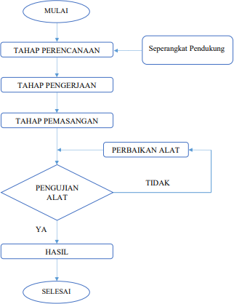

Figure 1. *Flowchart* Toolmaking

The installation stage is carried out to install *the panel box*, connect the sensors, and install the use of tools after which they will be used for testing. The testing phase consists of programming testing using esp 32-connected applications and actual testing . With an interval of each test for approximately 5 minutes, data testing is in the form of: solar panel voltage, alternator voltage, solar panel current, alternator current, wind speed, direction wind, and water pump discharge.

# RESULTS AND DISCUSSION

System testing is carried out to determine the accuracy of data from the performance of the system that has been created. The data display is in the form of a real-time graph for voltage, current, and discharge, while the display for wind speed values is in the form of a speedometer, and the wind direction is in the form of a compass display.

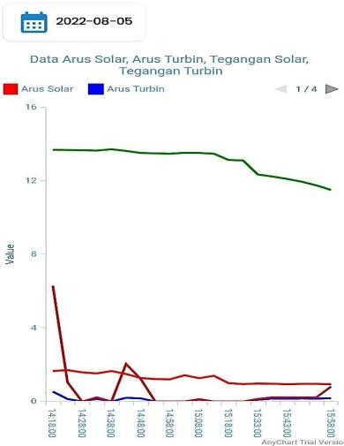

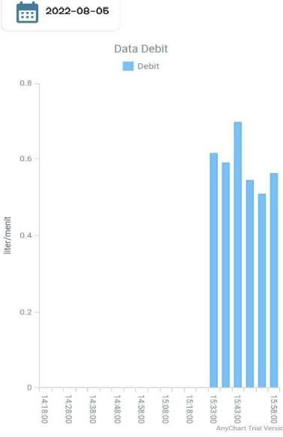

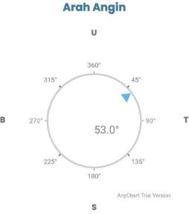 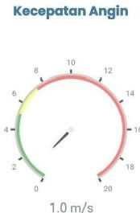

Figure 2. Display on The App

Data accuracy testing aims to compare the data read by the sensor through the application with the actual data using a measuring instrument directly.

# Data Accuracy Testing On Dc Solar Cel Voltage

Actual and Application *Solar Cell* DC Voltage Graph Aug 5, 2022

The Graph shows the difference in the actual solar cell DC voltage data with the application DC solar cell voltage almost no noticeable difference. So that

on the chart shows the same line pattern. The error value in the data is very small, which is only 0.008711749% (0.0087 %).

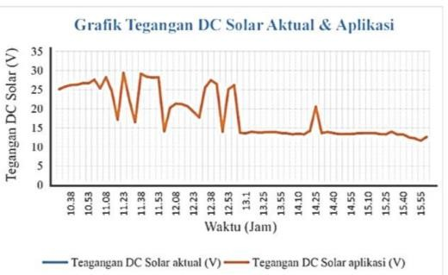

Actual *solar cell*  DC Voltage Graph and Application August 6, 2022

On the Graph, it can be seen that the difference in the actual solar cell DC voltage data with the application SOLAR cell DC voltage is almost no difference. So that the chart shows almost the same pattern and even looks like there is no difference in pattern. The error value generated in the data is very small, which is only 0.00901785% (0.009 %).

1. 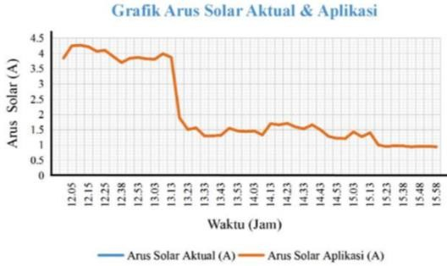 **Testing Data Accuracy** on  ***Solar Cell* Current**

Actual *Solar Cell*  Current Chart and Application August 5, 2022

On the Graph it can be seen that the difference in the data of the actual solar cell current and the application solar cell current is almost invisible. The average error value in the solar cell current observation data is very small where the error value is only 0.099571642% (0.01

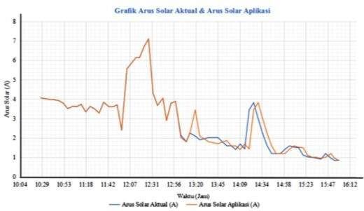%).

Actual *Solar Cell*  Current Graph and Application August 6, 2022

The graph shows that there is a similarity in the form of a graph between the actual solar cell current data and the application solar cell current at 10.28 WIB to 13.20 WIB. In the data after 13.20 WIB, it can be seen that the graph experiences a difference in pattern because there are different reading data between the actual solar cell current and the application solar cell current, thus causing a difference in the value of the difference which is quite large. For example, the data at 14.20 WIB is the data with the largest difference, which is 2,021. The average error value generated is also quite large , which is 8.095% (8.10 %).

# Data Accuracy Testing on DC Alternator Voltage

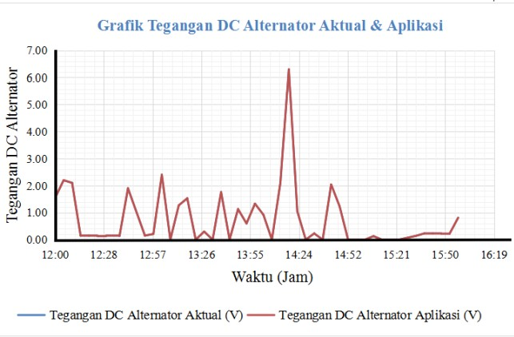

*Actual and Application ALTERNATOR DC Voltage* Chart Aug  *5, 2022*

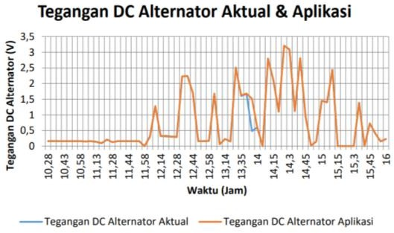The Graph shows that the data difference between the actual alternator's DC voltage and the application alternator's DC voltage is almost invisible. The average error value in the data is very high, which is only 0.04031366% (0.04%).

*Actual and Application ALTERNATOR DC Voltage* Chart  *Aug 6, 2022*

The Graph shows that there is a data difference between the actual alternator's DC voltage and the application alternator's DC voltage which is almost invisible. However, at 13.35 WIB to 13.55 WIB there is a difference in values in the actual and application measurement results so that the graph looks not in line. The average error value of the actual and application differences in the results of the difference in measurements is only 0.04031366% (0.04 %).

# Data Accuracy Testing on Alternator Current

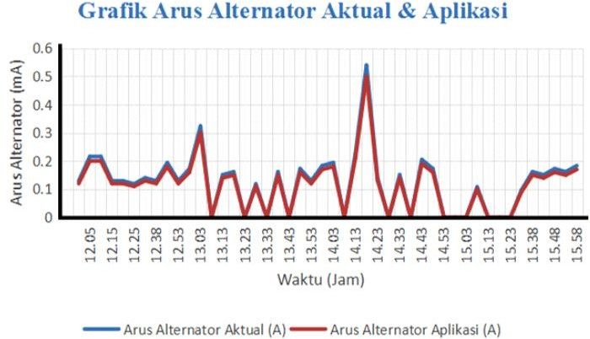

Actual and Application Alternator Current Chart Aug 5, 2022

The Graph shows that the difference between the actual alternator current data and the application alternator current is slightly noticeable but still remains one pattern line. The average error value in the data is quite small, which is 5.31%.

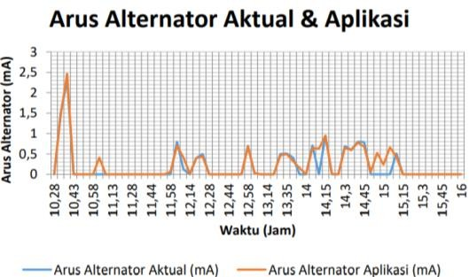

*Actual and Application Alternator Current* Graph  *Aug 6, 2022*

On the Graph shows that the difference between the actual alternator current data and the application is quite obvious. The average value of the resulting error is very high , which is 5.73466 % (5.74%).

# Testing Data Accuracy at Wind Speed

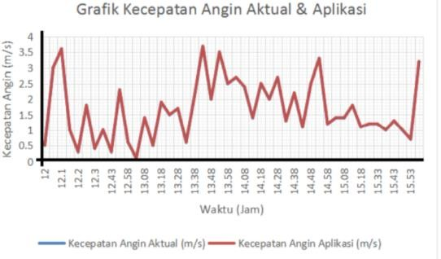

Actual wind speed graph and application August 5, 2022

The Graph shows that the difference in data between actual wind speed and wind speed in application looks almost non-existent. The average error value in the data was very large, which was 1.0878313 % (1.088%).

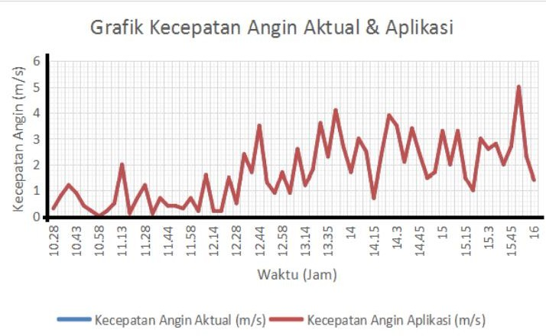

*Actual wind speed* graph  *and application August 6, 2022*

On the Graph shows that the difference in actual and application wind speed data looks almost non-existent. The average error value in the data is quite large, which is 1.7207375% (1.72%).

# Testing Data Accuracy on Water Pump Discharge

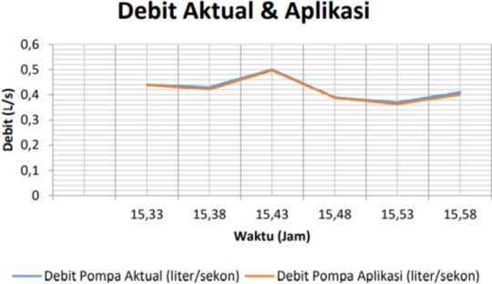

*Actual and Application* Water *Pump Discharge* Chart  *August 5, 2022*

On the Graph shows that the difference in the data on the chart is slightly noticeable. The average value of the error on the data is relatively large where the error value is 1.19507

%.

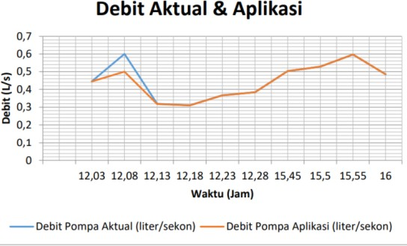

*Actual and Application* Water *Pump Discharge* Chart  *Aug 6, 2022*

On the Graph it can be shown that the difference in data is very clearly visible at the beginning of data retrieval.but entering 12:13 the data begins to stabilize until it is finished

data retrieval, the average value of errors in data retrieval shows a fairly small value of 1.75863%.

Testing has been carried out by observing actual data with conventional measuring instruments (multimeters, anemometers, measuring bottles, and stopwatches) and sensor data through applications which aim to find out whether the sensors and applications are working properly or not. The data on the application will appear continuously if the device is connected to the generator and its supporters (battery, inverter, etc.). The data on the application can also be exported and entered into the file manager on the smartphone. Considering from the test data that has been carried out, there is still a difference in readings between the actual data and the data in the application which is quite large on some sensors. This can be caused by several factors, including: lack of sensor sensitivity, lack of calibration of measuring instruments, lack of reader accuracy in making measurements, obstacles in from the cable because the placement of the sensor far from the source also affects the results of the observation data, and the anemometer there is a difference in height at the time of measurement as well as the material difference between the sensor and the conventional test equipment.

# CONCLUSION

Based on the research carried out, the conclusions of the Final Project "*Monitoring*  System in IoT-Based Wind and Solar *Hybrid* Power Plants for Agricultural Irrigation Systems" were as follows:

1. The results of the monitoring design were successfully carried out as their function and based on the results of observations obtained after carrying out the study, the average error value with the minimum results and can be said to be good for three days of testing, including: DC voltage solar cell 0.0087% (August 5 , 2022), solar cell current 0.099% (August 5 , 2022), DC alternator voltage 0.04% (August 5 , 2022), alternator current 5.31% (August 5, 2022), wind speed 1.087% (August 5, 2022), pump discharge 1.758% (August 6, 2022).
2. Monitoring technology makes it easier to monitor hybrid wind and solar power plants at a distance through an application on an installed Android smartphone. Data in a day can also be exported to a smartphone so that it can monitor the performance of the plant at that time of the day.

# BIBLIOGRAPHY

1. Hermansyah, B. 2019. *Designing a Hybrid System* of  *Pv Panels and Wind Turbines Interconnecting with the Grid to Meet Electricity Needs in Vannamei Shrimp Cultivation in Bayan District, North Lombok Regency , Nusa West Southeast* (Doctoral dissertation, Sepuluh Nopember Institute of Technology).
2. Ramadan et al. 2019. *Design and Implementation of Water Discharge Measurement Using* IoT-Based  *Water Flow Sensors.*   *Vol.*  *6, No.*  *August 2, 2019.*

Pg 2623

1. Ramadan, inspiration & Santoso, Dian. 2022. *Application of the Internet Of Things to Hybrid Generation Monitoring Systems.*  Karawang, Scientific Journal of Educational Vehicles, August 2022, 8(3), 168-176.