**ANALYSIS OF THE INFLUENCE OF ISLAMIC BANKING KNOWLEDGE,**

**SOCIAL VALUES, RELIGIOUSNESS, AND PERCEPTIONS ON STUDENT CAREER INTEREST IN ISLAMIC BANKING (STUDY OF ISLAMIC BANKING STUDY PROGRAM STUDENTS IN SEMARANG CITY)**

**Rosana Dika Afristina1 , Muhammad Asrori2 , Sam’ani3**

1Accounting Department, Politeknik Negeri Semarang, Indonesia

1Accounting Department, Politeknik Negeri Semarang, Indonesia

1Accounting Department, Politeknik Negeri Semarang, Indonesia

Corresponding Author E-mail: rosanadafristina11@gmail.com

**Abstract:** This study aims to analyse the significance of Islamic banking knowledge, social values, religiosity, and perceptions of career interest of students of the Semarang City Islamic Banking Study Program in Islamic Banking both simultaneously and partially. The population in this study were students of the Islamic Banking Study Program in Semarang City. Using a sampling technique, namely purposive and accidental sampling, 100 respondents met the criteria. The data used in this study are primary data obtained through distributing questionnaires. The analysis model used in this study is a multiple linear regression analysis model. In contrast, the analysis technique uses the F statistical test, the coefficient of determination (R2) test, and the t statistical test, which is processed using the SPSS 25.00 program. The hypothesis proving and discussion results show that Islamic Banking Knowledge, Social Values, Religiosity, and Perceptions significantly affect student career interest in Islamic Banking. Sharia Banking Knowledge and Social Values partially have a positive effect but do not substantially affect student career interest in Islamic Banking. Religiosity partially has a positive and significant impact on student career interest in Islamic Banking. Perception partially has a positive and significant effect on students' career interest in Islamic Banking.

**Keywords: Career Interest, Islamic Banking Knowledge, Social Value, Religiosity, Perception**.

**INTRODUCTION**

Islamic banking has its knowledge, so the human resources needed must also meet the criteria in driving the operational work of Islamic banks; this is a difference if a comparison is made with conventional banks, which have more straightforward calculations because they use more general measures. This is one of several problems that affect student interest in a career in Islamic banking.

The development of Islamic banking has consistently shown positive and satisfying results, both through banks and non-banks.

**Picture 1.**

**Asset Development of Islamic Commercial Banks February 2023-2023**.

**Source: Otoritas Jasa Keuangan.**

In this way, students can review supporting knowledge for in-depth knowledge related to banking. From learning at the master's level, Islamic banking students can consider careers after graduation. Qualified human resources are one factor determining the improvement of Islamic banking performance.

The Islamic Banking Education Program is an integrated education program aiming to attract graduates with good character, management skills and entrepreneurial spirit so that they can work in the field of Islamic finance and the industry in general. This course has produced many graduates with careers such as becoming Islamic bankers, swap institution operators, Islamic financial managers and career seekers by working in Islamic banks or other Islamic financial institutions. However, some may pursue a career in banking or finance.

**Table 2.**

**Number of BUS, UUS, and BPRS in Indonesia.**

|  |  |  |  |  |  |
| --- | --- | --- | --- | --- | --- |
|  | **2019** | **2020** | **2021** | **2023** | **2023** |
| BUS | 14 | 14 | 12 | 13 | 13 |
| UUS | 20 | 20 | 21 | 20 | 20 |
| BPRS | 164 | 163 | 164 | 167 | 169 |

**Source: SPS OJK February 2023.**

It can be seen from the table above that the number of Islamic commercial banks is currently increasing, marked by the opening of new Sharia-based banks. In reality, it shows that many human resources are still involved in Islamic institutions that do not have the academic and practical experience to support their work. Based on data from Bank Indonesia, around 90% of the workforce in Islamic banking does not have an educational background in banking or Islamic economics.

**RESEARCH PURPOSES**

This study aims to analyse and obtain empirical evidence regarding the direction and significance of the influence of Islamic banking knowledge, social values, religiosity, and perceptions simultaneously or partially on the career interest of students of the Semarang City Islamic Banking Study Program in Islamic Banking.

**LITERATURE REVIEW**

1. Career Interest

According to Djamaludin Ancok (1987: 13), a person's interest in choosing a type of work is essential for a person's success in their work. Interest in a job career can give a feeling of pleasure, attraction and strong attachment to all activities caused and will try to realise the job. Some indicators used in measuring employee performance variables refer to Slameto's research (2010: 182), namely attention, motive, and interest.

1. Islamic Banking Knowledge

The ability to produce knowledge can be generated from the detection process of the observed object; if we have high knowledge, we can say that he is a human being who will get such results. Understanding knowledge will also determine human actions (Irma & Luqman, 2023). Several indicators used in measuring compensation variables refer to Tyas and Rizky's research (2017): knowledge level, comprehension level, application level, and synthetic level.

1. Social Values

Social value is valuable and related to human relations, also emphasises the noble human aspect and shows behaviour that is willing to sacrifice (Umar, 2015). Several indicators used in measuring work environment variables refer to Ambari and Ramanta's research (2017), namely, the opportunity to interact with others, the opportunity to pursue hobbies, prestige, and the opportunity to work with experts in other fields.

1. Religiosity

According to Djamaludin Ancok (1987: 13) religiosity is how far knowledge, how firm beliefs, how diligent the implementation of worship and how deep the appreciation of religion that a person adheres to.

1. Perceptions

Rakhmat (2007: 51) states that perception is an observation of objects, events or relationships obtained by inferring information and interpreting messages. Perception also affects students who want to have a career in the world of work. Several indicators used in measuring organisational culture variables refer to Septian’s research (2019: 179), namely cognition, emotion, and attitude.

Based on the description and explanation above, the framework in this study can be seen in Figure 1.

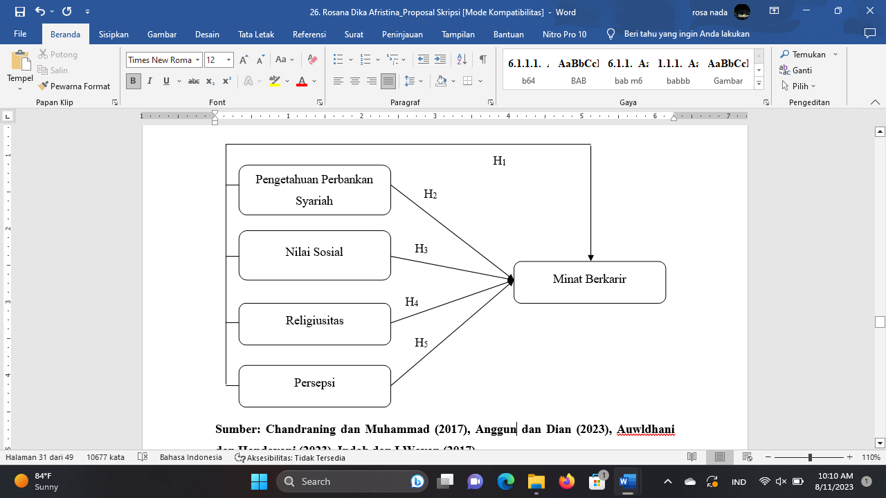

**Figure 1.**

**Research framework**

**Framework : Ambari dan Ramanta (2017), Chandraning dan Muhammad (2017), Indah dan I Wayan (2017), Tyas dan Rizky (2017), Gipson (2017), Walgito (Septian, 2019:179), Nurhalima *et al*., (2020) dan Widia, Usi A (2020), Khaidir *et al*., (2021), Anggun dan Dian (2023).**

**RESEARCH METHODOLOGY**

The research design used in this research is quantitative causality research. The primary data used in this study were obtained from direct respondents' answers to the questionnaires distributed to students of the Islamic Banking Study Program in Semarang City. The secondary data used in this study were obtained from research journals and reference books. Data collection methods used in this study were questionnaires, interviews, and a literature study. The population in this study were all students of the Islamic Banking Study Program in Semarang City. The number of samples in this study was 100 respondents. The sampling technique used in this research is the saturated sampling approach. This study uses a multiple linear regression analysis model.

**RESULTS AND ANALYSIS**

1. Validity & Reliability Test Results

**Table 3.**

**Validity and Reliability Test Results**

|  |  |  |  |  |  |  |  |
| --- | --- | --- | --- | --- | --- | --- | --- |
| Variabel | Jumlah pertanyaan | Nilai rentang | | Catatan | Uji Statistik | | |
| r hitting | r table | *Cronbach’s Alpha* | Minimum Standard | Catatan |
| Career Interest (Y) | 4 | 0,533 – 0,722 | 0,196 | Valid | 0,560 | 0,50 | Reliable |
| Islamic Banking Knowledge  (X1) | 10 | 0,613 -0,630 | 0,196 | Valid | 0,501 | 0,50 | Reliable |
| Social Values  (X2) | 10 | 0,533 – 0,722 | 0,196 | Valid | 0,512 | 0,50 | Reliable |
| Religiosity  (X3) | 10 | 0,531 – 0,763 | 0,196 | Valid | 0,643 | 0,50 | Reliable |
| Perceptions  (X4) | 10 | 0,598 – 0,701 | 0,196 | Valid | 0,522 | 0,50 | Reliable |

**Source: Processed primary data, 2023**

1. **Multiple Linear Regression Test Results**

**Table 4.**

**Multiple Linear Regression Test Results**

|  |  |  |  |  |  |  |
| --- | --- | --- | --- | --- | --- | --- |
| **Coefficients** | | | | | | |
| Model | | Unstandardised Coefficients | | Standardised Coefficients | t | Sig. |
| B | Std. Error | Beta |
| 1 | (Constant) | 4.008 | 2.413 |  | 1.661 | .100 |
| Pengetahuan Perbankan Syariah | .046 | .102 | .042 | .454 | .651 |
| Nilai Sosial | .081 | .094 | .075 | .855 | .395 |
| Religiusitas | .233 | .073 | .287 | 3.179 | .002 |
| Persepsi | .358 | .088 | .375 | 4.057 | .000 |
| a. Dependent Variable: Minat | | | | | | |

**Source: Processed primary data, 2023.**

Based on the table above, the multiple linear regression equation can be compiled: Career Interest = 4.008 + 0.046 Islamic Banking Knowledge + 0.081 Social Values + 0.233 Religiosity + 0.358 Perceptions.

Based on the multiple linear regression equation, it can be interpreted as follows:

1. A constant of = 4.008

This shows that if the variables of Islamic banking knowledge, social values, religiosity, and perceptions are constant, then the value of employee loyalty is 4.008.

1. Islamic Banking Knowledge Coefficient = 0.046

Each increase in the Islamic Banking Knowledge variable by one unit will impact increasing career interest by 0.046. This shows that the compensation variable positively affects career interest in Islamic banking.

1. Social Values Coefficient = 0.081

Each increase in the Social Values variable by one unit will impact increasing career interest by 0.081. This shows that the work environment variable positively affects career interest in Islamic banking.

1. Religiosity Coefficient = 0.233

Each increase in the Religiosity variable by one unit will impact increasing career interest by 0.233. This shows that the leadership style variable hurts career interest in Islamic banking.

1. Perceptions Coefficient = 0.358

Each increase in the Perceptions variable by one unit will have an impact on increasing career interest by 0.358. This shows that organisational culture variables positively affect career interest in Islamic banking.

1. **Normality Test**

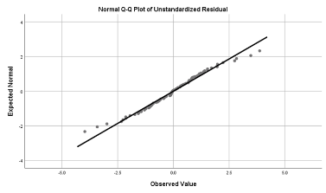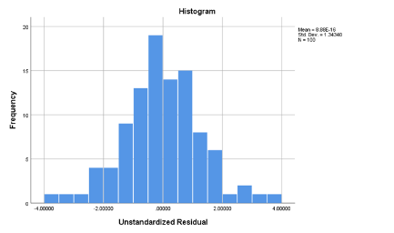

**Figure 2. Figure 3.**

**Histogram Graph Normal Probability Plot Graph**

**Source: Processed primary data, 2023 Source: Processed primary data, 2023**

Furthermore, the results of statistical tests using the Kolmogorov-Smirnov test can be seen in Table 5.

**Table 5.**

**Kolmogorov-Smirnov Non-Parametric Test Results**

|  |  |  |
| --- | --- | --- |
| **One-Sample Kolmogorov-Smirnov Test** | | |
|  | | Unstandardised Residual |
| N | | 100 |
| Normal Parametersa,b | Mean | .0000000 |
| Std. Deviation | 1.34339527 |
| Most Extreme Differences | Absolute | .063 |
| Positive | .056 |
| Negative | -.063 |
| Test Statistic | | .063 |
| Asymp. Sig. (2-tailed) | | .200c,d |

**Source: Processed primary data, 2023.**

Based on the results of the One-Sample Kolmogorov-Smirnov statistical test in Table 5. it can be seen that the significance value of 0.200 is more significant than 0.05. This shows that the data in this study are typically distributed.

1. **Classical Assumption Test**

* Multicollinearity Test

**Table 6.**

**Multicollinearity Tolerance and VIF Test Results**

|  |  |  |  |
| --- | --- | --- | --- |
| **Coefficients** | | | |
| Model | | Collinearity Statistics | |
| Tolerance | VIF |
| 1 | Pengetahuan Perbankan Syariah | .842 | 1.187 |
| Nilai Sosial | .932 | 1.073 |
| Religiusitas | .875 | 1.143 |
| Persepsi | .836 | 1.197 |
| a. Dependent Variable: Minat | | | |

**Source: Processed primary data, 2023**.

Table 6 shows that the tolerance value has a value of more than 0.10, and the VIF value is less than 10. Thus, there is no multicollinearity between the independent variables in the regression model.

* Heteroscedasticity test

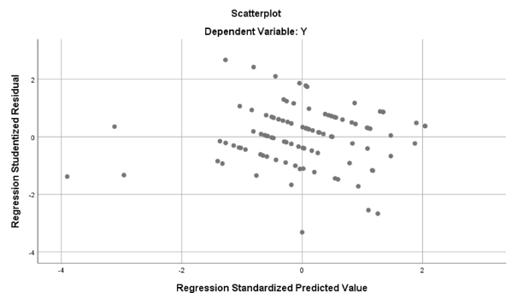

**Figure 4.**

**Scatterplot Test Results**

**Source: Processed primary data, 2023.**

**Table 7.**

**Glejser Test Results**

|  |  |  |  |  |  |  |
| --- | --- | --- | --- | --- | --- | --- |
| **Coefficients** | | | | | | |
| Model | | Unstandardised Coefficients | | Standardised Coefficients | t | Sig. |
| B | Std. Error | Beta |
| 1 | (Constant) | .185 | .092 |  | 2.020 | .046 |
| Pengetahuan Perbankan Syariah | -2.515E-5 | .004 | -.001 | -.006 | .995 |
| Nilai Sosial | -.007 | .004 | -.201 | -1.941 | .055 |
| Religiusitas | .002 | .003 | .069 | .649 | .518 |
| Persepsi | -.002 | .003 | -.079 | -.722 | .472 |
| a. Dependent Variable: ABS_Res3 | | | | | | |

**Source: Processed primary data, 2023.**

Figure 4. This shows that there are no symptoms of heteroscedasticity in this study because the points on the scatterplot are randomly distributed and spread above and below the number 0 (zero) on the Y axis.

Based on Table 7. it can be seen that all independent variable t values ​​are smaller than ttable (2.00758). So, it can be concluded that the regression model does not have symptoms of heteroscedasticity.

* Autocorrelation Test

Table 8.

Durbin-Waston Test Results

|  |  |  |  |  |  |
| --- | --- | --- | --- | --- | --- |
| **Model Summary** | | | | | |
| Model | R | R Square | Adjusted R Square | Std. Error of the Estimate | Durbin-Watson |
| 1 | .596a | .355 | .327 | 1.36925 | 1.933 |
| a. Predictors: (Constant), X4, X3, X2, X1 | | | | | |
| b. Dependent Variable: Y | | | | | |

**Source: Processed primary data, 2023.**

Based on the model summary output in Table 8. shows a DW value of 1.933. The value will be compared with the table value, where the number of samples (n) = 100, and the number of independent variables (k) = 4, then the lower limit (dL) is 1.592, and the upper limit (du) is 1.758. Therefore, the Durbin-Watson value is more than the upper limit (dU) of 1.758 and less than (4-dU), namely 2.242 or in other words, dU < d < 4-dL = 1.758 < 1.933 < 2.242, it can be concluded that there is no autocorrelation in this regression model.

1. **F Statistical Test**

**Table 9.**

**Statistical Test Results F**

|  |  |  |  |  |  |  |
| --- | --- | --- | --- | --- | --- | --- |
| **ANOVAa** | | | | | | |
| Model | | Sum of Squares | df | Mean Square | F | Sig. |
| 1 | Regression | 91.468 | 4 | 22.867 | 11.227 | .000b |
| Residual | 193.492 | 95 | 2.037 |  |  |
| Total | 284.960 | 99 |  |  |  |
| a. Dependent Variable: Minat Berkarir | | | | | | |
| b. Predictors: (Constant), Persepsi, Religiusitas, Nilai Sosial, dan Pengetahuan Perbankan Syariah | | | | | | |

Source: Processed primary data, 2023.

The F test carries out proof of hypothesis 1 (one). Based on Table 9. obtained F count = 11.227 > F table = 2.460 or significance = 0.000 <0.05, there is a significant influence between the variables of Islamic banking knowledge, social values, religiosity, and perceptions on career interest.

1. **Coefficient of Determination Test Results (R2)**

**Table 10.**

**Test Results for the Coefficient of Determination (R2)**

|  |  |  |  |  |  |
| --- | --- | --- | --- | --- | --- |
| **Model Summary** | | | | | |
| Model | R | R Square | Adjusted R Square | Std. Error of the Estimate | Durbin-Watson |
| 1 | .567a | .321 | .292 | 1.427 | 2.542 |
| a. Predictors: (Constant), X4, X3, X2, X1 | | | | | |
| b. Dependent Variable: Y | | | | | |

**Source: Processed primary data, 2023.**

Based on the test results for the coefficient of determination in Table 10, the Adjusted R Square value is 0.292 or 29.2 %. This means that the variables of Islamic banking knowledge, social values, religiosity, and perceptions contribute to the influence of career interest by 29.2%. At the same time, the remaining 70.8 % is influenced by other variables not examined in this study.

1. **t Statistical Test**

The t-statistic test aims to determine the effect of each independent variable partially on the dependent variable. The results of the t-statistical test in this study can be seen in Table 11.

**Table 11.**

**t Statistical Test**

|  |  |  |  |  |  |  |
| --- | --- | --- | --- | --- | --- | --- |
| **Coefficients** | | | | | | |
| Model | | Unstandardised Coefficients | | Standardised Coefficients | t | Sig. |
| B | Std. Error | Beta |
| 1 | (Constant) | 4.008 | 2.413 |  | 1.661 | .100 |
| Pengetahuan Perbankan Syariah | .046 | .102 | .042 | .454 | .651 |
| Nilai Sosial | .081 | .094 | .075 | .855 | .395 |
| Religiusitas | .233 | .073 | .287 | 3.179 | .002 |
| Persepsi | .358 | .088 | .375 | 4.057 | .000 |
| a. Dependent Variable: Y | | | | | | |

**Source: Processed primary data, 2023.**

Based on Table 11, obtained t count for the Islamic banking knowledge variable = 0.454 < t table = 1.983 or significance = 0.651 > 0.05, which means that there is a not significant effect between partial Islamic banking knowledge on career interest, then t count for social values variables = 0.855 < t table = 1.983 or significance = 0.395 > 0.05 which means that there is a not significant influence between the social values partially on career interest, and the resulting t count for the religiosity variable = 3.179 > t table = 1.983 or significance = 0.02 < 0.05 which means that there is significant effect between religiosity partially on career interest, and the resulting t count for perceptions variable = 4.057 > t table = 1.983 or significance = 0.00 < 0.05 which means there is significant influence between perceptions partially on career interest.

**CONCLUSION**

Based on the results of the research that has been done, the following conclusions are obtained: (1) Islamic banking knowledge, social values, religiosity, and perceptions simultaneously have a significant effect on employee loyalty, (2) Islamic banking knowledge has no significant effect on career interest, (3) social values partially has no significant effect on career interest, (4) religiosity partially has a significant effect on career interest, (5) perceptions partially has a significant effect on career interest. Suggestions for further research are to use other variables that affect the career interests of students of the Semarang City Islamic Banking Study Program in Islamic Banking.

**BIBLIOGRAPHY**

Djamaludin, Ancok. (1987). Pengembangan Skala Sikap terhadap Pekerjaan. *Jurnal Psikologi*.

Gipson. (2010). *Religiusitas Culture*. Erlangga

Mardiyani, I., Bintari, A., & Hakim, L. (2023). Pengaruh Lingkungan Keluarga, Religiusitas, Pengetahuan Perbankan Syariah Terhadap Minat Karir Keuangan Syariah. *Jurnal Riset Akuntansi Dan Keuangan*, *10*(1), 139–150. <https://doi.org/10.17509/jrak.v10i1.35731>

Jalaludin, Rakhmat. (2007). *Persepsi Dalam Proses Belajar*. Rajawali Pers.

Setiyorini, Tyas., & Asmono, R. T. (2017). Penerapan Gini Index dan K-Nearest Neighbor untuk Klasifikasi Tingkat Kognitif Soal Pada Taksonomi Bloom. *Pilar Nusa Mandiri*, *13*(2), 209–216. <https://ejournal.nusamandiri.ac.id/index.php/pilar/article/view/239>

Slameto. 2010. Belajar dan faktor-faktor yang Mempengaruhinya. Jakarta: PT. Rineka Cipta.

UMAR, J. (2015). Peranan Nilai Sosial Dalam Pengembangan Pendidikan Umum. *Al-Idarah : Jurnal Kependidikan Islam*, *5*(2), 1–18. https://doi.org/10.24042/alidarah.v5i2.758